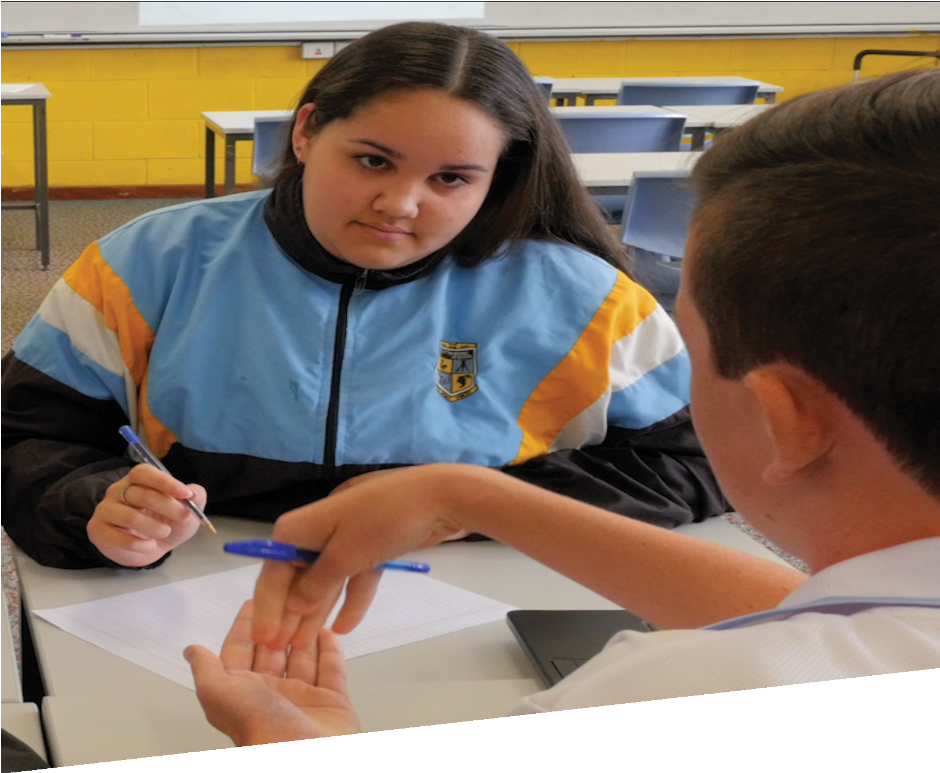


CURRICULUM RESOURCE MODULE
Reducing the burn
YEAR 9

Acknowledgements
The STEM Learning Project respectfully acknowledges the Traditional Custodians of the lands upon which our students and teachers live, learn and educate.

The STEM Learning Project is funded by the Western Australian Department of Education (the Department) and implemented by a consortium in STEM education comprising the Educational Computing Association of WA, the Mathematical Association of WA, the Science Teachers Association of WA and Scitech. We acknowledge and thank the teachers and schools who are the co-creators of these resources.

Copyright and intellectual property

The copyright and intellectual property of this module remain the property of the Department.

Any Western Australian Curriculum content in this resource is used with the permission of the School Curriculum and Standards Authority (the Authority); this permission does not constitute Authority endorsement of the resource. The Authority accepts no liability for any errors or damages arising from reliance on its content.

The Western Australian Curriculum content may be freely copied, or communicated on an intranet, for non-commercial purposes in educational institutions, provided that the Authority is acknowledged as the copyright owner. Copying or communication for any other purpose can be done only within the terms of the Copyright Act 1968 or with prior written permission of the Authority. Any Australian Curriculum content in the Western Australian Curriculum is used by the Authority under the terms of the Creative Commons Attribution-NonCommercial 3.0 Australia licence. Any content on the www.scsa.wa.edu.au domain that has been derived from the Australian Curriculum may be used under the terms of Creative Commons Attribution-NonCommercial 3.0 Australia licence.

Appendix 2: General capabilities continuums is adapted from ACARA, © Australian Curriculum, Assessment and Reporting Authority (ACARA) 2009 to present, unless otherwise indicated. This material was downloaded from the ACARA website (www.acara.edu.au) (Website) (accessed December 2015) and was not modified. The material is licensed under CC BY 4.0 (https://creativecommons.org/licenses/by/4.0/). ACARA does not endorse any product that uses ACARA material or make any representations as to the quality of such products. Any product that uses material published on this website should not be taken to be affiliated with ACARA or have the sponsorship or approval of ACARA. It is up to each person to make their own assessment of the product.

This resource includes references and examples of iOS, Android and other apps. The Department does not endorse or recommend any commercial products and simply provides these as examples for teachers.

The Department is committed to providing quality information to its customers. Whilst every effort has been made to ensure accuracy, currency and reliability of the information within these documents, the Department accepts no responsibility for errors, omissions or amendments made since the time of publishing. Confirmation of information may be sought from the Department or the originating bodies providing the information. The Department has no control over the content of material published on websites to which users are referred in this resource. It is the responsibility of the internet user to make their own decision as to the relevancy, accuracy, currency and reliability of information found on those sites.
This resource contains various images from iStock used under license.
Attributions: Kidblog, Weebly, Evernote, Cool tools for school, Powtoon, Adobe Spark, Microsoft Word.

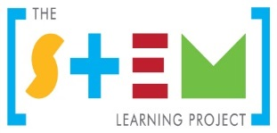
Table of contents
The STEM Learning Project 2
Overview 3
Activity sequence and purpose 7
Background 8
Activity 1: Being sun and skin aware 10
Activity 2: UVR exposure 23
Activity 3: Designing a risk reduction strategy 34
Activity 4: Communicating the strategy 41
Appendix 1: Links to the Western Australian Curriculum 45
Appendix 1B: Mathematics proficiency strands 48
Appendix 2: General capabilities continuums 49
Appendix 3: Design process guide 52
Appendix 4: Student journal 53
Appendix 5: Student activity sheet 1.0: Portfolio checklist 54
Appendix 6: Teacher resource sheet 1.1: Cooperative learning – Roles 55
Appendix 7: Teacher resource sheet 1.2: Cooperative learning – Jigsaw 56
Appendix 8: Teacher resource sheet 1.3: Cooperative learning – Placemat 57
Appendix 9: Teacher resource sheet 1.4: Cooperative learning – Think, Pair, Share 58
Appendix 10: Teacher resource sheet 1.5: Sample parent/carer letter 59
Appendix 11: Teacher resource sheet 1.6: Scientific notation and significant figures 60
Appendix 12: Student resource sheet 2.1: Scale model of the Earth and atmosphere 63
Appendix 13: Student resource sheet 2.2: Spreadsheet for Variations in UVR intensity during the day. 64
Appendix 14: Teacher resource sheet 3.1: Flowcharting symbols 65
Appendix 15: Teacher resource sheet 3.2: Flowchart examples 66
Appendix 16: Student activity sheet 4.1: Peer evaluation 68
Appendix 17: Student activity sheet 4.2: Self-evaluation 69

The STEM Learning Project
The aim of the STEM Learning Project is to generate students’ interest, enjoyment and engagement with STEM (Science, Technology, Engineering and Mathematics) and to encourage their ongoing participation in STEM both at school and in subsequent careers. The curriculum resources will support teachers to implement and extend the Western Australian Curriculum across Kindergarten to Year 12 and develop the general capabilities.
Why STEM?
A quality STEM education will develop the knowledge and intellectual skills to drive the innovation required to address global economic, social and environmental challenges.
STEM capability is the key to navigating the employment landscape changed by globalisation and digital disruption. Routine manual and cognitive jobs are in decline whilst non-routine cognitive jobs are growing strongly in Australia. Seventy-five per cent of the jobs in the emerging economy will require critical and creative thinking and problem solving, supported by skills of collaboration, teamwork and literacy in mathematics, science and technology. This is what we call STEM capability. The vision is to respond to the challenges of today and tomorrow by preparing students for a world that requires multidisciplinary STEM thinking and capability.
The approach

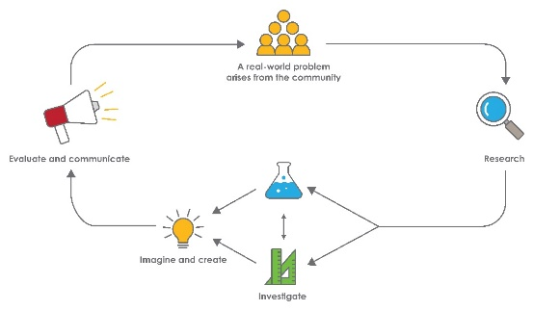
STEM capabilities are developed when students are challenged to solve open-ended, real-world problems that engage students in the processes of the STEM disciplines.

Year 9 – Reducing the burn
STEM Consortium

Overview
What is the context?
According to the Cancer Council, the incidence of skin cancer in Australia is one of the highest in the world. It is the most commonly diagnosed cancer in Australia, and approximately two in three Australians will be diagnosed with skin cancer by the time they are 70.
Almost all skin cancers result from skin damage caused by exposure to ultra-violet radiation (UVR) throughout a person’s life. This exposure occurs while people go about their daily routines, including spending time in the outdoors at work or undertaking recreational activities.
In this module, students use their knowledge of this significant health issue to develop a mathematically rigorous solution that allows Australians determine their level of sun exposure.
What is the problem?
Australia has the highest rate of skin cancer in the world. How can you change this?
How does this module support integration of the STEM disciplines?
Science
Students explore skin as an organ of the body including its structure and function and how skin cancers develop (ACSSU175). Students use the wave model to explain the characteristics of ultraviolet radiation (UVR) and research its transfer and transformation as it travels from the Sun through the atmosphere to our skin (ACSSU182).
Student are given opportunities to analyse patterns and trends in data, including describing relationships between variables such as location, time of day, elevation of the Sun and path length through the atmosphere that impact on UVR intensity and identifing inconsistencies (ACSIS169). They critically analyse the validity of information in primary and secondary sources such as their own data as well as data from the ARPANSA and BoM websites (ACSIS172) and are required to communicate their findings from investigations to justify proposed sun protection strategies using appropriate scientific language, conventions and representations (ACSIS170, ACSIS171, ACSIS174).

Technology
As students design and develop a sun protection strategy, they identify and define the needs of a stakeholder and create a brief for a solution (WATPPS54). They collect and analyse data regarding the stakeholder’s lifestyle in relation to sun exposure to inform the design (ACTDIP037) and apply design thinking, creativity and enterprise skills to develop their strategy(WATPPS56). Students evaluate their solutions against student-developed criteria (WATPPS59) and work independently and collaboratively to manage the design project, using digital technology and an iterative and collaborative approach (WATPPS60). Students design their strategy in the form of an algorithm, represented diagrammatically and in structured English (ACTDIP040) and use digital technologies to communicate their strategy to their stakeholder.
Mathematics
Students apply scientific notation, index laws and significant figures as they develop an understanding of how to represent the magnitude of wavelengths of various forms of electromagnetic radiation (ACMNA209, ACMNA210, ACMNA212). Students apply scale factors and trigonometry to interpret variations in the path of the Sun and UVR intensity (ACMMG221, ACMMG224). Students analyse data they have collected and from secondary sources as they develop an understanding of UVR (ACMSP228).

General capabilities
There are opportunities for the development of general capabilities and cross-curriculum priorities as students engage with Reducing the burn. In this module, students:
- Develop problem solving skills as they research the problem and its context (Activity 1); investigate parameters impacting on the problem (Activity 2); imagine and develop solutions (Activity 3); and evaluate and communicate their solutions to an audience (Activity 4).
- Develop skills in creative thinking and numeracy as they generate and evaluate a range of solutions, making judgements aligned to criteria they develop themselves.
- Utilise personal and social capability as they develop socially cohesive and effective working teams; collaborate in generating solutions; adopt group roles; and reflect on their group work capabilities through self and peer evaluation.
- Utilise a range of literacies and information and communication technologies capabilities as they collate records of work completed throughout the module; represent and communicate their solutions to an audience using digital technologies in Activity 4.
- Communicate and, using evidence, justify their sun protection strategy to an authentic audience using a digital resource.

What are the pedagogical principles of the STEM learning modules?
The STEM Learning Project modules develop STEM capabilities by challenging students to solve real-world problems set in authentic contexts. The problems engage students in the STEM disciplines and provide opportunities for developing higher order thinking and reasoning, and the general capabilities of creativity, critical thinking, communication and collaboration.
The design of the modules is based on four pedagogical principles:
- Problem-based learning
This is an underlying part of all modules with every module based around solving an initial problem. It is supported through a four-phase instructional model: research the problem and its context; investigate the parameters impacting on the problem; design and develop solutions to the problem; and evaluate and communicate solutions to an authentic audience.
- Developing higher order thinking

Opportunities are created for higher order thinking and reasoning through questioning and discourse that elicits students' thinking, prompts and scaffolds explanations, and requires students to justify their claims. Opportunities for making reasoning visible through discourse are highlighted in the modules with the question mark icon shown here.
- Collaborative learning
This provides opportunities for students to develop teamwork and leadership skills, challenge each other’s ideas, and co-construct explanations and solutions. Information that can support teachers with aspects of collaborative learning is included in the resource sheets.
- Reflective practice
Recording observations, ideas and one’s reflections on the learning experiences in some form of journal fosters deeper engagement and metacognitive awareness of what is being learnt. Information that can support teachers with journaling is included in the resource sheets.
These pedagogical principles can be explored further in the STEM Learning Project online professional learning modules located in Connect.

Activity sequence and purpose
 | Being sun and skin aware  Students engage with the significant health issue of skin cancer and develop an understanding of the skin and the nature and causes of skin cancers. Students research UV electromagnetic radiation and how its energy is transferred from the Sun to our skin.
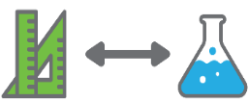 | UVR exposure  Students investigate variations in UVR intensity using first and second-hand data. They calculate the elevation of the Sun above the horizon and the distance travelled by UVR through the atmosphere.
 | Designing a risk reduction strategy  Using the design process and knowledge gained from their science and mathematics investigations, students work with a family or class member to develop a strategy, in the form of an algorithm, to minimise their exposure to UVR.
 | Communicating the strategy  Students develop digital resources (eg video, slide show, infographic) to communicate recommended sun protection strategies that will convince a family or class member to establish routines to protect themselves from excessive UVR exposure.

Background
Expected learning | Students will be able to:  - Use a wave model to describe the characteristics of UVR and explain how it reaches the skin.  - Describe the structure of skin and explain how it acts as an organ of the body to keep us healthy.  - Plan and conduct investigations, analyse and explain patterns in collected data and communicate evidence-based ideas using appropriate scientific language.  - Express frequencies and wavelengths using scientific notation.  - Collect and interpret data from secondary sources.  - Apply trigonometry to solve problems relating to the elevation of the Sun in the sky.  - Calculate the UVR path length through the atmosphere using scale factors.  - Identify the needs of a stakeholder and create a design brief for developing solutions that meet the needs of the stakeholder.  - Apply design thinking and creativity in developing a decision-making algorithm for selecting appropriate sun protection strategies.  - Design and develop a digital resource for communicating the sun protection solution to the stakeholder.
Vocabulary | The following vocabulary list contains terms that need to be understood, either before the module commences or developed as they are used:  algorithm, basal cell carcinoma, continuous data, criteria, design brief, design thinking, discrete data, electromagnetic radiation, electromagnetic spectrum, intensity, melanoma, ozone, qualitative data, quantitative data, scientific notation, significant figures, squamous cell carcinoma, ultra-violet radiation, wavelength.
Timing | There is no prescribed duration for this module. The module is designed to be flexible enough for teachers to adapt. Activities do not equate to lessons; one activity may require more than one lesson to implement.
Safety notes | There are potential hazards inherent in these activities and with the equipment being used, and a plan to mitigate any risks will be required.  Potential hazards specific to this module include but are not limited to:  - Possible exposure to cyber bullying, privacy violations and uninvited solicitations when using the internet  - Potential for emotional responses from students when sharing cancer stories and sensitivity to the comparison of skin colours  - Potential to look at the Sun directly when investigating its trajectory across the sky.
Assessment | The STEM modules have been developed to provide students with learning experiences to solve authentic real-world problems using science, technology, engineering and mathematics capabilities. While working through the module, the following assessment opportunities will arise:  - Development of a flowchart algorithm in Activity 3 and its digital resource in Activity 4 will provide individual work samples.  - A Student journal is to be used throughout the activities for students to reflect on their learning and justify their thinking and should form part of the final portfolio. Journal entries from Activities 2 and 4 could be used to assess science inquiry skills. Digital Technologies content descriptions can be assessed through journal entries for Activities 3 and 4.  - This module could provide context for test items on science understanding of ultraviolet radiation, the electromagnetic spectrum and science inquiry skills.  Appendix 1 indicates how the activities are linked to the Western Australian Curriculum.  Evidence of learning from journaling, presentations and anecdotal notes from this module can contribute towards the larger body of evidence gathered throughout a teaching period and can be used to make on-balance judgements about the quality of learning demonstrated by the students in the science, technologies and mathematics learning areas.  Students can further develop the general capabilities of Information and communication technology capability, Critical and creative thinking and Personal and social capability. Continuums for these are included in the General capabilities continuums but are not intended to be for assessment purposes.

Activity 1: Being sun and skin aware
  Activity focus | Students engage with the significant health issue of skin cancer and develop an understanding of the skin and the nature and causes of skin cancers. Students research UV electromagnetic radiation and how its energy is transferred from the Sun to our skin.
Background information | Skin as an organ  The skin is the largest organ of the body. It performs many important functions including:  - Protecting underlying tissues from injury, overexposure to ultraviolet light, microorganisms and harmful chemicals  - Acting as a sensory organ for pressure, touch, temperature, pain and vibration  - Thermoregulation  - Preventing excessive water loss.  With a complex structure, skin principally consists of three parts: the epidermis, dermis and subcutaneous layer.  The epidermis is the outer, thinner and major protective layer of the skin. Basal cells on the lower layer of the epidermis actively undergo cell division, moving up and flattening out to form squamous cells at the top layer of the epidermis.  Melanocytes are cells that, when exposed to sunlight, produce extra melanin, which is a dark pigment that protects the skin from burning and causes it to tan.  The dermis provides support to the epidermis as well as its blood and nerve supply. Also located in the dermis, are the hair follicle, sebaceous(oil) glands and sweat glands.  The epidermis, dermis and associated structures are illustrated in the following diagram.  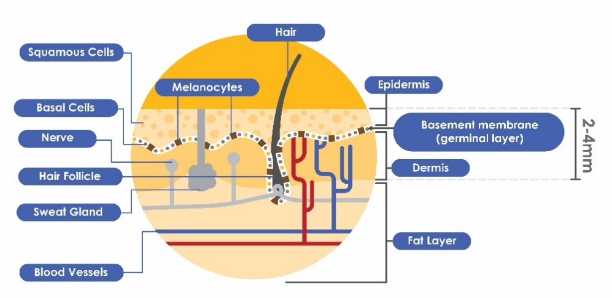  STEM Consortium  ARPANSA  The Australian Radiation Protection and Nuclear Safety Agency (ARPANSA) ensures private and government organisations that use radiation do so in a safe way and protect people and the environment from the harmful effects of radiation such as UVR, X-rays and Gamma rays.  Ultraviolet Radiation (UVR)  UVR emitted from the Sun, comprises:  - UVA, with longer wavelengths of 320 to 400 nm, and lower energy  - UVB, with shorter wavelengths of 290 to 320 nm and higher energy  - UVC, with the shortest wavelengths of 100 to 290 nm and highest energy of all types of UVR.  Shorter wavelengths are the most harmful to our skin and, fortunately for life on Earth, almost all UVC is absorbed by the atmosphere before it reaches Earth. Ozone plays an important role in blocking UVC.  Both UVA and UVB damage skin cells and contribute to skin cancer. UVA contributes more to ageing because it penetrates deeper into skin layers and UVB causes sunburn.  The following diagram demonstrates the penetrative potential of three components of UVR emitted from the Sun.  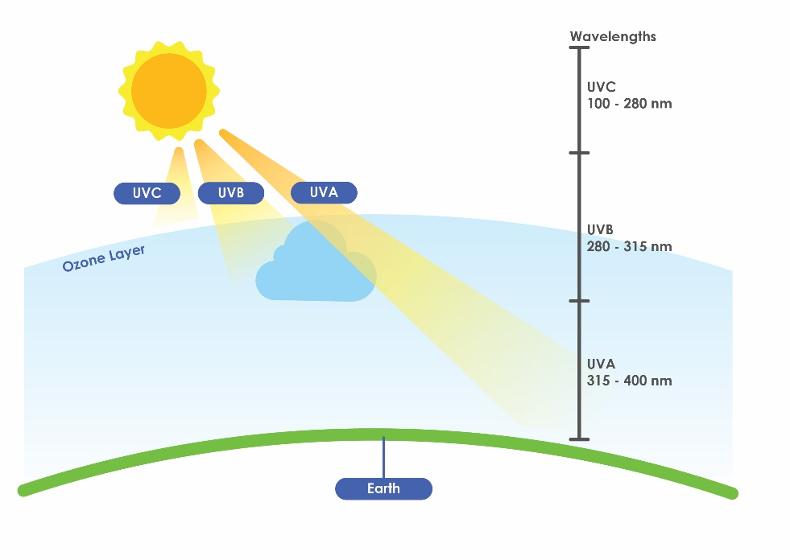  The Cancer Council advises that most people living in Australia are at risk of developing skin cancer, with the following factors significantly affecting that risk – skin, eye and hair colour, large numbers of freckles or moles, childhood sunburn, childhood spent in Australia, familial and individual history of skin cancer, the use of solariums and working or leisure time spent predominantly in the sun.  STEM Consortium  The Ultraviolet (UV) Index  The intensity of electromagnetic radiation, including UVR is measured in Watts per square metre, or Wm⁻². An internationally recognised way of measuring UV intensity has been developed by the World Health Organization and is known as the UV Index. It was introduced in 2002.  The UV Index is a numerical indicator of the maximum potential solar UVR hazard on a given day of the year, for a particular location (latitude and altitude) and at a specified time, allowing for variable atmospheric conditions such as cloud cover.  Each point on the UV Index scale represents 25 mWm⁻² (milliWatts per square metre) of UVR. The World Health Organization recommends that at a UV index of: 1-2 no sun protection is required; 3-8 protection is required including sunscreen, a shirt and hat and seeking shade at midday; and at a UV index of 8 and above, in addition to sunscreen, a shirt and hat and seeking shade, people should avoid being outdoors at midday.  This standard way of reporting solar UVR allows us to compare the potential UVR hazard between different geographical locations throughout the world using simple numbers that have a consistent meaning. The World Health Organization’s UV Index (see Digital resources) shows a chart with the sun protection methods to be used at each level.  Index measures like this are used in science, health, economics and other areas of human endeavour to represent ‘how much of something’ is present.  This is a different meaning of the word ‘index’ in mathematics, which normally means a number that is written smaller and to the top right of another number called the base. In scientific notation, the base is 10 and the index shows how many times 10 is multiplied by itself. For example, 10³ is 1000, 10⁻³ is $\frac{1}{1 000}$ etc.  Sun protection measures  The Cancer Council recommends that we Slip, Slop, Slap, Seek and Slide (the 5Ss) to protect ourselves from UV radiation:  - Slip on some sun protective clothing that covers as much skin as possible.  - Slop on broad spectrum, water resistant SPF30 (or higher) sunscreen.  - Slap on a hat - broad brim or legionnaire style to protect your face, head, neck and ears.  - Seek shade.  - Slide on some sunglasses - make sure they meet Australian Standards.  www.cancer.org.au/preventing-cancer/sun-protection/preventing-skin-cancer/
Instructional procedures | In this activity students engage in research, discuss their findings in groups and report them to the class. Students will be documenting their findings in their portfolios and also as infographics, which can be shared with the class. Sensitivity is needed around sharing family cancer stories and comparison of skin types.  Remind students that they should never look directly at the Sun. Support this by reading with students the article Will looking at the sun really make you blind? (see Digital resources).
Expected learning | Students will be able to:  - Describe the structure of the skin and its role as an organ of the body (Science).  - Explain the types of UVR and how UVR intensity is measured and reported (Science).  - Using a wave model, explain how UVR as a form of electromagnetic radiation transfers energy to the skin (Science).  - Use scientific notation and significant figures in reporting measures (Mathematics and Science).  - Explain how cell division enables tissues to repair themselves and grow (Science).  - Describe the types of skin cancer, their incidence and impacts on lives (Science).
Equipment required | For the class:  Computer  Digital projector  Whiteboard or interactive whiteboard
Equipment required | For the students:  Internet access or access to a resource library
Preparation | Ask students to inform their parents that they will be examining the effect of UVR on skin and how this can lead to skin cancer. Students should also seek information about any family history of skin cancer. This could provide a personal framework for students as they select strategies to raise awareness of the dangers of UVR and then develop a plan for a family or class member to reduce the long-term risk of melanoma due to excessive exposure to UVR. See Teacher resource sheet 1.5: Sample parent/carer letter to assist with this.  Ensure students have access to digital devices for online research.  Check the websites listed in the Digital resources section are accessible to students for their research.
Activity parts | Part 1: The 5Ss; slip, slop, slap, seek and slide  This part is designed to create an authentic connection to the topic and an emotional imperative for solving the problem. Students view the video Wes Bonny Story: Family and friends (see Digital resources). This is a highly personal story that is intended to help students appreciate the devastating impact of losing a son, daughter or close friend to skin cancer.  Inform students that the context for the module will be set through personal stories. Ask students whether there is any history of skin cancer in their extended families and if it is okay to share this information with their group. If the experience is upsetting, students should feel free not to share their story.  In groups, students indicate whether any of their extended family members have had skin cancer and, if comfortable to do so, share their family skin cancer story with group members. Prompt discussion with the following questions:  - How common is the incidence of skin cancer in the families of your group?  - Do you know anything about the risk factors for skin cancer and how these risk factors might have impacted the person in your story?  - How sun safe are you?  - How many of the 5Ss (slip, slop, slap, seek and slide) did you apply on your way to school/at lunch time?  - How might our friends influence how sun safe we are?  Introduce students to the module problem statement: Australia has the highest rate of skin cancer in the world. How can you change this?  Prompt discussion and research with the following question:  - Why does Australia have a high rate of skin cancer?
Part 2: Structure and function of the skin
Using digital or design technologies, students create an infographic or a scale model of human skin that includes the features and other information they have found. As a minimum it should include the following elements:
- The structure of skin
- The functions of skin
- How different skin cells respond to UVR
- The functions of different skin cell types.
When each group has a first draft of their infographic/model, encourage students to share with two other groups. Students use this sharing process to add to or modify their group’s infographic/model.
Part 3: Skin cancer – What’s your risk?
In this part, students begin to understand skin cancer risk factors such as skin types, genetic predisposition, protective strategies and behaviour. In this research task, they will likely encounter the concept of UV radiation and the impact of too much or too little UV radiation on the body.
The following questions can be used to guide exploration and discussion. Students should record answers in their portfolios with some reference to the initial problem: Australia has the highest rate of skin cancer in the world.
- What are some of the risk factors for UV exposure and can they be mitigated?
- How does the skin react to exposure to sunlight?
Show students the ARPANSA Fitzpatrick skin phototype (see Digital resources) classification system that was first developed in 1975 by American Professor Thomas Fitzpatrick, MD, of the Harvard Medical School. Explain that it examines three components of skin cancer risk:
- Genetic components as measured by the fairness of skin and hair, eye colour etc.
- How the body reacts to exposure to sunlight
- Intentional sun exposure or tanning habits.
Skin type is determined by adding scores from the three components.
Students complete the test – either the paper version, Fitzpatrick skin phototype or the online version Are You at Risk for Skin Cancer? (see Digital resources). Questions to prompt discussion include:
- What type of data is being collected through this survey? Why? (The webpage What is Data? in Digital resources can be used to define and review data types)
- What is your total score?
- Into which skin type did this score place you?
- What does this tell you about your risk of skin cancer in the future?
- Did all questions have clear, unambiguous categories, or for some questions were the answers not so clear cut? Which ones?
- What is it in our skin that enables some people to tan easily whereas others do not?

Encourage students to ask their family members to complete the skin type test and compare their skin type with that of their family members. Students review the test results, examine them for any relationships and share with their group.
Part 4: The electromagnetic spectrum
Students explore the concept of electromagnetic radiation in more detail, referring to the following Digital resources to assist with completing this activity:
- The Electromagnetic Spectrum, Basic (NASA)
- The Electromagnetic Spectrum, Advanced (NASA). Note this link contains a useful video for students, Tour of the EMSO1 – Introduction
- What is the electromagnetic spectrum? (Earth Sky).
The range of the electromagnetic spectrum is very large, over 15 orders of magnitude, and so could be difficult for students to grasp. This is an excellent opportunity to spend some time teaching scientific notation as the way scientists, mathematicians and engineers record and use numbers that are very large or very small. From here it is a logical progression to consider significant figures and numerical prefixes.
Teacher resources sheet 1.6: Scientific notation and significant figures can be used for review and practise.

Ask students to consider the following questions while discussing these mathematical concepts:
- What are the differences between a metre (m), decimeter (dm), centimeter (cm), millimeter (mm), micrometer (μm) and nanometer (nm)?
- What do significant figures tell us?
- Why do scientists use significant figures and scientific notation? Use examples to support your explanation.
Working in their groups, students make notes in their portfolios and answer the following questions as they use these resources.
- What is a wavelength and what unit is used to measure it?
- What is frequency and what unit is used to measure it?
- What are the types of electromagnetic radiation?
Students use the knowledge gained from viewing the resources on EM radiation to develop a deck of flash cards that can be used to help understand the major concepts, including:
- Types of radiation
- Frequency
- Wavelength
- Energy transfer by waves and particles
- Under the UV spectrum, a pop out diagram that shows UVA, UVB and UVC radiation, including wavelength and frequency.
Optional extension questions for this part can include:
- What effect does UV light have on our skin and the DNA of our skin cells?
- How does this lead to cancer?
Part 5: UVR and energy transformations
Students research the characteristics of UVA, UVB and UVC, their absorption by ozone in the atmosphere and their impacts on skin, and describe these in an explainer video using a tool like Powtoon or Adobe Spark. The World Health Organization’s UV radiation webpage (see Digital resources) is a useful resource to initiate research.
Encourage class discussion with the following prompt questions:
- How do UVA, UVB and UVC differ in wavelength, frequency and the energy they carry?
- To what extent are these forms of UVR absorbed in the atmosphere?
- What effects do the forms of UVR have on our skin?
Read NASA’s Ozone article (see Digital resources) with students to develop an understanding of the relationship between UVR and ozone. Relate this to UVR penetrating the skin and affecting the bonding of parts of the DNA molecule, resulting in mutations to genes that can give rise to uncontrolled division of skin cells and skin cancer.
Challenge students to use this article to create a flowchart that summarises the energy transfers and transformations as solar energy passes through the atmosphere and is absorbed by the skin and affects the structure of cell DNA.
The following questions could guide their research:
- In what form is UV energy emitted from the Sun?
- How does ozone in the atmosphere interact with UV radiation?
- How is the energy of UV radiation transformed as it is absorbed by the skin?
- What changes occur on the surface of the skin and inside the skin cells as a response to UVR exposure?
- What could these changes mean for the individual in the short and long term?
Part 6:
SPF and UPF
To design a UVR exposure reduction strategy, students will need to understand the following two UVR-related measures:
- Sun Protection Factor (SPF), which relates to sunscreen
- Ultraviolet Protection Factor (UPF), which relates to fabrics used to make clothing.
Both indicate ‘how much longer a person takes to burn compared with unprotected skin’, if they are wearing a product with an SPF or UPF rating.
Explaining SPF
As a class discuss the meaning of SPF, with specific reference to the examples below.
If a person’s bare skin starts to show early signs of sunburn by turning pink or red after 10 minutes in direct sunlight, then being protected by sunscreen rated at:
- SPF30, means it would take 10 minutes X 30 = 300 minutes or 5 hours before they would start to burn
- SPF50, means it would take 10 minutes X 50 = 500 minutes or 8 hours and 20 minutes before burning when protected with clothing made from a SPF50 fabric.
Students view the sunscreens currently available from the Cancer Council on their Sunscreen webpage (see Digital resources).
Prompt class discussion with the following questions:
- What is the benefit of making a range of different types of sunscreens available to consumers?
- What is the most suitable sunscreen for you to use during your daily activities? Explain your choice.
- How should sunscreen be applied to be effective?
- Why would other forms of sun protection be used in conjunction with a sunscreen?
Explaining UPF
Student groups work together to read the ARPANSA magazine article Ready to Wear Sun Protection which explains UPF (see Digital resources) and answer the following questions:
- What type of knit or weave blocks most UVR?
- What colours, or colour types, block more UVR?
- How would a fabric with a UPF rating of 3 and a fabric with a UPF rating of 30 appear when viewed under a microscope?
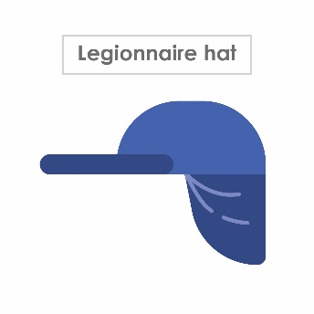
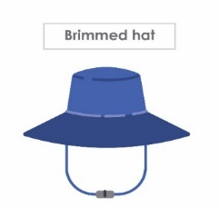

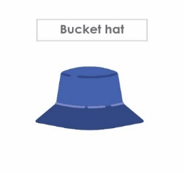
As a class, use these questions to discuss the meaning of UPF, with reference to ratings and fabrics. Project images of a legionnaire hat, a brimmed hat, a baseball cap and a bucket hat for students to view.
STEM Consortium

Ask students to determine which hat design provides the best protection and explain their choice using the UPF terminology previously discussed.
Part 7: Reflection and journaling
Students reflect on what has been learnt in this activity and record their reflections in the journal section of their portfolio. Focus questions could include:
- Why is healthy skin important? What makes skin an organ?
- What is UVR?
- What energy transfers and transformations occur as UVR passes through the atmosphere and is absorbed by the skin?
- How does exposure to high levels of UVR affect the skin?
Resource sheets | Teacher resource sheet 1.5: Sample parent/carer letter  Teacher resource sheet 1.6: Scientific notation and significant figures
Digital resources | UV Index (World Health Organization, 2019)  www.who.int/uv/intersunprogramme/activities/uv_index/en/index1.html
Digital resources | Australian Radiation Protection and Nuclear Safety Agency (ARPANSA) website:  www.arpansa.gov.au/
Digital resources | Wes Bonny Story: Family and friends (SunSmart Victoria, 2012)  youtu.be/X1P1po6bH3w
Digital resources | Patient’s Stories (Melanoma Institute of Australia, 2019)  https://www.melanoma.org.au/understanding-melanoma/support-patient-stories/patient-stories/
Digital resources | The Electromagnetic Spectrum, Basic (NASA, 2013)  imagine.gsfc.nasa.gov/science/toolbox/emspectrum1.html
Digital resources | The Electromagnetic Spectrum, Advanced (NASA, 2013)  imagine.gsfc.nasa.gov/science/toolbox/emspectrum2.html
Digital resources | What is the electromagnetic spectrum? (EarthSky, 2017)  earthsky.org/space/what-is-the-electromagnetic-spectrum
Digital resources | UV radiation (World Health Organization, 2019)  www.who.int/uv/faq/whatisuv/en/index2.html
Digital resources | Ozone (NASA, 1999)  earthobservatory.nasa.gov/features/Ozone/ozone_2.php
Digital resources | Sunscreen (Cancer Council, 2019)  www.cancercouncilshop.org.au/category/sunscreen
Ready To Wear Sun Protection (ARPANSA, n.d)
www.arpansa.gov.au/sites/default/files/legacy/pubs/upf/SCF2012_Ready-to-Wear-Clothing.pdf
Fitzpatrick skin phototype (ARPANSA, n.d)
www.arpansa.gov.au/sites/default/files/legacy/pubs/RadiationProtection/FitzpatrickSkinType.pdf

Are You at Risk for Skin Cancer? (The Skin Cancer Foundation, 2019)
www.skincancer.org/blog/are-you-at-risk-for-skin-cancer/#panel1-3
What is Data? (Maths is Fun, 2017)
www.mathsisfun.com/data/data.html
Mitosis: The Amazing Cell Process that Uses Division to Multiply! (Amoeba Sisters, 2016)
youtu.be/f-ldPgEfAHI
UV Radiation and your skin
www.skincancer.org/risk-factors/uv-radiation/

Activity 2: UVR exposure
 | Activity focus |  | Students investigate variations in UVR intensity using first and second-hand data. They calculate the elevation of the Sun above the horizon and the distance travelled by UVR through the atmosphere.
 | Background information |  | The intensity of UVR at a given location varies during the day and season. The position of the Sun in the sky determines the angle of incidence of the UVR and the length of its path through the atmosphere. The longer the path, the greater the reflection of UVR and absorption of UVR by ozone.  The amount of UVR at a location can be measured directly using a UVR meter. These can be accessed from the Regional Laboratory Technicians science loan pool.  There are also several cheap, portable personal UVR meters on the market that would provide similar results.
 | Expected learning |  | Students will be able to:  - Plan and conduct science investigations, and collect, analyse and interpret data (Science and Technologies).  - Access, collate and interpret second-hand data from government agencies’ websites (Science, Mathematics and Technologies).  - Apply trigonometry to calculate the angle of elevation of the Sun in the sky (Mathematics).  - Calculate the UVR path length through the atmosphere using scale factors (Mathematics).  - Explain variations in UVR intensity in terms of the time of day, time of year, the elevation of the Sun and path through the atmosphere (Science).
 | Equipment required |  | For the class:  Computer and data projector
For the students:
Meter for measuring UVR intensity
Cameras and devices
Student resource sheet 2.1: Scale model of the Earth and atmosphere
Student resource sheet 2.2: Spreadsheet, Variations in daytime UVR intensity
 | Preparation |  | Determine the method that will be used to directly measure UV radiation intensity and source equipment.  Provide students with access to the resource sheet.
Activity parts |  | Part 1: Measuring UVR  Students examine variables that influence variations in UVR intensity. They analyse and interpret second-hand data and use direct measures to collect their data.  Second-hand data  Explain to students that there are government agencies, for example, the Bureau of Meteorology (BoM), who have high-quality UVR meters at various locations around Australia. Data from these sites are collected by the BoM and made available to the public as a daily report, which is often included in weather reports.  Direct students to view the Perth Forecast page on the BoM website (see Digital resources) and identify today’s UV index for their location. Ask them to click on the location tabs at the top of the page to access live or daily UV readings for several locations in Australia.  Ask students to compare live readings from Darwin, Perth and Hobart. Prompt class discussion with the following questions:  - Why might UV readings at these locations differ?  - What factors would influence UVR intensity? Why? …because…  Direct students to the ARPANSA Ultraviolet radiation index (see Digital resources) which calculates UVR by location and times of the day. Ask students to choose the city nearest to them and investigate a range of dates including mid-summer and mid-winter.  Prompt discussion with the following focus questions:  - How do the UV readings vary? Why?  - What else does the graph tell its reader?  Refer students to the BoM’s webpage About UV and sun protection times (see Digital resources) to assess what additional information is provided on this site.  Using direct measures to investigate variables impacting on UVR intensity  Engage students in a brainstorm of variables that might impact on the intensity of UV radiation that we experience. Encourage students to hypothesise how each of the variables impacts on UVR intensity. As a class, agree on the variables that would be worth investigating. Have each group select one variable that they will investigate and support the groups to plan their investigations.  Prompt questions might include:  - What independent variable are you investigating? What is your dependent variable?  - What is the question you are investigating? What is your prediction?  - What are the steps of your experimental procedure?  - Which variable will need to be controlled?  - How will you measure UVR intensity? How will you ensure that you get reliable data? What does it mean to be reliable?  - How will your data be recorded? Would spreadsheets assist with recording and graphing your data?  Have each group report their investigation plan to the class. Allow other groups to provide feedback on the plans as they are presented so that plans can be improved before they are implemented. Teacher guidance may be required to assist with the scheduling of data collection.  Following data collection, provide time for groups to re-represent, analyse and interpret their data. Prompt questions might include:  - Why have you chosen to represent your data this way?  - What pattern can you see in your results? What relationship is there between your independent and dependent variables?  - How did your independent variable cause changes to UVR intensity?  - Are there any inconsistencies in your data? How did they occur?  - How reliable is your data? How do you know?  - How could your experimental design be improved to enhance the reliability of the data?  - What is your conclusion? How does your conclusion answer your question? Was your prediction supported?  Once the groups have analysed and interpreted their data, have each group present their findings to the class and allow other groups to provide feedback on their investigations and findings. Scaffold a discussion in which the findings of the different groups can be summarised and then documented in student portfolios.  Discuss with students the advantages and disadvantages of taking direct UVR measurements at school compared to accessing data from high-quality UVR meters at city locations through websites such as BoM or ARPANSA.
Part 2: Investigating variation in UVR intensity during the day
Explain to students that as UVR travels through the atmosphere, some of it is absorbed or reflected. Ozone in the atmosphere plays an important role in absorbing UVR energy.
Explain that in this part of the activity they will be investigating the extent to which the path of UVR through the atmosphere varies in length during the day from sunrise, through midday to sunset, and how this affects the UV intensity experienced on Earth’s surface.
It is useful at this stage to ask the students to predict how the path length changes throughout the day and how this might affect UVR intensity at the Earth’s surface.
Refer students to Student resource sheet 2.1: Scale model of the Earth and atmosphere, which provides a diagram of the Earth and its atmosphere drawn to scale. Students need to accurately draw the Sun’s rays entering the atmosphere at different angles of elevation above the horizon at two-hour intervals between sunrise and sunset.
This is an opportunity for students to apply mathematical reasoning to calculate the angles of elevation. For example, if they assume sunrise is at 6 am and sunset is at
6 pm, the Sun appears to travel through an arc of 180° in
12 hours. This is the equivalent of 15° per hour, so at 8 am the Sun will be at 30° to the horizontal. Once the Sun’s rays have been drawn, students measure the length of the ray’s path through the atmosphere in millimetres and use the scale on the diagram to convert path lengths into kilometres.
Prompt students to create a spreadsheet for recording the measurements of the ray’s path in mm and the ray’s path in km at two-hour intervals from sunrise at 6 am to sunset at
6 pm. Once the data has been recorded, prompt students to use spreadsheet functions to create a graph of path length (km) against time (hr) showing variations in UVR intensity during the day. See Student resource sheet 2.2: Spreadsheet, Variations in UVR intensity during the day.
Lead a class discussion with the following questions:
- How did you calculate the angles of elevation above the horizon? What assumptions did you make?
- How did you calculate the path lengths in kilometres?
- How did the path lengths vary? What did you learn from your graph about the pattern in the data?
- What is your prediction about how path length might affect UV intensity on the surface of the Earth? Why? …because…
Students use the ARPANSA Ultraviolet radiation index (see Digital resources) and select the most appropriate city for their location. They read the graph from the ARPANSA site to find the UVR index at 6.00 am, 8.00 am, 10.00 am 12.00 noon, 2.00 pm, 4.00 pm and 6.00 pm.
Students add two additional columns to their spreadsheet to record:
- The UVR index at each time
- Percentage of maximum UVR that reaches Earth at each time.
The resulting spreadsheet should resembling the following:
Time | Path length (mm) | Path length (km) | UVR index from ARPANSA | % of daily maximum UVR reaching Earth
8:00 am
10:00 am
12:00 noon
2:00 pm
4:00 pm
6:00 pm
Once the data is entered, students explore the relationship between path length through the atmosphere and UVR intensity.
Facilitate a class discussion using the following questions:
- How did the UV intensity vary during the day?
- When was it at its highest and lowest?
- What was the path length when the UV intensity was at its highest and lowest?
- What is the relationship between time of day, path length and UV intensity?
- What is significant about the percentage of maximum UVR data?
- How would this information influence your approach to reducing your UVR exposure?
Part 3: Investigating daily and seasonal variation in the apparent path of the Sun across the sky
Use the diagram below to explain to students that they will map the apparent path of the Sun across the sky, and use the data to calculate the angle of the Sun’s elevation above the horizon.
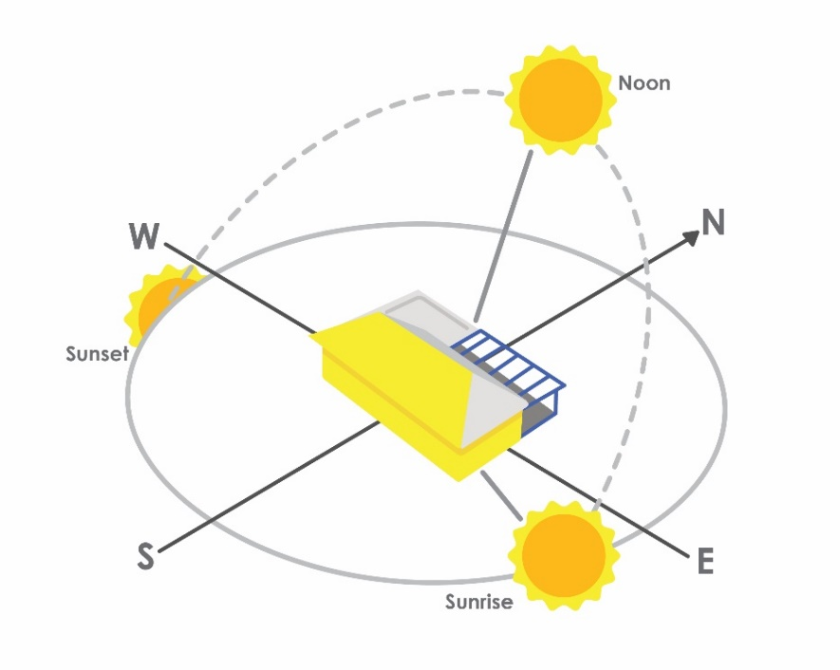
STEM Consortium
Initiate a class discussion by asking:
- How could you track the apparent movement of the Sun across the sky?
- Why do we use the term ‘apparent movement’ rather than simply ‘movement’ of the Sun?
- Where will we need to set up this activity to ensure we get a full set of results?
- What mathematics will we need to use to calculate the elevation of the Sun above the horizon?
- What measurements will we need to make so we have the data needed to calculate elevation?
- At what time intervals will observations be made?
- What precautions will we need to take while we complete this investigation?
In the open, where it won’t be touched by students during the day, and with the help of a compass, align a desk in an east-west direction and ensure it will be in direct sunlight for most of the day. The best results will be collected on a day where there are no or few clouds.
Place the long edge of an A3 piece of paper or card along the northern edge of the desk with a piece of tape in each corner to stop the wind moving it. Place a pencil mark ‘x’ halfway along the long edge of the paper. Finally, stand a pencil or sharpened piece of dowel at ‘x’ and fix it vertically so it casts a shadow on the A3 paper.
This arrangement is illustrated in the diagram below.

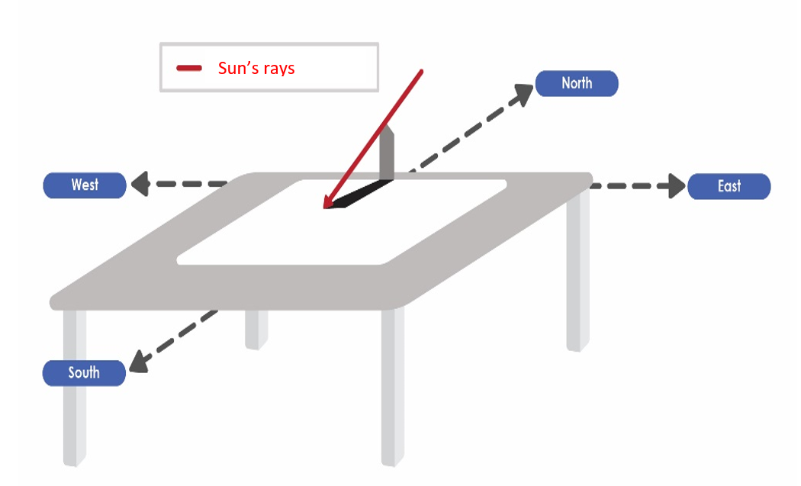
STEM Consortium
Roster students to record the position of the end of the shadow each hour between 9.00 am and 3.00 pm. A copy of the A3 recording sheet can be made for each group.
Students use a spreadsheet to record the time, length of shadow (mm), height of pencil or dowel (mm), the direction of the Sun’s shadow (W, WSW, SW, SSW, S, SSE, SE, ESE, E) and the angle of elevation of the Sun (degrees).

Explain the angle of elevation of the Sun above the horizon is calculated using trigonometry. These formulas are shown on the Maths is Fun website at Finding an Angle in a Right Angled Triangle (see Digital resources) and can be used to support students’ calculations.
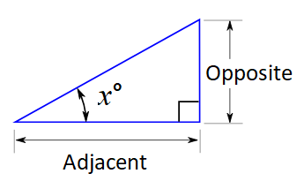
Here is an example of the steps the students could follow. All steps in the example refer to the image below:
- Calculate the ‘angle ratio’ of opposite ÷ adjacent, also known as the tangent of the angle x, in the smaller triangle (ie the height of the pencil divided by the length of its shadow). For example, if the pencil is 14 cm and the shadow is 16 cm then the ratio (tangent of the angle x°) will be 0.875.
- Measure the length of the shadow of the larger object (eg the shadow of a student) horizontally along the ground using a tape measure or trundle wheel or some other method. This measurement would need to be taken at the same time as the measurement of the pencil’s shadow so that the Sun’s rays are at the same angle.
- Multiply the length of the tall object’s shadow by the angle ratio of the smaller triangle (ie the tangent of the angle x°). For example, if the angle ratio is 0.875 and the student’s shadow is 184 cm long, then they are
161 cm tall (since 184 × 0.875 = 161).
Refer students to ARPANSA’s Ultraviolet radiation index (see Digital resources) and select the city closest to them to determine the UVR level and per cent of maximum UVR reaching Earth at hourly intervals.
Students add data regarding UVR intensity to their spreadsheet.
Challenge students to analyse and interpret their data using the following prompt questions:
- How would you describe the apparent path of the Sun across the sky during the day? How is this related to the movement of shadows?
- Which values in your table suggest that sunlight is travelling through a thin layer of atmosphere at midday?
- When is there less chance of sunburn? Why?
- What season should we use more sun protection? Why?
- What happens to the energy in sunlight as it travels through Earth’s atmosphere?
- How is UVR intensity related to the angle of elevation of the Sun? Would graphing the data help reveal the relationship between these variables?
- How can this relationship be represented mathematically?
- What is the relationship between the angle of elevation, path length through the atmosphere and UVR intensity?
Lead a class discussion under the open sky to confirm and consolidate findings. Help students to link cardinal points of the compass to where the Sun would be on the horizon at sunrise, noon and sunset.
Part 4: Investigating variations in the path of the Sun and UVR intensity with seasons of the year – an opportunity for further learning
Now that the apparent movement of the Sun has been mapped manually, students may use web-based simulation software to simulate its apparent daily and seasonal movement.
SunCalc (see Digital resources) is an application that simulates the Sun’s movement and sunlight phases during a given day at a given location. This simulator enables the viewer to select a location on Earth.
Students relocate the marker to their current location and consider the following questions:
- At your location, where and when does the Sun rise in the morning?
- Where and when does it set in the evening?
- At what time is it highest in the sky? Is this noon exactly? If not, why?
- What was the angle of elevation of the Sun at this time?
Students use the simulator to model the apparent movement of the Sun at the winter solstice, summer solstice and the two equinoxes and consider the following:
- What do you notice about the length of time the Sun is visible on each of these days?
- Why are winter days shorter than summer days?
- How does the angle of elevation of the Sun differ as it tracks across the sky in winter and summer?
Another valuable application is Sun-Path (see Digital resources). Allow students some time to explore and manipulate information on this website, comparing their home location to a location in the northern hemisphere.
Part 5: Reflection and journaling
Students reflect on what they have learnt in this activity and record their reflections in the journal section of their portfolios.
Focus questions could include:
- Why is ozone an important component of Earth’s atmosphere? What role does it play in protecting us from harmful UVR?
- How can data about UVR intensity be accessed?
- Why is it important to check the UV forecast each day to determine if sun protection is required?
- How does UVR intensity vary during the day and between seasons? Why does it vary? How does this variation affect your risk?
- When are we at greatest risk of UVR exposure? Why is this?
- What have you learnt about how to investigate scientifically so that your data is reliable?
- What mathematical calculations did you carry out in this activity? How did it relate to the collection and analysis of your data?
- Why is mathematics an essential component of scientific investigations?
- What have you learnt that will inform the sun protection strategy you will develop to address the problem of how to minimise skin cancer risk?
Resource sheets |  | Student resource sheet 2.1: Scale model of the Earth and atmosphere  Student resource sheet 2.2: Spreadsheet, Variations in UVR intensity during the day.

Digital resources | Perth Forecast (Bureau of Meteorology, 2019)  www.bom.gov.au/wa/forecasts/perth.shtml
Digital resources | Ultraviolet radiation index (ARPANSA, n.d) www.arpansa.gov.au/our-services/monitoring/ultraviolet-radiation-monitoring/ultraviolet-radiation-index
Digital resources | About UV and sun protection times (Bureau of Meteorology, 2019)  www.bom.gov.au/uv/index.shtml
Digital resources | Will looking at the sun really make you blind? (Australian Academy of Science, 2019)  www.science.org.au/curious/people-medicine/will-looking-sun-really-make-you-blind
Digital resources | Finding an Angle in a Right-Angled Triangle (Maths Is Fun, 2017)  www.mathsisfun.com/algebra/trig-finding-angle-right-triangle.html
Digital resources | Apps for observing path of Sun  SunCalc  suncalc.net  Sun-Path  andrewmarsh.com/apps/staging/sunpath3d.html

Activity 3: Designing a risk reduction strategy
  Activity focus | Using the design process and knowledge gained from their science and mathematics investigations, students work with a family or class member to develop a strategy, in the form of an algorithm, to minimise their exposure to UVR.
Background information | An algorithm is a sequence of steps. People use algorithms every day to solve problems and complete tasks, for example, baking a cake or getting dressed.  A flowchart is a diagrammatic representation of an algorithm. A flowchart can take the form of a branching set of shapes with decision-making steps. The shapes used in a flowchart are shown in Teacher resource sheet 3.1: Flowcharting symbols and an example of a possible flowchart is shown in Teacher resource sheet 3.2: Flowchart example.  Teachers should make an opportunity to discuss the importance of flowcharting and identify any point of need teaching that is required so students can complete the task.  In its most developed form, an algorithm can be converted to computer code or generalised with a mathematical model.
Instructional procedures | The sun protection algorithm developed in this activity can be extended to include a mathematical model that considers risks associated with, for example, the daily UV Index rating, the Fitzpatrick Skin Type, the individual’s family history of skin cancer and likely hours of direct exposure to UVR.  Problem-solving in collaborative situations is a STEM capability that students need to exercise. This activity provides an opportunity for students to engage with negotiation, critical thinking and reasoning as they work on their designs.  Facilitated by the teacher, students follow the design process (see Design process guide) to refine and enhance their model. The steps of ideation, development and production are followed in this activity.  Students are encouraged to build resilience and embrace the design cycle.  Teachers should provide the scaffolding for students to problem-solve but it is important not to provide too much detail and produce the algorithm for the students.
Expected learning | Students will be able to:  - Identify variables that impact on the level of UVR exposure for a family or class member (Science).  - Prepare a design brief for a sun protection strategy that will be developed for a family or class member (Technologies).  - Assess the UVR exposure of a family or class member over seven days and assign values to each of the UVR exposure variables (Science and Mathematics).  - Identify the features and processes of a decision-making algorithm (Technologies)  - Design an algorithm that uses risk factors (input variables) to determine the sun safe strategies required to protect a person from UVR exposure (output variables) (Mathematics).  - Use scientific and mathematical evidence to justify the choice of strategies (Science and Mathematics).  - Compare and evaluate alternative algorithms (Technologies).  - Document the design process (Technologies).
Equipment required | For the class:  Interactive whiteboard or data projector  Teacher resource sheet 3.1: Flowcharting symbols  Teacher resource sheet 3.2: Flowchart examples
Equipment required | For the students:  Coloured pencils, pens  Digital devices
Preparation | Make resource sheets available to the class.

Activity parts | Part 1: Outlining the task  Explain to students they will create an algorithm that will generate an output recommending a sun protection strategy that could be adopted by a family or class member to minimise their exposure to harmful UVR as they go about their daily routines.  The Skin Cancer Foundation (www.skincancer.org/risk-factors/uv-radiation) reports that:  “Recent research shows that the UV rays that damage skin can also alter a gene that suppresses tumours, raising the risk of sun-damaged skin cells developing into skin cancer.”  and  “Damage from UV exposure is cumulative and increases your skin cancer risk over time. While your body can repair some of the DNA damage in skin cells, it can’t repair all of it. The unrepaired damage builds up over time and triggers mutations that cause skin cells to multiply rapidly. That can lead to malignant tumours.”  Each student’s sun protection strategy should aim to minimise exposure to UVR throughout a lifetime because the effects of the radiation are cumulative.
Activity parts | Part 2: Approaches to minimising exposure to UVR  The first SunSmart advertising campaign was released in the 1980s and focused on slip, slop and slap only. As a class, view Slip! Slop! Slap! – The original Sid the Seagull Video (see Digital resources).  The most recent campaign highlights the need to use the 5Ss. As a class, view Slip, Slop, Slap, Seek and Slide – SunSmart Sid the Seagull Video (see Digital resources).  Refer students to SunSmart – Twenty Years On (see Digital resources) and discuss the following:  - What types of research would have provided evidence on which sun protection strategies have been devised?  - Why have ‘seek’ and ‘slide’ been added to the original message?  - How effective was the campaign in changing people’s attitudes to sun protection? How do you know?  - What ideas would guide the creation of a sun protection strategy?
Activity parts | Part 3: Algorithms and flowcharts  Students watch the Khan Academy video, What is an algorithm and why should you care? and read CSER Professional Learning’s Algorithms: Plugged & Unplugged (see Digital resources) to review algorithms and flowcharts.  Encourage students to connect this concept to the scenario in everyday life of buying a new pair of red shoes. Students consider the example flowchart used to represent the algorithm for buying a pair of red shoes in Teacher resource sheet 3.2: Flowchart examples.  Emphasise the need to think about the decisions that need to be made and the steps that need to be included.  Discuss the use of a flowchart to help visualise and plan an algorithm. Ask students to identify the meaning of the shapes and lines in the flowchart and use that to develop their own ‘red shoe’ algorithm.  Students add to the Buying red shoes flowchart to reflect alterations to the algorithm based on various scenarios, including if you could only spend $80 or to include shoe size.  A full set of flowcharting symbols is available in Microsoft Word using the ‘Insert – Shapes’ menu.
Activity parts | Part 4: Development of a design brief  Students develop a design brief for solving the problem of sun exposure for a family or class member. The design brief should include:  - A statement of the problem  - A list of success criteria  - An outline of the design steps to be taken, including evaluation and refinement.  The design brief will be included in students’ final portfolios.  Review the design process with students, referring to the Design process guide.
Activity parts | Part 5: Identifying variables that need to be considered in developing a sun safety algorithm  Working in their groups, students identify the variables to consider as they develop an algorithm that generates a recommendation regarding a sufficient level of sun protection for a family or class member for a range of activities.  Collate students’ suggestions in a table for discussion by the class.  Ask students to consider the following:  - What data will you need to help design your algorithm?  - How will you collect the data from your family or class member? Would a diary, survey or interview method be most effective, or a combination of methods?  - How will you document the data collected?
  Description of variable | Range of values | Data type | Data source
Activity parts | Part 6: Collecting individual data on UVR exposure  Students identify the family or class member whose daily activities would result in UVR exposure. Students document in their portfolio the person’s typical pattern of activities for a typical weekday and weekend, including the time spent on each activity.
Activity parts | Part 7: Designing and constructing the algorithm  Individually, students design and construct a decision-making algorithm that inputs key UVR exposure variables such as UV index, time of exposure, wearing of protective clothing, etc and produces outputs relating to sun protection measures to be adopted.  For each strategy selected, students justify, drawing on scientific and mathematical evidence, and document it in their portfolio.  Note: There is an example provided in the Teacher resource sheet 3.2: Sun Protection Flowchart, however, as there are many solutions, students should not view this example before developing their solution.  Working in pairs, students compare each other’s algorithms, evaluate them and identify improvements. This will enhance collaboration, problem-solving, and stimulate reasoning and justification of their decisions.  Encourage students to ask questions such as:  - Why is this the best sun protection strategy for …?  - What would happen if…?  - How would the subject respond to …?  - What happens if this bit keeps repeating …?  - What other choices could there be for …?  Feedback, improvements made and justifications for changes should be documented in the journal section of student portfolios.
Activity parts | Part 8: Reflection and journaling  Students reflect on what they have learnt by engaging in the design process to produce a decision-making algorithm for devising a sun protection strategy. Focus questions could include:  - How important was it to devise a strategy for a nominated individual?  - How did the initial data collection about the individual’s activities and the design brief contribute to the development of the algorithm and an appropriate strategy?  - What scientific and mathematical evidence was used to justify your choices of strategies?  - How well did the strategy fit the needs and success criteria identified in the design brief?  - How can your solution be most effectively communicated to the individual, the family and potentially to the broader community?
Resource sheets | Teacher resource sheet 3.1: Flowcharting symbols  Teacher resource sheet 3.2: Flowchart examples  Design process guide
Digital resources | Slip! Slop! Slap! – The Original Sid the Seagull Video (Cancer Council Victoria, 2010)  youtu.be/b7nocIenCYg
Digital resources | Slip, Slop, Slap, Seek and Slide – SunSmart Sid the Seagull Video (SunSmart Victoria, 2012)  youtu.be/WOv5HGOJYTA
Digital resources | SunSmart – Twenty Years On (SunSmart, 2001)  www.sunsmart.com.au/downloads/about-sunsmart/sunsmart-20-years-on.pdf
Digital resources | What is an algorithm and why should you care? (Khan Academy, 2017)  www.khanacademy.org/computing/computer-science/algorithms/intro-to-algorithms/v/what-are-algorithms
Digital resources | Algorithms: Plugged & Unplugged (CSER Professional Learning, 2016)  docs.google.com/presentation/d/1K-6F3yYRf2lkwkU1C2-yLxveV9Zt8RtyrVBfEzB0qS8/edit#slide=id.g13ec2dcc77_1_67
Digital resources | Legend of symbols used in algorithm (Unknown)  1.bp.blogspot.com/_-n5ew-cmW7o/TU6u0Mt768I/AAAAAAAAAIE/9PB0Vy0BeJU/s1600/flowchart-symbols.gif

Activity 4: Communicating the strategy
  Activity focus | Students develop digital resources (eg video, slide show, infographic) to communicate recommended sun protection strategies that will convince a family or class member to establish routines to protect themselves from excessive UVR exposure.
Instructional procedures | The presentations provide a rich opportunity for assessing students’ understanding of the science, technology and mathematics principles and processes.  Working collaboratively in groups, students plan a communication strategy that will be used to encourage a family or class member to adopt sun protection strategies appropriate to their lifestyle and UVR exposure.  Individual students develop a digital resource to communicate their strategy and present it to their group members. Students may need support and scaffolding to help them prepare for their presentation, including information about effective presentation skills such as voice clarity, projection, volume, pitch and tone. Tailor the timing and format of presentations to suit the class.  Following peer evaluation, the best strategy from each group is selected to be presented to an authentic audience.  Some parts of this activity (1, 2, 4 and 5) may be implemented as group work while Parts 3 and 6 are intended to be individual tasks that could generate work samples for assessment.
Expected learning | Students will be able to:  - Design and develop a digital resource to communicate a sun protection strategy (Technologies).  - Utilise mathematical and scientific evidence to justify the choices made about a sun protection strategy (Mathematics and Science).  - Evaluate and identify enhancements that can be made to design processes, solutions to the problem and how it is communicated (Technologies).
Equipment required | For the class:  Digital data projection facilities  An appropriate space to conduct student presentations
Equipment required | For the students:  Student portfolios  Access to digital devices  Student activity sheet 1.0: Portfolio checklist  Student activity sheet 4.1: Peer evaluation  Student activity sheet 4.2: Self-evaluation
Preparation | Ensure devices are available.  Consider the time students will require to develop and review their presentations.  Dates will need to be planned for the presentation of digital resources to small groups and to an authentic audience.  Audience members will need to be identified and invited (eg school nurse, physical education teacher, skin cancer survivors).  Arrange a room for presentations.  Provide access to activity sheets.
Activity parts | Part 1: Review the problem  Review the problem being addressed by the students: Australia has the highest rate of skin cancer in the world. How can you change this?  Introduce the need to plan how their sun protection strategy will be communicated to an audience.
Part 2: Planning the strategy
Students work in collaborative groups to brainstorm ideas and plan the elements of their digital resource.
Focus questions could include:
- What type of digital resource would be appropriate? Why?
- What elements could be included to make the presentation convincing?
- What could be included to ensure the person understands the reason for the recommended sun protection strategy and how this might vary depending on circumstances? (eg activities, seasons)
- How long should it take for the person to work through the resource? Why?
Part 3: Design and development of a digital resource
Working individually, students design and develop their digital resource. The resource should be self-explanatory and available to share with peers at the next meeting of the working groups.
Students decide on the content of their presentation by asking themselves:
- Why is there a need for a sun protection strategy?
- What was the solution trying to achieve?
- What decisions were made as the solution was developed?
- How did mathematics and science knowledge help in developing ideas and justifying choices?
- How did technology help in developing the solution?
Part 4: Sharing and peer evaluation of the digital resources
Using their devices, students take turns to share their resources with their group members. After each showing, peers complete Student activity sheet 4.1: Peer evaluation to provide feedback.
Following the viewing of all students’ resources, the groups are provided with time to apply the feedback. The class then selects the most convincing resource to be presented to an authentic audience.
Students should add a link or embed their final presentation and peer assessments in their portfolios.
Part 5: Presentation to an authentic audience
Engage students in planning the presentation of their selected resource, including inviting audience members, welcoming guests, introducing speakers and inviting feedback from audience members.

Part 6: Reflection and journaling
Provide time for students to reflect on what they have learnt from this module and to record reflections in the journal section of their portfolio.
Focus questions might include:
- What are the characteristics of UVR? What factors influence its transfer through the atmosphere to your skin and how does it affect the skin?
- Why were scientific notation and index laws helpful in describing the characteristics of UVR?
- What role does the skin play in homeostasis, keeping us healthy and how does it repair itself?
- Why is sun protection important and what strategies can be adopted to reduce UVR exposure?
- Why is data collection and organisation a crucial part of public health? How do we ensure the collected data are reliable?
- How did you evaluate your design processes and solutions against the success criteria you developed?
- What have you learnt about the design process during this module?
- How well did your clients use scientific knowledge to evaluate whether they accept your recommendations for sun safety?
- What changes would you make if you were to run another public health campaign?
Students complete Student activity sheet 1.0: Portfolio checklist.
Resource sheets | Student activity sheet 1.0: Portfolio checklist  Student activity sheet 4.1: Peer evaluation  Student activity sheet 4.2: Self-evaluation

Appendix 1: Links to the Western Australian Curriculum
The Reducing the burn module provides opportunities for developing students’ knowledge and understandings in science, technologies and mathematics. The tables below show how this module aligns to the content of the Western Australian Curriculum and can be used by teachers for planning and monitoring.

REDUCING THE BURN  Links to the Western Australian Curriculum | ACTIVITY
 | 1 | 2 | 3 | 4
SCIENCE
SCIENCE UNDERSTANDING
Biological sciences: Multi-cellular organisms rely on coordinated and interdependent internal systems to respond to changes to their environment (ACSSU175) | ● | ●
Physical sciences: Energy transfer through different mediums can be explained using wave and particle models (ACSSU182) | ● | ●
SCIENCE INQUIRY SKILLS
Processing and analysing data and information: Analyse patterns and trends in data, including describing relationships between variables and identifying inconsistencies (ACSIS169) |  | ● | ●
Processing and analysing data: Use knowledge of scientific concepts to draw conclusions that are consistent with evidence (ACSIS170) |  | ● | ● | ●
Evaluating: Evaluate conclusions, including identifying sources of uncertainty and possible alternative explanations, and describe specific ways to improve the quality of the data (ACSIS171) |  | ●
Evaluating: Critically analyse the validity of information in primary and secondary sources and evaluate the approaches used to solve problems (ACSIS172) | ● | ●
Communicating: Communicate scientific ideas and information for a particular purpose, including constructing evidence-based arguments and using appropriate scientific language, conventions and representations (ACSIS174) |  | ● | ● | ●
REDUCING THE BURN  Links to the Western Australian Curriculum | ACTIVITY
 | 1 | 2 | 3 | 4
DIGITAL TECHNOLOGIES
PROCESSES AND PRODUCTION SKILLS
Collecting, managing and analysing data: Analyse and visualise data to create information and address complex problems (ACTDIP037) |  | ● |  | ●
Digital implementation: Design algorithms, represented diagrammatically and in structured English, and validate plans and programs through tracing (ACTDIP040) |  |  | ●
Investigating and defining: Identify and define the needs of a stakeholder, to create a brief, for a solution (WATPPS54) |  |  | ●
Investigating and defining: Apply design thinking, creativity and enterprise skills (WATPPS56) |  |  | ●
Evaluating: Evaluate design processes and solutions against student developed criteria (WATPPS59) |  |  | ● | ●
Collaborating and managing: Work collaboratively to manage projects, using digital technology and an iterative and approach. Considers time, cost, risk, safety (WATPPS60) |  |  | ● | ●
REDUCING THE BURN  Links to the Western Australian Curriculum | ACTIVITY
 | 1 | 2 | 3 | 4
MATHEMATICS
NUMBER AND ALGEBRA
Real numbers: Apply index laws to numerical expressions with integer indices (ACMNA209) | ●
Real numbers: Express numbers in scientific notation (ACMNA210) | ●
Patterns and algebra: Extend and apply the index laws to variables, using positive integer indices and the zero index (ACMNA212) | ●
MEASUREMENT AND GEOMETRY
Geometric reasoning: Solve problems using ratio and scale factors in similar figures (ACMMG221) |  | ●
Pythagoras and trigonometry: Apply trigonometry to solve right-angled triangle problems (ACMMG224) |  | ●
STATISTICS AND PROBABILITY
Data representation and interpretation: Identify everyday questions and issues involving at least one numerical and at least one categorical variable, and collect data directly and from secondary sources (ACMSP228) |  | ●
Further information about assessment and reporting in the Western Australian Curriculum can be found at: k10outline.scsa.wa.edu.au/home.

Appendix 1B: Mathematics proficiency strands
Key ideas
In Mathematics, the key ideas are the proficiency strands of understanding, fluency, problem-solving and reasoning. The proficiency strands describe the actions in which students can engage when learning and using the content. While not all proficiency strands apply to every content description, they indicate the breadth of mathematical actions that teachers can emphasise.
Understanding
Students build a robust knowledge of adaptable and transferable mathematical concepts. They make connections between related concepts and progressively apply the familiar to develop new ideas. They develop an understanding of the relationship between the ‘why’ and the ‘how’ of mathematics. Students build understanding when they connect related ideas, when they represent concepts in different ways, when they identify commonalities and differences between aspects of content, when they describe their thinking mathematically and when they interpret mathematical information.
Fluency
Students develop skills in choosing appropriate procedures; carrying out procedures flexibly, accurately, efficiently and appropriately; and recalling factual knowledge and concepts readily. Students are fluent when they calculate answers efficiently, when they recognise robust ways of answering questions, when they choose appropriate methods and approximations, when they recall definitions and regularly use facts, and when they can manipulate expressions and equations to find solutions.
Problem-solving
Students develop the ability to make choices, interpret, formulate, model and investigate problem situations, and communicate solutions effectively. Students formulate and solve problems when they use mathematics to represent unfamiliar or meaningful situations, when they design investigations and plan their approaches, when they apply their existing strategies to seek solutions, and when they verify that their answers are reasonable.
Reasoning
Students develop an increasingly sophisticated capacity for logical thought and actions, such as analysing, proving, evaluating, explaining, inferring, justifying and generalising. Students are reasoning mathematically when they explain their thinking, when they deduce and justify strategies used and conclusions reached, when they adapt the known to the unknown, when they transfer learning from one context to another, when they prove that something is true or false, and when they compare and contrast related ideas and explain their choices.

Source: ACARA – www.australiancurriculum.edu.au/f-10-curriculum/mathematics/key-ideas/?searchTerm=key+ideas#dimension-content

Appendix 2: General capabilities continuums
The general capabilities continuums shown here are designed to enable teachers to understand the progression students should make with reference to each of the elements. There is no intention for them to be used for assessment.
Information and communication technology (ICT) capability learning continuum
Sub-element | Typically by the end of Year 8 | Typically by the end of Year 10
Create with ICT  Generate ideas, plans and processes | use appropriate ICT to collaboratively generate ideas and develop plans | select and use ICT to articulate ideas and concepts, and plan the development of complex solutions
Create with ICT  Generate solutions to challenges and learning area tasks | design and modify simple digital solutions, or multimodal creative outputs or data transformations for particular audiences and purposes following recognised conventions | design, modify and manage complex digital solutions, or multimodal creative outputs or data transformations for a range of audiences and purposes
Communicating with ICT  Collaborate, share and exchange | select and use appropriate ICT tools safely to lead groups in sharing and exchanging information, and taking part in online projects or active collaborations with appropriate global audiences | select and use a range of ICT tools efficiently and safely to share and exchange information, and to collaboratively and purposefully construct knowledge

Critical and creative thinking learning continuum
Sub-element | Typically by the end of Year 8 | Typically by the end of Year 10
Inquiring – identifying, exploring and organising information and ideas  Organise and process information | critically analyse information and evidence according to criteria such as validity and relevance | critically analyse independently sourced information to determine bias and reliability
Generating ideas, possibilities and actions  Imagine possibilities and connect ideas | draw parallels between known and new ideas to create new ways of achieving goals | create and connect complex ideas using imagery, analogies and symbolism
Generating ideas, possibilities and actions  Seek solutions and put ideas into action | predict possibilities, and identify and test consequences when seeking solutions and putting ideas into action | assess risks and explain contingencies, taking account of a range of perspectives, when seeking solutions and putting complex ideas into action
Reflecting on thinking and processes  Transfer knowledge into new contexts | justify reasons for decisions when transferring information to similar and different contexts | identify, plan and justify the transfer of knowledge to new contexts

Personal and social capability learning continuum
Sub-element | Typically by the end of Year 8 | Typically by the end of Year 10
Social management  Work collaboratively | assess the extent to which individual roles and responsibilities enhance group cohesion and the achievement of personal and group objectives | critique their ability to devise and enact strategies for working in diverse teams, drawing on the skills and contributions of team members to complete complex tasks
Social management  Negotiate and resolve conflict | assess the appropriateness of various conflict resolution strategies in a range of social and work-related situations | generate, apply and evaluate strategies such as active listening, mediation and negotiation to prevent and resolve interpersonal problems and conflicts
Social management  Develop leadership skills | plan school and community projects, applying effective problem-solving and team-building strategies, and making the most of available resources to achieve goals | propose, implement and monitor strategies to address needs prioritised at local, national, regional and global levels, and communicate these widely  discuss the concept of leadership and identify situations where it is appropriate to adopt this role
Further information about general capabilities is available at:
k10outline.scsa.wa.edu.au/home/p-10-curriculum/general-capabilities-over/general-capabilities-overview/general-capabilities-in-the-australian-curriculum

Appendix 3: Design process guide
Safe production of the final design or multiple copies of the final design.
Fine tuning the production process, such as division of labour for batch or mass production.
Use of intended materials and appropriate tools to safely make the solution to the design problem.
Reflection on the process taken and the success of the design.
Evaluation can lead to further development or improvement of the design and can be a final stage of the design process before a conclusion is reached.
Could be formal or informal and verbal or written.
Ideation
Development
Development of the design ideas. Improvements, refinements, adding detail, making it better.
Activities such as detailed drawings, modelling, prototyping, market research, gaining feedback from intended user, further research – if needed – to solve an issue with the design, testing different tools or equipment, trialling production processes, measuring or working out dimensions, testing of prototypes and further refinement.
Idea generation – turning ideas into tangible forms so they can be organised, ordered and communicated to others.
Activities such as brainstorming, mind mapping, sketching, drawing diagrams and plans, collecting colour samples and/or material samples and talking through these ideas can help to generate more creative ideas.
Using the SCAMPER model can assist with this: www.mindtools.com/pages/article/newCT_02.htm
www.designorate.com/a-guide-to-the-scamper-technique-for- creative-thinking
Analysis
Finding useful and helpful information about the design problem.
Gathering information, conducting surveys, finding examples of existing solutions, testing properties of materials, practical testing.
Understanding the meaning of the research findings.
Analysing what the information means, summarising the surveys, judging the value of existing solutions, understanding test results.
Research
Production
Evaluation

Appendix 4: Student journal

When students reflect on learning and analyse their ideas and feelings, they self-evaluate, thereby improving their metacognitive skills.
These modules encourage students to self-reflect through journaling. Journals, along with other records of learning, are included in a final portfolio.
istockphoto.com
Using digital portfolios can help develop students’ Information and Communication Technology (ICT) capability.
Reflective practice and recording can be supported in classrooms by creating opportunities for students to think about and record their learning through notes, drawings or pictures. Teachers should encourage students to revisit earlier journal entries to help them observe the progress of their thoughts and understanding.
Journals are a useful tool that gives teachers additional insight into how students value their own learning and progress, as well as demonstrating their individual achievements.
The following links provide background information and useful apps for journaling.
Reflective journal (University of Technology Sydney)
www.uts.edu.au/sites/default/files/reflective_journal.pdf
Reflective writing (University of New South Wales Sydney))
student.unsw.edu.au/reflective-writing
Balancing the two faces of ePortfolios (Helen Barrett, 2009)
electronicportfolios.org/balance/Balancing.jpg
Digital portfolios for students (Cool tools for school)
cooltoolsforschool.wordpress.com/digital-student-portfolios
Kidblog – digital portfolios and blogging
kidblog.org/home
Evernote (a digital portfolio app)
evernote.com
Weebly for education (a drag and drop website builder)
education.weebly.com
Connect – the Department of Education’s integrated, online environment
connect.det.wa.edu.au

Appendix 5: Student activity sheet 1.0: Portfolio checklist

As an ongoing part of this module, you have been keeping a portfolio of work.
Before submitting your portfolio, please ensure you have included the following information.
- Tick each box once complete and included.
- Write N/A for items that were not required in this module.
istockphoto.com

Your name and group member's names or photographs
An explanation of the problem you are solving
Your notes from Activity 1
Your records of investigations and reflections on Activity 2
Your reflections on Activity 3
Your reflectionson Activity 4
Student activity sheet 4.1: Peer evaluation
Student activity sheet 4.2: Self evaluation
Student activity sheet 1.0: Portfolio checklist

Appendix 6: Teacher resource sheet 1.1: Cooperative learning – Roles

Cooperative learning frameworks create opportunities for groups of students to work together, generally to a single purpose.
As well as having the potential to increase learning for all students involved, using these frameworks can help students develop personal and social capability.
When students are working in groups, positive interdependence can be fostered by assigning roles to group members.
istockphoto.com
These roles could include:
- Working roles such as Reader, Writer, Summariser, Time-keeper
- Social roles such as Encourager, Observer, Noise monitor, Energiser.
Further to this, specific roles can be delineated for specific activities that the group is completing. It can help students if some background to the purpose of group roles is made clear to them before they start, but at no time should the roles get in the way of the learning. Teachers should decide when or where roles are appropriate to given tasks.
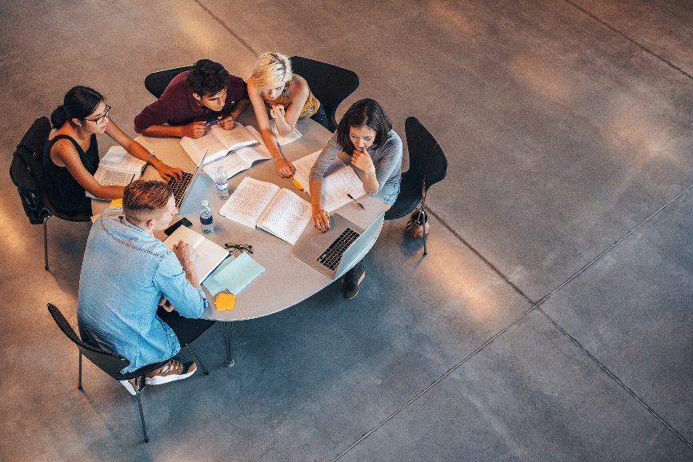

istockphoto.com

Appendix 7: Teacher resource sheet 1.2: Cooperative learning – Jigsaw
Cooperative learning frameworks create opportunities for groups of students to work together, generally for a single purpose.
As well as having the potential to increase learning for all students involved, using these frameworks can help students develop personal and social capability.
The jigsaw strategy typically has each member of the group becoming an 'expert' on one or two aspects of a topic or question being investigated. Students start in their cooperative groups, then break away to form 'expert’ groups to investigate and learn about a specific aspect of a topic. After developing a sound level of understanding, the students return to their cooperative groups and teach each other what they have learnt.
Within each expert group, issues such as how to teach the information to their group members are considered.

Step 1 | Cooperative groups  (of four students) | 1 2 3 4 |  | 1 2 3 4
Step 2 | Expert groups  (size equal to the number of groups) | 1 1 | 2 2 | 3 3 | 4 4
Step 3 | Cooperative groups  (of four students) | 1 2 3 4 |  | 1 2 3 4

Appendix 8: Teacher resource sheet 1.3: Cooperative learning – Placemat
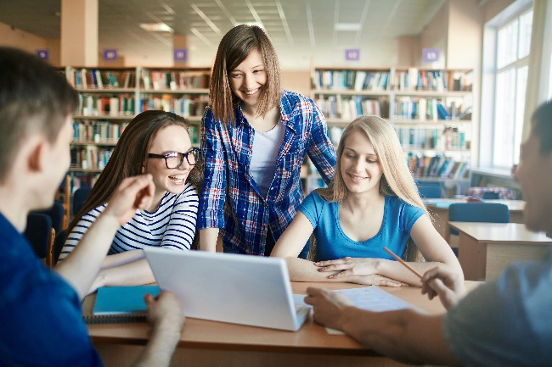
Cooperative learning frameworks create opportunities for groups of students to work together, generally for a single purpose.
As well as having the potential to increase learning for all students involved, using these frameworks can help students develop personal and social capability.
The placemat strategy involves students working collaboratively to record prior knowledge about a common topic and brainstorm ideas. It also allows teachers to readily see the contribution of each student. The diagram below shows a typical placemat template.
istockphoto.com

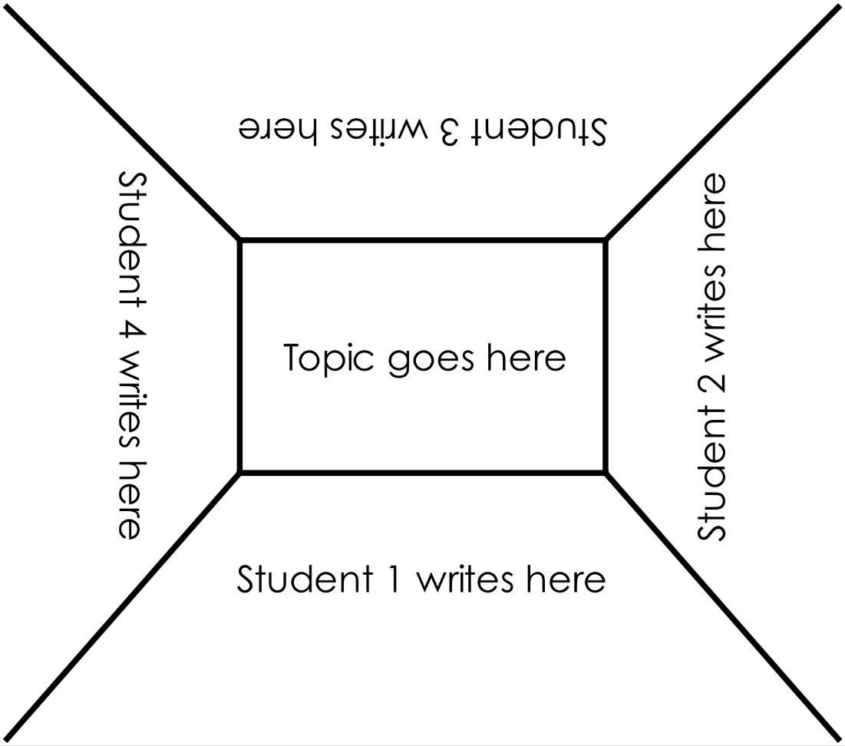

STEM Consortium

Appendix 9: Teacher resource sheet 1.4: Cooperative learning – Think, Pair, Share
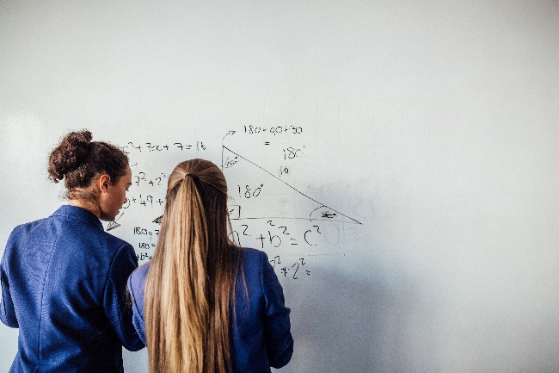
Cooperative learning frameworks create opportunities for groups of students to work together, generally to a single purpose.
As well as having the potential to increase learning for all students involved, using these frameworks can help students develop personal and social capability.
In the 'think' stage, each student thinks silently about a question asked by the teacher.
istockphoto.com
In the 'pair' stage, students discuss their thoughts and answers to the question in pairs.
In the 'share' stage, the students share their answer, their partner’s answer or what they decided together. This sharing may be with other pairs or with the whole class. It is important also to let students 'pass'. This is a key element of making the strategy safe for students.
Think–pair–share increases student participation and provides an environment for higher levels of thinking and questioning.
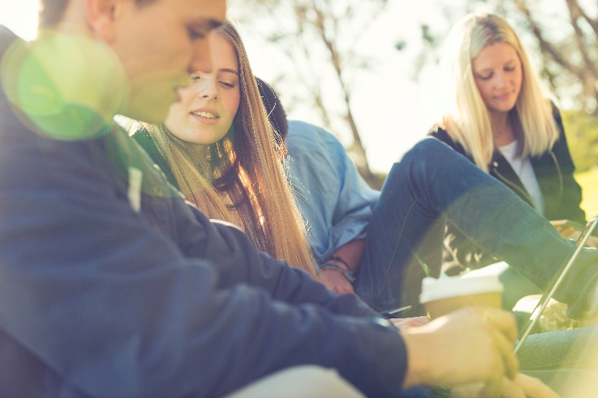
istockphoto.com

Appendix 10: Teacher resource sheet 1.5: Sample parent/carer letter
The following sample letter is a template to be modified by teachers to suit the class and school. It can be sent to parents/caregivers prior to commencing the Reducing the burn module to advise them that the topics discussed in class may be sensitive to some students.

(School details and letterhead)
(Date)

Dear Parents/Caregivers
Re: Content in Reducing the burn STEM project
This term, our class is undertaking a STEM (Science, Technology, Engineering and Mathematics) project called Reducing the burn. This project will involve students examining the effect of ultra-violet radiation (UVR) on skin and its relationship to skin cancer, as well as strategies that can be used to raise awareness of the dangers of UVR. Students will be developing a plan for a family or class member to reduce the longer-term risk of melanoma due to excessive exposure to UVR.
If they feel comfortable to do so, students will have the opportunity to share stories of family members or friends who have experienced skin cancer. There will also be some discussion about variations in skin types and how that influences susceptibility to skin cancer. We recognise that some of the content in this project may be delicate and will be sensitive in our approach to teaching these issues.
Our school values your role in the education of your child, especially on sensitive matters. We encourage you to talk to your child prior to the commencement of this project and during its implementation, as you see necessary.
Please do not hesitate to contact me via phone (XXXX XXXX) or email (XXXXXXXXXXXXXXXXXXXX) if you have any concerns about the project and I will endeavor to ensure your child’s needs are addressed. The school counsellor or your child’s year adviser are also available to discuss any concerns with students at school.
Further information on communicating with your child about cancer can be accessed at www.cancerwa.asn.au or by calling the Cancer Council Helpline on
13 11 20. Please encourage your child to use these services where appropriate.
Yours sincerely,
(Classroom teacher)

Appendix 11: Teacher resource sheet 1.6: Scientific notation and significant figures
Introduction
This resource sheet provides content to support teachers in communicating key mathematical concepts relevant to this module.
Scientific notation
Scientific notation is used to represent very large and very small numbers to make communicating data in science, technology, engineering and mathematics easier.
For example, the mass of Earth is 5 970 000 000 000 000 000 000 000 000 g which can be represented as 5.97 x 10²⁷ g, and the mass of a single bacterium is around
0.000 000 000 001 g which can be represented as 1.0 x 10⁻¹² g
Numbers written in scientific notation are expressed in the form a × 10^{b} where, a is a number that is greater than or equal to 1 but less than10 and b is a positive or negative integer.
To write numbers using scientific notation, place the decimal point after the first non-zero digit and then multiply by the appropriate power of 10.
Large numbers written in scientific notation have positive powers of 10. | Small numbers written in scientific notation use negative powers of 10.
The mass of Earth  = 5.97 Octillion grams  = 5 970 000 000 000 000 000 000 000 000 g  = 5.97 x 10²⁷  Four million years  = 4 000 000 years  = 4 × 1 000 000 years  = 4 × 10⁶ years | The mass of a bacterium  = One trillionth of a gram  = $\frac{1}{1 000 000 000 000}$ g  = 1 x $\frac{1}{1 000 000 000 000}$ g  = 0.000 000 000 001 g  = 1.0 x 10⁻¹² g  Five thousandths of a metre  = $\frac{5}{1 000}$ metre  = 5 x $\frac{1}{1 000}$ metre  = 0.005 metre  = 5 × 10⁻³ m

See the following resources for rules that are used write numbers using scientific notation and practise problems:
Scientific Notation: Introduction (Tyler DeWitt, 2012)
youtu.be/Dme-G4rc6NI
Scientific Notation Practice Problems (Tyler DeWitt, 2012)
youtu.be/7iGAa0BVS9I
In addition to writing numbers using scientific notation, abbreviations are often used to represent the number of times a number is multiplied or divided by 10.
Two familiar examples of this are:
- Kilometre (km) which can be written in the form of a x 10³ m
for example 3 km = 3 x 10³ m
- Millimetre (mm), which can be written in the form of a x 10⁻³ m
for example 3 mm = 3 x 10⁻³ m.
The following table shows the abbreviations used for some prefixes.
Prefix | Symbol | Multiplier | Exponential | Description
exa | E | 1 000 000 000 000 000 000 | 10¹⁸ | Quintillion
peta | P | 1 000 000 000 000 000 | 10¹⁵ | Quadrillion
tera | T | 1 000 000 000 000 | 10¹² | Trillion
giga | G | 1 000 000 000 | 10⁹ | Billion
mega | M | 1 000 000 | 10⁶ | Million
kilo | k | 1 000 | 10³ | Thousand
hecto | h | 100 | 10² | Hundred
deca | da | 10 | 10¹ | Ten
base |  | 1 | 10⁰ | One
deci | d | $\frac{1}{10}$ | 10⁻¹ | Tenth
centi | c | $\frac{1}{100}$ | 10⁻² | Hundredth
milli | m | $\frac{1}{1 000}$ | 10⁻³ | Thousandth
micro | μ | $\frac{1}{1 000 000}$ | 10⁻⁶ | Millionth
nana | n | $\frac{1}{1 000 000 000}$ | 10⁻⁹ | Billionth
pico | p | $\frac{1}{1 000 000 000 000}$ | 10⁻¹² | Trillionth
Significant figures
Significant figures, as the name suggests, tell us about the importance of each digit used to make up a number that comes from a measurement.
Students need to be aware of the number of significant figures in measurements when processing data. The results of any calculations must not be more precise than the measured data used. That is, answers should be given with as many significant figures as the measurement with the least number of significant figures.

See the following resources for rules that are used to count the number of significant figures in a measurement and practice problems:
Significant Figures Made Easy! (Tyler DeWitt, 2008)
youtu.be/5UjwJ9PIUvE
Significant Figures and Zero (1.3) (Tyler DeWitt, 2010)
youtu.be/7b60RZqut0U
Significant Zero Practice Problems (1.4) (Tyler DeWitt, 2010)
youtu.be/ExETL3IiRSw
Scientific Notation and Significant Figures (1.7) (Tyler DeWitt, 2010)
youtu.be/IIQPHC5gZT8

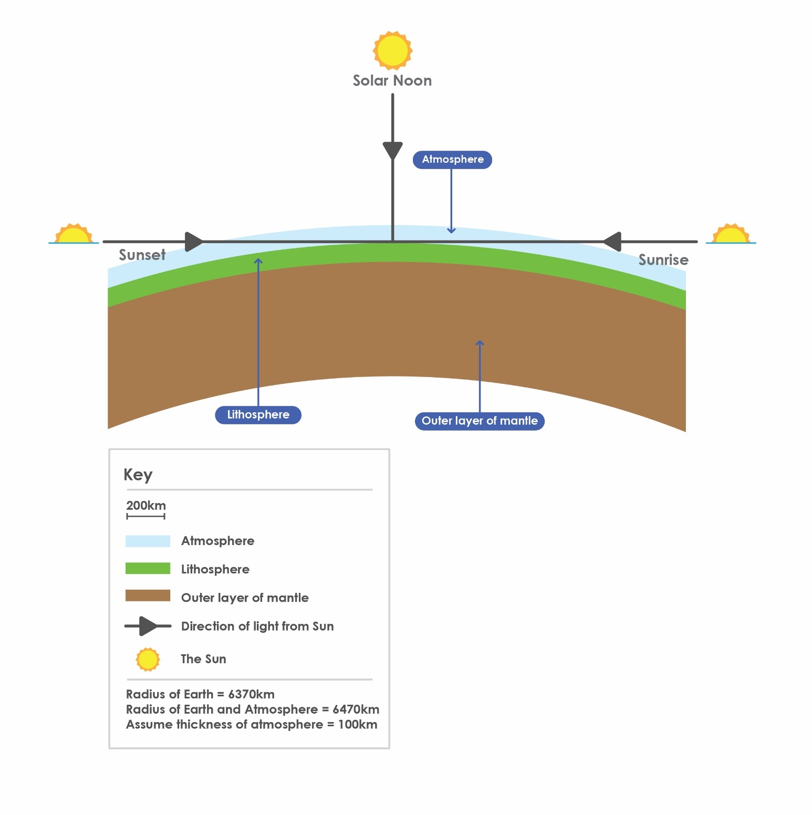
Appendix 12: Student resource sheet 2.1: Scale model of the Earth and atmosphere
STEM Consortium

Appendix 13: Student resource sheet 2.2: Spreadsheet for Variations in UVR intensity during the day.
Record your findings in the table or create a digital version using the Excel document.
Variations in UVR intensity during the day
 | Scale Model Investigation |  |  |  | Shadow Stick Investigation
Time | Path length | Path length | UVR index  from ARPANSA | % of daily max UVR reaching Earth | Direction of  shadow | Length of  shadow (mm) | UVR index  from ARPANSA | % of daily max UVR reaching Earth | Angle of  elevation
 | (mm) | (km)

Appendix 14: Teacher resource sheet 3.1: Flowcharting symbols
A flowchart is a diagrammatic representation of an algorithm. It can take the form of a branching set of shapes with decision-making steps. The shapes used in a flowchart are shown here with explanations of their purpose.

Terminator
This symbol is used to represent the start and end of a flowchart.
Process
This symbol is used to represent one or more instructions or things to do.
Data
This symbol is used to represent the input or output of any information.
Decision
This symbol is used to represent a point in the flowchart where a decision is made and from which two or more paths could be followed.
Flowline
This symbol is used to show the direction of the process or data flow.

Appendix 15: Teacher resource sheet 3.2: Flowchart examples

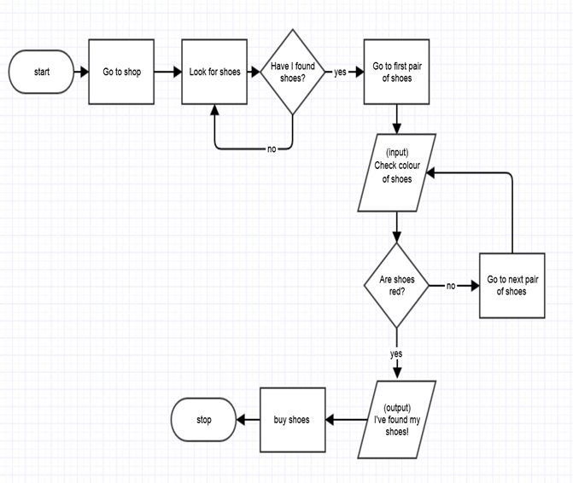
Buying red shoes flowchart
STEM Consortium

Sun Protection Assessment Flowchart
Subject: Mother
Location: Outdoor activities in backyard, park, shopping centres, school.
Description of tasks performed: Hanging out clothes, gardening, supervising children on the playground, walking in the park, walking to and from the car.
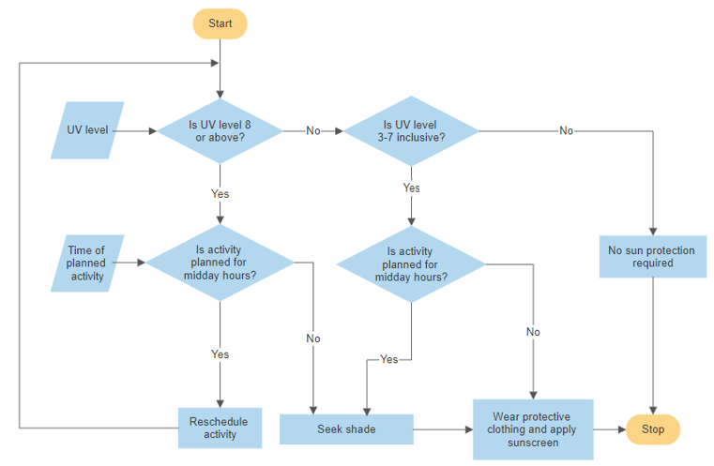

Note the following that applies to the algorithm above:
‘Midday hours’ are between 10 am to 2 pm as defined by Global Solar UV Index (World Health Organization, 2003, page 6) apps.who.int/iris/bitstream/handle/10665/42459/9241590076.pdf;jsessionid=201255626E96E64C06364C0788A2AFFB?sequence=1
‘Protective clothing’ refers to clothes that cover arms and legs, close-fitting sunglasses, and a hat in legionnaire, broad-brimmed or bucket style.
‘Sunscreen’ refers to a broad-spectrum, water-resistant sunscreen that is SPF30 or higher.

Appendix 16: Student activity sheet 4.1: Peer evaluation
 | Always | Usually | Sometimes | Rarely
Remains focused on tasks presented
Completes set tasks to best of their ability
Works independently without disrupting others
Uses time well
Cooperates effectively within the group
Contributes to group discussions
Shows respect and consideration for others
Uses appropriate conflict resolution skills
Comes to class prepared for activities
Actively seeks and uses feedback

Comments: __________________________________________________________________________________________________________________________________________________________________________________________________________________________________________________________________________________________________________________________________________________________

Appendix 17: Student activity sheet 4.2: Self-evaluation
 | Always | Usually | Sometimes | Rarely
Remains focused on tasks presented
Completes set tasks to best of their ability
Works independently without disrupting others
Uses time well
Cooperates effectively within the group
Contributes to group discussions
Shows respect and consideration for others
Uses appropriate conflict resolution skills
Comes to class prepared for activities
Actively seeks and uses feedback

Comments: __________________________________________________________________________________________________________________________________________________________________________________________________________________________________________________________________________________________________________________________________________________________

Notes
________________________________________________________________________________________________________________________________________________________________________________________________________________________________________________________________________________________________________________________________________________________________________________________________________________________________________________________________________________________________________________________________________________________________________________________________________________________________________________________________________________________________________________________________________________________________________________________________________________________________________________________________________________________________________________________________________________________________________________________________________________________________________________________________________________________________________________________________________________________________________________________________________________________________________________________________________________________________________________________________________________________________________________________________________________________________________________________________________________________________________________________________________________________________________________________________________________________________

