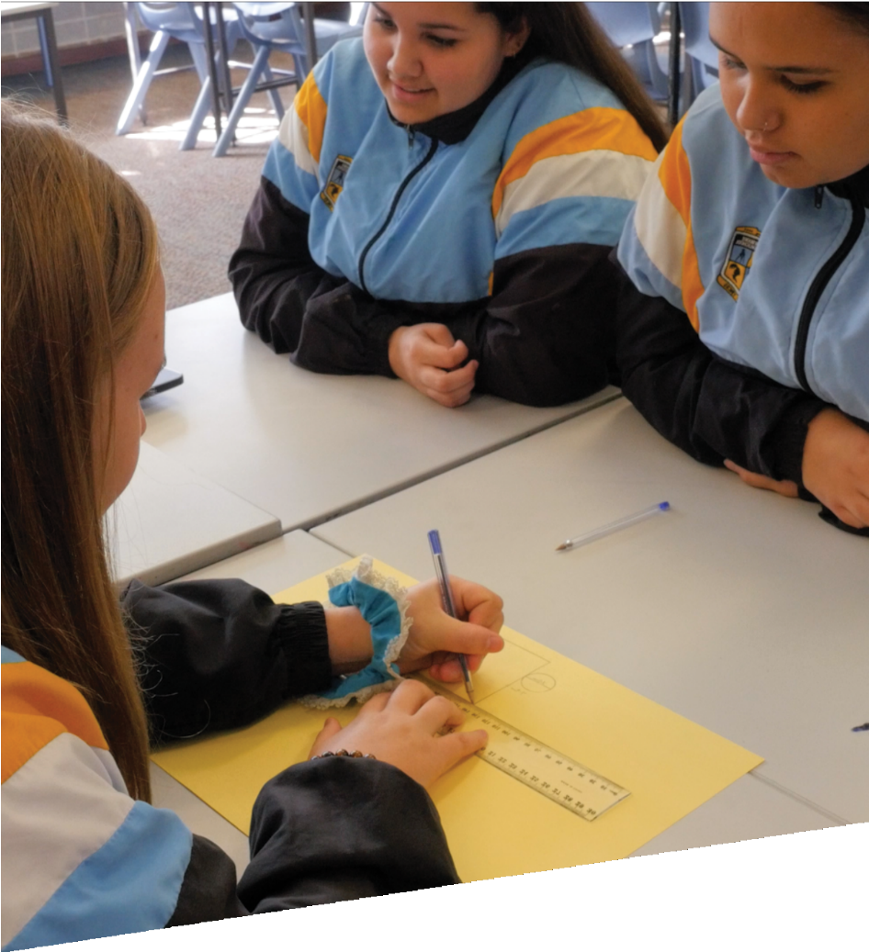


CURRICULUM RESOURCE MODULE
Digital tectonics
YEAR 9
Acknowledgements

The STEM Learning Project respectfully acknowledges the Traditional Custodians of the lands upon which our students and teachers live, learn and educate.

The STEM Learning Project is funded by the Western Australian Department of Education (the Department) and implemented by a consortium in STEM education comprising the Educational Computing Association of WA, the Mathematical Association of WA, the Science Teachers Association of WA and Scitech. We acknowledge and thank the teachers and schools who are the co-creators of these resources.

Copyright and intellectual property

The copyright and intellectual property of this module remain the property of the Department.

Any Western Australian Curriculum content in this resource is used with the permission of the School Curriculum and Standards Authority (the Authority); this permission does not constitute Authority endorsement of the resource. The Authority accepts no liability for any errors or damages arising from reliance on its content.

The Western Australian Curriculum content may be freely copied, or communicated on an intranet, for non-commercial purposes in educational institutions, provided that the Authority is acknowledged as the copyright owner. Copying or communication for any other purpose can be done only within the terms of the Copyright Act 1968 or with prior written permission of the Authority. Any Australian Curriculum content in the Western Australian Curriculum is used by the Authority under the terms of the Creative Commons Attribution-NonCommercial 3.0 Australia licence. Any content on the www.scsa.wa.edu.au domain that has been derived from the Australian Curriculum may be used under the terms of Creative Commons Attribution-NonCommercial 3.0 Australia licence.

Appendix 2: General capabilities continuums is adapted from ACARA, © Australian Curriculum, Assessment and Reporting Authority (ACARA) 2009 to present, unless otherwise indicated. This material was downloaded from the ACARA website (www.acara.edu.au) (Website) (accessed December 2015) and was not modified. The material is licensed under CC BY 4.0 (https://creativecommons.org/licenses/by/4.0/). ACARA does not endorse any product that uses ACARA material or make any representations as to the quality of such products. Any product that uses material published on this website should not be taken to be affiliated with ACARA or have the sponsorship or approval of ACARA. It is up to each person to make their own assessment of the product.

This resource includes references and examples of iOS, Android and other apps. The Department does not endorse or recommend any commercial products and simply provides these as examples for teachers.

The Department is committed to providing quality information to its customers. Whilst every effort has been made to ensure accuracy, currency and reliability of the information within these documents, the Department accepts no responsibility for errors, omissions or amendments made since the time of publishing. Confirmation of information may be sought from the Department or the originating bodies providing the information. The Department has no control over the content of material published on websites to which users are referred in this resource. It is the responsibility of the internet user to make their own decision as to the relevancy, accuracy, currency and reliability of information found on those sites.

This resource contains various images from iStock used under license.
Attributions: BagTheWeb, Trello, Padlet, Google, Google Docs, Google Drive, Google Science Journal, HTC Vive, Oculus Rift, Microsoft Office365, Microsoft Excel, Microsoft Word, Microsoft PowerPoint, GoPro, Algodoo, PocketLab Voyager, SPARKvue by PASCO Scientific, Vernier Graphical Analysis 4, Lab4Physics, iPad, Kidblog, Weebly, Evernote, Autodesk, Tinkercad, SketchUp.

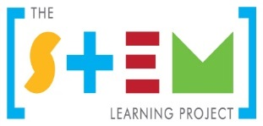
Table of contents

The STEM Learning Project 2
Overview 3
Activity sequence and purpose 7
Background 8
Activity 1: Good vibrations 11
Activity 2: Shake, rattle and roll 19
Activity 3: We built this city 33
Activity 4: We will rock you 41
Appendix 1: Links to the Western Australian Curriculum 46
Appendix 1B: Mathematics proficiency strands 50
Appendix 2: General capabilities continuums 51
Appendix 3: Materials list 54
Appendix 4: Design process guide 55
Appendix 4B: Drawing in the design process 56
Appendix 5: Student journal 57
Appendix 6: Student activity sheet 1.0: Journal checklist 58
Appendix 7: Teacher resource sheet 1.1: Cooperative learning – Roles 59
Appendix 8: Teacher resource sheet 1.2: Cooperative learning – Think-pair-share 60
Appendix 9: Teacher resource sheet 2.1: Science Journal by Google 61
Appendix 10: Teacher resource sheet 2.2: Investigated variables option/extension 70
Appendix 11: Student activity sheet 3.1: Case study 71
Appendix 12: Student activity sheet 3.2: Prototype troubleshooting 73
Appendix 13: Teacher resource sheet 4.1: 3–2–1 Reflection 74
Appendix 14: Student activity sheet 4.2: Self-evaluation 75
Appendix 15: Student activity sheet 4.3: Skills self-evaluation 76

The STEM Learning Project
The aim of the STEM Learning Project is to generate students’ interest, enjoyment and engagement with STEM (Science, Technology, Engineering and Mathematics) and to encourage their ongoing participation in STEM both at school and in subsequent careers. The curriculum resources will support teachers to implement and extend the Western Australian Curriculum across Kindergarten to Year 12 and develop the general capabilities.
Why STEM?
A quality STEM education will develop the knowledge and intellectual skills to drive the innovation required to address global economic, social and environmental challenges.
STEM capability is the key to navigating the employment landscape changed by globalisation and digital disruption. Routine manual and cognitive jobs are in decline whilst non-routine cognitive jobs are growing strongly in Australia. Seventy-five per cent of the jobs in the emerging economy will require critical and creative thinking and problem-solving, supported by skills of collaboration, teamwork and literacy in mathematics, science and technology. This is what we call STEM capability. The vision is to respond to the challenges of today and tomorrow by preparing students for a world that requires multidisciplinary STEM thinking and capability.
The approach
STEM capabilities are developed when students are challenged to solve open-ended, real-world problems that engage students in the processes of the STEM disciplines.
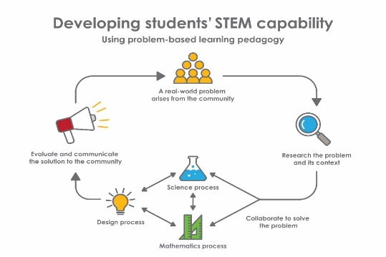
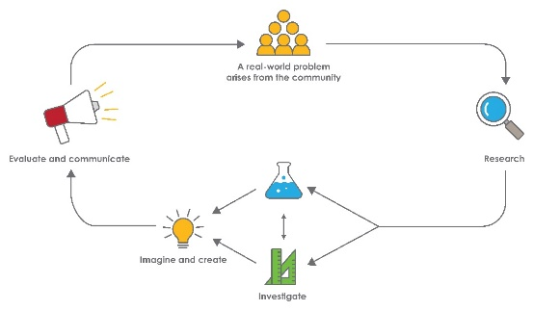

STEM Consortium
Year 9 – Digital tectonics

Overview
Globally, one in three people is at risk of experiencing earthquakes. As the human population has grown, the number of people living in earthquake zones has steadily risen, from 1.4 billion in 1975 to 2.7 billion in 2015 (Joint Research Centre of the European Commission, 2015).
Some of the most at-risk populations are island nations in East and South-East Asia such as Japan and Indonesia, where designing earthquake-resistant buildings is a high priority. One of the largest ever recorded earthquakes was the major 8.9-magnitude earthquake and subsequent tsunami that struck the coast of Japan on March 11th 2011.
While less geologically active, Australia also experiences seismic activity. Some of these earthquakes have had significant impacts on buildings. Local examples include the 6.5-magnitude earthquake in 1968 which caused $2.2 million of damage to the town of Meckering, only 130 km from Perth and a 5.2-magnitude earthquake which caused extensive damage to buildings throughout Kalgoorlie-Boulder in April 2010. The 2019 earthquake 202 km west of Broome recorded a magnitude of 6.6 and is listed as the largest earthquake affecting Western Australia in modern times. The second most damaging earthquake in the history of the state was on 2 June 1979, just east of Cadoux in the northeastern Wheatbelt region, with a Richter magnitude of 6.1.
What is the context?
The ability to accurately measure, understand and predict seismic activity remains an important area of scientific research, as does the design of earthquake-resistant buildings. Buildings in Australia are required to comply with strict building codes (AS 1170.4, last revised 2007), which specify minimum load-bearing capacities in response to dynamic lateral and vertical forces. Design and construction must also take into account relevant factors such as the location and importance level of the building, the height of the structure and the sub-soil type (Master Builders Queensland, 2019).
This module challenges students to use accessible digital technologies and hands-on engineering to measure simulated seismic vibrations, analyse and present data, and determine criteria for the design of earthquake tolerant buildings.
What is the problem?
How can we design buildings to withstand seismic activity?

How does this module support integration of the STEM disciplines?
Students investigate the impact of seismic activity on society. They investigate the regional implications of such activity and relate this to the design and construction of earthquake-resistant buildings. Students explore the social considerations of construction of earthquake-resistant buildings and develop a case study on the design of such a building.
Using the principles of design thinking, students refine and develop their ideas into a model which describes solutions to these problems, evaluating and reflecting as they go.
Science
Students investigate how the theory of plate tectonics explains global patterns of geological activity and continental movement through a research task (ACSSU180). Students use internet research to identify problems that can be investigated. They examine the causes and effects of seismic activity at a regional level, how it affects the structural integrity of buildings and use this to determine criteria for a fair test of simulated seismic vibrations on a range of built structures (ACSHE157, ACSHE158, ACSHE160, ACSHE228).
Students formulate questions or hypotheses for revising and refining research questions to target specific information and data collection or finding a solution to the specific problem identified (ACSIS164). They plan, select and use appropriate investigation types and equipment to collect reliable data (ACSIS165, ACSIS166), and analyse patterns and trends in data, including describing relationships between variables, identifying inconsistencies and explaining the choice of variables to be controlled, changed and measured in the investigation (ACSIS169). Students critically analyse the validity of information in primary and secondary sources (ACSIS172).
The data students generate is used to develop a case study outlining a design for an earthquake-resistant building. Students present this as a designed structure/solution accompanied by a reflection on their journey through the design process, communicating scientific ideas and information for a particular purpose, including constructing evidence-based arguments and using appropriate scientific language, conventions and representations (ACSIS170, ACSIS171, ACSIS174).
Technology
In Digital tectonics, students are asked to consider the social, ethical and sustainability considerations impacting design solutions (ACTDEK040, ACTDEK041, ACTDIP044). They examine the characteristics and properties of materials, combined with force, motion and energy, to create solutions (ACTDEK043).

Students study the characteristics and properties of materials, systems, components, tools and equipment used to create designed solutions (ACTDEK046) and demonstrate how technologies can be combined and used to create designed solutions (ACTDEK047). They design solutions assessing alternative designs against given criteria, using appropriate technical terms and technology (WATPPS57, WATPPS59, WATPPS56) and select and test appropriate technologies and processes, to make solutions (WATPPS58).
The Design process guide is included as a resource to help teachers understand the complete design process as developed in the Technologies curriculum.
Mathematics
Students identify everyday questions and issues involving at least one numerical and at least one categorical variable from collected and secondary source data (ACMSP228). They compare data displays using mean, median and range to describe and interpret numerical data sets in terms of location (centre) and spread (ACMSP283).
Students calculate relative frequencies from given or collected data to estimate probabilities of events involving 'and' or 'or' (ACMSP226).
General capabilities
There are opportunities for the development of general capabilities and cross-curriculum priorities as students engage with Digital tectonics. In this module, students:
- Develop critical and creative thinking skills as they research the problem and its context (Activity 1); investigate parameters impacting on the problem (Activity 2); imagine and develop solutions (Activity 3); and evaluate and communicate their solutions to an audience (Activity 4).
- Utilise creative thinking as they generate possible design solutions; and critical thinking, numeracy skills and ethical understanding as they choose between alternative approaches to solving the problem of designing vibration-tolerant structures from their collection and analysis of vibration data.
- Utilise personal and social capability as they develop socially cohesive and effective working teams; collaborate in generating solutions; adopt group roles; and reflect on their group work capabilities through self and peer evaluation.
- Utilise a range of literacies and information and communication technology (ICT) capabilities as they collate records of work completed throughout the module in a journal; represent and communicate their solutions to an audience using digital technologies in Activity 4.
- Communicate and, using evidence, justify their group’s design to an authentic audience.
What are the pedagogical principles of the STEM learning modules?
The STEM Learning Project modules develop STEM capabilities by challenging students to solve real-world problems set in authentic contexts. The problems engage students in the STEM disciplines and provide opportunities for developing higher order thinking and reasoning, and the general capability skills of creativity, critical thinking, communication and collaboration.
The design of the modules is based on four pedagogical principles:
- Problem-based learning
All modules are designed around students solving an open-ended, real-world problem. Learning is supported through a four-phase instructional model: research the problem and its context; investigate the parameters impacting on the problem; design and develop solutions to the problem; and evaluate and communicate solutions to an authentic audience.
- Developing higher order thinking

Opportunities are created for higher order thinking and reasoning through questioning and discourse that elicits students' thinking, prompts and scaffolds explanations, and requires students to justify their claims. Opportunities for making reasoning visible through discourse are highlighted in the modules with the icon shown here.
- Collaborative learning
This provides opportunities for students to develop teamwork and leadership skills, challenge each other’s ideas, and co-construct explanations and solutions. Information that can support teachers with aspects of collaborative learning and social management skills is included in the resource sheets.
- Reflective practice
Recording observations, ideas and one’s reflections on the learning experiences in some form of journal fosters deeper engagement and metacognitive awareness of what is being learnt. Information that can support teachers with journaling is included in the resource sheets.
These pedagogical principles can be explored further in the STEM Learning Project online professional learning modules located in Connect Resources.

Activity sequence and purpose
 | Good vibrations  Students investigate how the theory of plate tectonics explains global patterns of geological activity and continental movement through a research task.
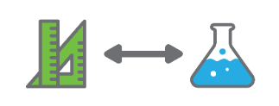 | Shake, rattle and roll  Students determine criteria for a fair test of simulated seismic vibrations on structures of varying dimensions and built from a range of construction materials. They explain the choice of variables to be controlled, changed and measured, and collect reliable data, assess risk and address ethical issues associated with these methods.
 | We built this city  Students develop a case study and use their data to inform their design of an earthquake-resistant building. They analyse patterns and trends in data, draw conclusions that are consistent with the evidence and critically analyse the validity of information to solve problems.
 | We will rock you  Students present details of their structure, supported with critical analysis and evidence-based arguments, including how their data and research findings influenced design decisions and improvements.

Background
Expected learning | Students will be able to:  - Select and use appropriate equipment, including digital technologies, to collect and record data systematically and accurately.  - Formulate questions or hypotheses that can be investigated scientifically.  - Use the theory of plate tectonics to explain the seismic activity.  - Create and compare data displays using mean, median and range to describe and interpret numerical vibration data sets.  - Select evidence from texts to analyse and communicate scientific ideas and information for a particular purpose, including constructing evidence-based arguments and using appropriate scientific language, conventions and representations to an audience.  - Design solutions assessing alternative designs against given criteria, using appropriate technical terms and technology.  - Work independently and collaboratively to manage projects, using digital technology and an iterative and collaborative approach, considering time, cost, risk and safety.  - Describe and interpret numerical data sets.  - Evaluate design processes and solutions against student-developed criteria.
Vocabulary | This module uses subject-specific terminology.  The following vocabulary list contains other terms that need to be understood, either before the module commences or developed as they are used:  aerodynamic stability, accelerogram, convection, earthquake, histogram, magnitude, seismic waves (P-waves, S-waves and surface waves), seismometers, seismograms, seismographs, taper ratio, tectonic plate(s).
Timing | There is no prescribed duration for this module. The module is designed to be flexible enough for teachers to adapt. Activities do not equate to lessons; one activity may require more than one lesson to implement.
Consumable materials | A Materials list is provided for this module. The list outlines materials outside of normal classroom equipment that will be needed to complete the activities.
Safety notes | There are potential hazards inherent in these activities and with the equipment being used, and a plan to mitigate any risks will be required.  Potential hazards specific to this module include but are not limited to:  - Possible exposure to cyber bullying, privacy violations and uninvited solicitations when using the internet  - Possible risk of injury when constructing and testing shake tables and buildings.
Enterprise skills | This module focuses on higher order skills with significant emphasis on expected learning from the general capabilities and consideration of enterprise skills.  Enterprise skills include problem-solving, communication skills, digital literacy, teamwork, financial literacy, creativity, critical thinking and presentation skills.  Further background is available from the Foundation for Young Australians article The New Basics: Big data reveals the skills young people need for the New Work Order (Foundation for Young Australians, 2016) at www.fya.org.au/wp-content/uploads/2016/04/The-New-Basics_Web_Final.pdf.
Assessment | The STEM modules have been developed to provide students with learning experiences to solve authentic real-world problems using science, technology, engineering and mathematics capabilities. While working through the module, the following assessment opportunities will arise:  - Building and testing the earthquake simulator provides an opportunity for experimental design assessment  - Self and peer assessment at the end of Activities 3 and 4  - Development of case study and following the design brief in Activity 3.  Links to the Western Australian Curriculum shows the expected learning students will engage in as they work through the module.  Evidence of learning from journaling, presentations and anecdotal notes from this module can contribute towards the larger body of evidence gathered throughout a teaching period and can be used to make on-balance judgements about the quality of learning demonstrated by the students in the science, technologies and mathematics learning areas.  Students can further develop the general capabilities of Information and communication technology (ICT) capability, Critical and creative thinking, and Personal and social capability. Continuums for these are included in the General capabilities continuums but are not intended to be for assessment purposes.

istockphoto.com

Activity 1: Good vibrations
  Activity focus | Students investigate how the theory of plate tectonics explains global patterns of geological activity and continental movement through a research task.
Background information | What is an earthquake and where do they occur?  Most earthquakes are extremely small. Around half a million earthquakes occur every year around the world, but only a fraction of these are strong enough to be felt. Major earthquakes (greater than magnitude 7 on the Richter scale) occur approximately 20 times on average per year globally.  An earthquake is a sudden movement of the Earth's surface caused by a rapid release of kinetic energy in the Earth's crust and upper mantle (more technically known as the lithosphere). This energy release is often the result of the irregular movement of tectonic plates against one another, meaning that most earthquakes are located at the edges of tectonic plates. However, earthquakes can occur anywhere. Earthquakes that are located away from the edge of a tectonic plate are called intraplate earthquakes; these are harder to predict, and cities not located near a tectonic boundary tend to be less prepared, making this type of earthquake particularly dangerous.  Seismic waves  The Earth’s crust is continually in motion. There are weak points within the crust and stress can build up there. Energy increases, like a rubber band being stretched, until the rock at the weak point fractures and releases the stored energy.  In an earthquake, the release of energy within the lithosphere creates seismic waves, which travel in different ways and cause different types of vibration. There are compression waves (called P waves), where the surface of the Earth moves in the same direction as the propagating wave. The surface of the earth can also move at right angles to the propagating (S waves). These vibrations can make the Earth's surface shake violently, causing significant damage and injury. Earthquakes can also trigger a tsunami, landslides and occasionally volcanic activity.  Although not on the edge of a tectonic plate, the Australian plate is the fastest moving continental landmass on Earth and is colliding into the Pacific plate to Australia's north and east, and the Eurasian Plate to the northwest. This means that Australia does still experience significant seismic activity, including earthquakes. For example, in 2010 Kalgoorlie-Boulder experienced an earthquake that caused significant structural damage to buildings in the town and temporarily closed gold mines in the area.  How do we measure earthquake vibrations?  A seismograph is an instrument used to detect and record seismic vibrations. In an earthquake, the case of the seismometer moves with its surroundings while a large suspended mass resists motion due to inertia. This recording of ground motion is a seismogram which displays the displacement of the ground on the vertical axis with the time displayed on the horizontal axis. Seismograms were previously paper recordings of ground motion but are now digital.  The main measurement of earthquake magnitude is the Richter scale, which describes the power of an earthquake as measured by the size (amplitude) of the waves measured by a seismograph. The Richter scale gives a score from level 0 to 9, with each level being 10 times as powerful as the level before it. For example, a level 3 earthquake is 10 times as powerful as a level 2 earthquake. A level 0 earthquake is not even powerful enough to be felt by a person, and a level 8 earthquake is strong enough to crumble buildings. One way you might explain this idea of earthquake magnitude, is to suggest your students to press their hand on their desk lightly and imagine this is the power of a level 2 earthquake. Next, they can press hard on the desk, imagine this is the strength of a level 3. Finally, they could press down with all their weight on the desk, imagining this is level 4. Then ask what would a level 5 or level 9 would be like? (It would shatter the desk). The main idea here is that the earthquake must be 10 times as strong before it rates at the next level in the scale.  Earthquake resistant buildings  Designing buildings that can withstand earthquakes is a priority for every country, including Australia. Buildings in Australia are required to comply with strict building codes which specify minimum load-bearing capacities in response to dynamic lateral and vertical forces.
Instructional procedures | The goal of Activity 1 is for students to conduct internet-based research to develop their knowledge of earthquakes. Throughout their research process, students should take notes and develop a journal (paper-based or digital) which collects and communicates the results of their research. See Student journal for more information.  It is recommended that students work in small groups of three or four for all activities. Mixed ability groups encourage peer tutoring and collaboration in problem-solving. Collaboration is an important STEM capability. Students should undertake research collaboratively to experience its benefits and accelerate learning.  Teachers may wish to model internet research best practice with the class before students commence their research work and choose to refer students to specific websites. A list of useful websites is included in the Digital resources section.  It is suggested students usea KWL chart in this activity. A KWL chart is a graphic organiser which helps students organise information before, during and after learning. They are useful formative assessment tools as they can be used to engage students in a new topic, activate prior knowledge, share objectives and monitor students' learning. The KWL Chart: Teaching Strategies #4 video shows how to use a KWL strategy (see Digital resources).
Expected learning | Students will be able to:  - Describe the occurrence of earthquakes related to plate boundaries (Science).  - Explain the movement of tectonic plates based on convection currents in the mantle (Science).  - Identify the different types of seismic waves, and how the movement of energy transferred by seismic waves varies across the different layers of the Earth (Science).  - Explain how the extreme age (very large time scales) and geological stability of the Australian continent influence its seismic activity (Science, Mathematics).  - Identify and explain social and ethical factors that may be considered in design solutions for earthquake-resistant buildings (Technology).
Equipment required | For the class:  Interactive whiteboard or data projector  Computer or device with internet access
Equipment required | For the students:  Computers or devices with internet access  Student journals  Device for creating digital journal (optional)  Sticky notes
Preparation | Content warning  When planning for the delivery of this topic, it is important to consider the students’ backgrounds and experiences as the content may cause distress for some students. If necessary, notify parents, alert students and provide alternative lesson content.  Some of the online images may provoke emotional responses and should be used sensitively. It is suggested an information package be sent home to parents equipping them to manage discussions and questions their children may have.  View the suggested videos in Digital resources, download where possible, exclude advertising, and plan where to pause for discussion.
Activity parts | Part 1: Introduce the topic  To establish context for the research, begin the activity with a whole class discussion to explore students’ prior knowledge and personal experiences of the topic.  A cooperative learning strategy such as think-pair-share could help encourage discussion and may help manage unpleasant personal memories and responses. See Teacher resource sheet 1.2: Cooperative learning – Think-pair-share.  Ask students the following questions to prompt discussion:  - What do you know about the interior structure of the Earth?  - How does this structure contribute to seismic activity?  - What do you know about earthquakes?  - How often do earthquakes happen?  - Are there ever earthquakes in Western Australia?  - Where do most earthquakes occur? Why is that? …because…  - What causes an earthquake?  - How do we measure earthquakes?  - Does anyone have a personal experience story about an earthquake event? Where?  The last question is an effective way of providing immediate real-life context, but could also possibly trigger unpleasant memories for some students.  Students record their answers in their student journal (paper-based or digital), curating them with group members to form a consensus. The journal may take the form of a mind map, which students add to throughout the module. Different coloured pens or sticky notes could be used to identify the different stages of learning. Using sticky notes allows ideas to be arranged and rearranged as student understandings develop.  A KWL chart is an alternative graphic organiser student may find helpful as they sort their information before, during and after learning.  It will be useful for students to revisit and reflect on their answers once they have conducted research.
Activity parts | Part 2: Recent seismic activity  Encourage students to explore the Seismic monitor interactive map of recent earthquakes (see Digital resources).  Show students the video Global Earthquake Animation: The 20th Century (see Digital resources), which displays every recorded earthquake in sequence as they occurred from the years 1901 to 2000.  Ask students:  - What did you notice in each of the resources?  - Did watching the video change any of the answers you wrote in your journal?  If students used sticky notes on a mind map, they could use a different colour to show what they learnt from the video.
Activity parts | Part 3: Earthquake research  Establish the objectives of the research and explain to students they will be conducting internet-based research to explore the following questions:  - How do patterns of earthquake activity in Australia compare with the rest of the world?  - How does the layered structure of the Earth enable the energy from earthquakes to travel across the Earth?  - What is the source of energy and how is it transferred during an earthquake?  - How is the intensity of an earthquake measured? What is a logarithmic scale?  Instruct students to make notes and add their research findings in their journals.  Communicate clear expectations to students in terms of recording what they find. Ideas may be collected and communicated using a combination of text, illustrations, graphs, photographs or videos. Digital curation tools such as BagTheWeb, Trello, Padlet or Google Docs could be used to curate resources.  Students should also aim to include some form of data in their research, such as a table showing magnitudes of earthquakes in Australia.  As an extension activity, students could compare linear and logarithmic scales to explain why logarithmic scales are used for magnitude.  Ask students to develop a classroom glossary of seismic terminology they learnt during their research.
Activity parts | Part 4: Bringing it together and journaling  As a class, students report and discuss their findings. They could record their findings in a physical journal or a shared digital platform such as Office365, Google Docs or Trello, for example.  Provide an opportunity for students to reflect on what they have learnt and document new understandings.  If students used a mind map or KWL chart in Part 1, they could add to it.
Activity parts | Part 5: Reflection and connection  Hold a class discussion and have students consider the question:  - What needs to be considered when designing buildings to withstand earthquakes?  Ask students to expand their research to connect earthquakes to the global and social context. A global thinking routine such as the 3 Ys (see Digital resources) can be applied:  - Why might this (topic, question) matter to me?  - Why might it matter to people around me (family, friends, city, nation)?  - Why might it matter to the world?  This is a good opportunity for students to build relationships with community and interview family, or even extended family, about their knowledge and experiences with earthquakes.
Resource sheets | Student journal  Teacher resource sheet 1.1: Cooperative learning – Roles  Teacher resources sheet 1.2: Cooperative learning – Think-pair-share
Digital resources | KWL Chart: Teaching Strategies #4 (Teachings in Education, 2018)  youtu.be/L8ZhucZczxE
Digital resources | Earthquakes of the 20th Century (PacificTWC, 2018)  youtu.be/jhmF-IwP6uM
Digital resources | Seismic monitor (IRIS, Incorporated Research Institutions for Seismology)  ds.iris.edu/seismon/index.phtml
Digital resources | How to be a global thinker - 3 Ys (Veronica Boix Mansilla, Educational Leadership, 2016)  www.pz.harvard.edu/sites/default/files/Educational%20Leadership-The%20Global-Ready%20Student-How%20to%20Be%20a%20Global%20Thinker.pdf
Digital resources | Earthquake Glossary – Accelerogram (USGS, n.d.)  earthquake.usgs.gov/learn/glossary/?term=accelerogram
Digital resources | Seismometers, seismographs, seismograms - what's the difference? How do they work? (USGS, n.d.)  www.usgs.gov/faqs/seismometers-seismographs-seismograms-whats-difference-how-do-they-work?qt-news_science_products=0#qt-news_science_products
Digital resources | Seismic waves (British Geological Survey, n.d.)  www.bgs.ac.uk/discoveringGeology/hazards/earthquakes/seismicWaves.html
Digital resources | Earthquake (Geoscience Australia, n.d.)  www.ga.gov.au/scientific-topics/community-safety/earthquake
Digital resources | 1968 Meckering (Australian Earthquake Engineering Society, n.d.)  aees.org.au/gallery/1968-meckering/
Digital resources | Understanding the Meckering earthquake: Western Australia (Johnston & White, 2018)  www.dmp.wa.gov.au/gswa_enews/files/2-page-spread_Meckering_Earthquake.pdf

Activity 2: Shake, rattle and roll
Activity focus  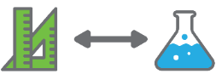 | Students determine criteria for a fair test of simulated seismic vibrations on structures of varying dimensions and built from a range of construction materials. They explain the choice of variables to be controlled, changed and measured and collect reliable data, assess risk and address ethical issues associated with these methods.
Background information | Types of movement in 3D space  When considering types of seismic vibration, it is useful to be aware of how objects can move and the established language framework for describing this.  There are essentially six different types of movement which are possible within three-dimensional space. These are known as the ‘six degrees of freedom’ or ‘6DoF’.  The first three types are movement in a straight line, along one of the three-dimensional axes: X, Y and Z.  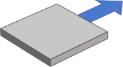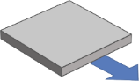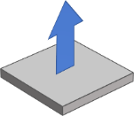  X  Y  Z  The second three types of movement are rotation around one of these axes: X rotation, Y rotation, and Z rotation.  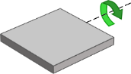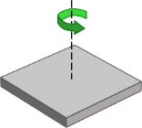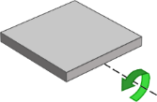  STEM Consortium  X rotation  (  Y rotation  Z rotation  An understanding of the ‘six degrees of freedom’ concept is useful to animators and video game designers who often work in three dimensions and is also an important consideration when navigating virtual reality environments. Many of the more advanced virtual reality systems such as HTC Vive and Oculus Rift enable users to move with the full six degrees of freedom.  Straight-line movement along the X, Y, and Z, axes can be produced using earthquake simulators and is comparable to the impact of P-waves and S-waves. It is not possible to fully replicate the rotational movement, which would be a consequence of surface waves (L-waves).  Digital measurement  Recent advances in digital technology have changed the scientific landscape considerably, and it is now possible for anyone to investigate seismic vibrations without the need for expensive dedicated scientific tools. In this activity, teachers and students use everyday devices, such as phones or tablets, to capture data and measure simulated seismic vibrations. Phones and tablets typically feature a wide array of sensors, such as accelerometers and gyroscopes. A multitude of apps is also available, which allow users to tap into these sensors and use them for scientific observation and measurement.  A phone’s accelerometer can be used to measure linear acceleration in the X, Y and Z direction. It is important to note that the accelerogram created looks nearly identical to a seismogram; the difference being that the vertical axis shows acceleration on an accelerometer and ground displacement on a seismogram. This could cause confusion and misconceptions concerning the relationship between displacement, velocity and acceleration, and the difference must be made clear to students.  Seismogram Acclerogram  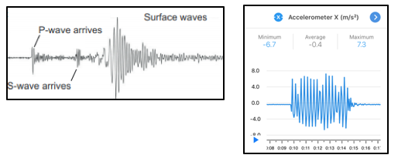  STEM Consortium  The use of an app such as Google Science Journal may be dependent on the school’s policies, as well as accessibility to mobile devices. All data in this activity can be measured using either digital technology or analogue devices.  Histogram: What is it? And how do I construct one?  A histogram is a type of vertical column graph that indicates the distribution of raw numerical data. Histograms are different from standard column graphs in a couple of important ways.  Column graphs are normally used to show the relationship between two variables: a categorical variable (such as favourite colour), and a numerical variable (such as how many people). A histogram is used to show the distribution of a single numerical variable (ie how many there are of each number). Another important difference is that column graphs should have gaps between the columns, whereas histograms do not.  The two example graphs below illustrate the difference between a column graph and a histogram.  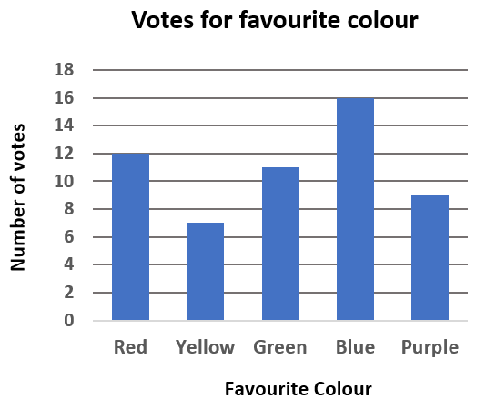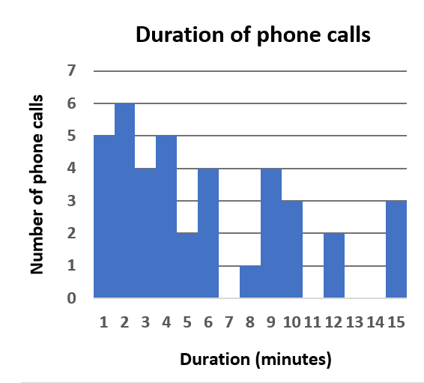  STEM Consortium  The data for the second graph may look like two variables (duration and number of phone calls), but in fact, it is only one variable. The raw data from this graph is shown below:  9 6 4 5 1 9 4 6 2 6 2 10 6 4 3 3 4 12 9 1 10 10 9 5  15 2 1 1 15 8 2 2 12 4 15 3 1 3 2 3  Although spreadsheet software such as Microsoft Excel can be used to create column graphs or histograms at the click of a button, it is important to understand the conceptual difference between them and how they are created.  For a simple data set like the one above, where the numbers are all integers (ie whole numbers), the first step is to write all the numbers in sequence:  1 1 1 1 1 2 2 2 2 2 2 3 3 3 3 3 4 4 4 4 4 5 5 6 6 6 6 8 9 9 9 9 10 10 10 12 12 15 15 15  It is then easier to count how many there are of each number (in this case there are five 1s, six 2s, and so on).  This approach works for simple data sets with a small quantity of whole numbers. However, for more complex data sets it is necessary to use more advanced techniques. If teachers are feeling confident, this is an opportunity for students to gain skills using Excel functions.  For example, in the data set below, the function  =COUNTIF(A1: A7,9)  will count how many cells in the range A1: A7 are equal to 9.  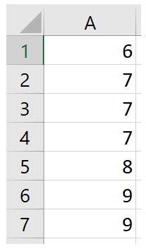  STEM Consortium  Creating histograms using data from digital sensors  Data sets that are exported from digital sensors or apps such as Google Science Journal will often be very raw, in that it will be extensive (containing hundreds or even thousands of numerical values), and messy (not rounded or ordered). Instead of a neat list of integers, data will be accurate to many decimal places and students will need to be prepared to evaluate data similar to the example below that goes on for many pages.  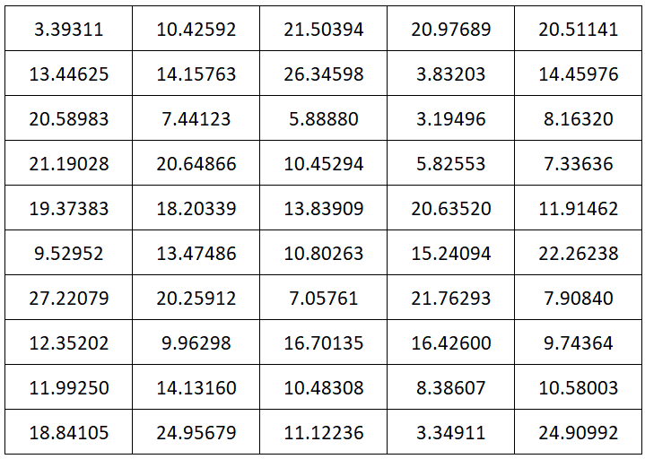  STEM Consortium  To create a histogram from this data, a good starting point might be to round all numbers to the nearest integer. Although this sacrifices some scientific data, it has the advantage of making the data much easier to work with.  Rounding can be done by hand, but for a large data set, this is not feasible. Once again it is recommended that students use digital tools such as Microsoft Excel.  Either of the functions =ROUND(A1,1) or =INT(A1) can be used to convert the value of cell A1 to an integer.  Alternatively, at this point, students can simply use the Insert/Chart option and select Histogram from the list.  Earthquake resistant building standards  There is no such thing as a building that is completely earthquake-proof. The aim of constructing earthquake-resistant buildings is to enable them to withstand vibrations of an agreed frequency and probability, based on their geographical location and likelihood of experiencing an earthquake of a certain size. In other words, all structures are built to be able to survive a certain percentage of earthquakes, based on carefully selected and agreed-upon mathematical criteria. These criteria take the form of building codes and regulations.  The engineering of full-size buildings differs in many ways from scale models which may be constructed in a classroom. However, there are certain construction techniques used which may be meaningful for students to learn and experiment with. These techniques are often specific to the material being used. For example, an image search for ‘cardboard construction techniques’ will quickly provide a wealth of images that illustrate a variety of useful engineering approaches.  When planning their investigation, students may need to review how to identify variables (ie Independent variable – the variable that is altered; Dependent variable – the variable being tested or measured; Controlled variable – a variable that is kept the same). Any change in a controlled variable would invalidate the results.
Instructional procedures | Throughout this module, students should take notes and develop a journal (paper-based or digital means) which collects together and communicates the results of their research.  It is recommended that students work in small groups of three to four. Mixed ability groups encourage peer tutoring and collaboration in problem-solving. Collaboration is an important STEM capability.
Expected learning | Students will be able to:  - Experiment to replicate a seismic event (Science).  - Calculate areas of built structures to inform seismic stability (Mathematics, Science, Technology).  - Collect and record vibration data systematically and accurately (Science).  - Create and compare data displays using mean, median and range to describe and interpret numerical vibration data sets (Mathematics).  - Recognise how at least one numerical and at least one categorical variable are used to display earthquake data (Mathematics).  - Evaluate the success of a structure concerning vibrations (Technology, Science).
Equipment required | For the class:  Interactive whiteboard or data projector  Computer or device
Equipment required | For the students:  Construction materials – see Materials list.  Rulers, timers, and balances (if measuring the weight of structures)  Devices to measure simulated seismic vibrations (eg device with the Science Journal app)
Preparation | Gather all construction materials required for the shake tables and structures.  If using devices for the measurement of seismic vibration, ensure they are adequately charged before the lesson and that the required apps have been installed and enabled. The ICT administrator may need to be contacted to facilitate this.  It is recommended that the teachers familiarise themselves with any apps they are planning to use. Detailed instructions on how to use the recommended app (Science Journal) are provided in Teacher resource sheet 2.1: Science Journal by Google.  Set up the interactive whiteboard or data projector to demonstrate how to use Science Journal (optional).
Activity parts | Part 1: Build an earthquake simulator  In preparation for testing their earthquake-tolerant buildings in the next activity, students will need to build an earthquake simulator platform (ie shake table) that can simulate seismic vibrations on a flat surface, such as moving forwards/backward, side-to-side, up and down or tilting. Their shake table must be able to perform a reliable and predictable fair test in each round of testing to ensure the data collected is valid.  In addition to being able to simulate seismic vibrations, the flat surface will need to be big enough for both a building/structure and the optional device (such as a mobile phone or tablet) that will be used to capture vibration data.  The following example of a shake table could be used:  A suspended piece of cardboard or other flat rigid sheeting held on all four sides to an open rectangular container using rubber bands and butterfly clips. This design allows for sustained vibrations as well as horizontal movement in both the x and y directions and vertical vibrations in the z-direction as students will shake the table themselves.  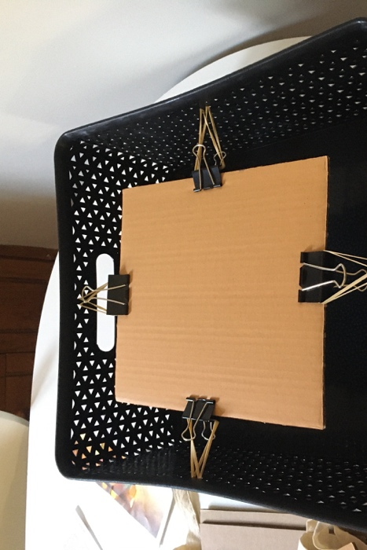  Alternatively, the design of the shake table could be determined by students through discussion:  STEM Consortium  - How can we simulate the different seismic waves (P-waves, S-waves, and surface waves)?  - Is it important for the structures to be resistant to a particular time interval of vibrations?  - What scale will be used to compare to for vibrations? (Mercalli scale and/or peak ground acceleration (PGA) are recommended).  See Digital resources for more examples and instructions. Other designs for shake tables are widely available online by searching ‘how to build a shake table’.  Once the shake tables have been built, students need to test them and practise how data will be collected.  An important component of science inquiry skills is selecting and using appropriate equipment to record precise and accurate data. These will be contingent on the type of shake table used and the measurement devices selected (and available).  Through discussion, students need to consider:  - How can we maintain consistency in repeated trials? Why is this important?  - How much data is enough?  Maintaining consistent vibrations can be done by taping a perimeter for a range of movement (analogue option) or maintaining a specific maximum and minimum acceleration on the x (and/or y) axes using the accelerometer in the Science Journal app (digital option).  A simulation of approximately 0.3 g (3 m/s² in the horizontal plane) for 30 seconds would be a greater peak ground acceleration (PGA) than predicted in Australia but is still relatively close.
Activity parts | Part 2: Test it out, build  Using the earthquake simulator platform that was created and tested in the previous activity, students use construction materials to build a structure directly onto their simulator platform.  Initiate a conversation about variables and building criteria with a ‘build-off’ challenge. Provide students with the construction materials and challenge them, for example, to build the tallest free-standing tower they can within a limited timeframe.  Once this activity is complete, ask students to conduct a gallery walk around the room to examine each other’s structures. Teams should record their observations in their journals.  Students test out the seismic stability of their structures by simulating an earthquake (reminder that a simulation of approximately 0.3 g (3 m/s² in the horizontal plane) for 30 seconds would be a greater peak ground acceleration (PGA) than predicted in Australia, but is still relatively close).  Encourage students to assess their building based on the Mercalli index.
Activity parts | Part 3: Variables and measurements  Ask students to reflect on the quick test structures that they have created. This will help guide students through the process of establishing important factors for seismic stability and criteria for collecting valid data to help inform their later designed structures.  After this reflection, revisit the discussion about data collection from Part 1:  - How can we collect reliable data?  - How can we maintain consistency in repeated trials? Why is this important?  - How much data do you need?  Add to the planning phase of the investigation by determining independent and dependant variables and how they will be measured. These variables need to be determined before the structures are created for testing.  Additional questions to consider are:  - How can we maintain consistency in repeated trials?  - Which variables are being tested and which are being controlled?  - What are the independent and dependent variables?  - How will each variable be measured? In this analysis and ideation part of the design process, multiple independent and dependant variables could be investigated. See Teacher resource sheet 2.2: Investigated variables option/extension for variable options and extensions.  The following procedure is a suggestion to facilitate consistent and adequate data collection:  Divide the class into groups of three or four students. Each group will test their dependent variable and measure and record the independent variable. Each group will perform the test one time for each modification of the dependent variable then share their information with the group so that all groups’ data is collected and the mean, median, range, etc. can be calculated.  Height and base area are the two factors that will most impact the seismic stability. These also contribute to factors such as surface area, volume, height to base area ratio and taper ratio. Depending on the class and the structures built, this could lead to a more open mathematics investigation.  Trial 1:  - Independent variable: height variation within groups.  - Dependent variable: the time takenfor the building to collapse or sustain significant damage during earthquake simulation.  - Control variables: each group has the same building materials and construction design, the same base area (A_{b}), and the same horizontal acceleration (chosen location*).  Trial 2:  - Independent variable: base area (A_{b}) variation within groups.  - Dependent variable: the time interval of for the building to collapse or sustain significant damage during earthquake simulation.  - Control variables: each group has the same building materials and construction design, the same height and the same horizontal acceleration (chosen location*). The height can be selected based on an approximate average of buildings, the median height from the first round of varying heights, etc.  *The acceleration can be selected based on a particular location in Australia or the world. A simulation of approximately 0.3 g (3 m/s² in the horizontal plane) for 30 seconds would be a greater peak ground acceleration (PGA) than predicted in Australia but is still relatively close. The 2016 Kaikoura earthquake in New Zealand had a PGA or 3.0 g (30 m/s² in the horizontal plane. Students should aim for PGA between 0.2 g and 0.3 g as higher values are likely to cause severe damage to the models.  See the Digital resources for predicted PGAs and hazard maps.
Activity parts | Part 4: Testing, testing shake it up!  Students build, measure, shake and record data as determined in Part 3.  The goal of these tests is to generate data and documentation in the testing of the earthquake resistance of the structures. Ensure students are aware of the expectation that each time they conduct a test they should also be generating:  - Written notes, such as the name of the student whose model they are testing, a description of its appearance, and all relevant measurements such as its height  - Documentary evidence of their experiment in the form of photographs, sketches, audio narration and/or video  - Experimental data in the form of a written table, graph, chart, spreadsheet or comma-separated variable file (.csv).  The above items, that are required output of each experiment, will be shared with the class to create a larger set of data and will be used to inform students’ case studies and designs in the next activity.  Students must appraise all structures and could:  - move around the room to observe other groups’ structures and experimental tests, similar to a ‘gallery walk’  - use their previously determined criteria to develop a data collection instrument, such as a paper-based or electronic form, which they fill in with the results of their evaluation and share with the class  - produce documentary evidence of their experiment in the form of photographs, audio narration, video, or annotated screenshots of graphs from digital measurement devices such as Google’s Science Journal.  It is important that all students have access to the data from the seismic simulation for each structure. This can be facilitated by access to a shared digital space like Office365 or Google Docs.  When collating data, some group’s structures may be damaged in less time with the same acceleration and building materials. This provides an opportunity to discuss building quality and explore the importance of building code standards.
Activity parts | Part 5: Data analysis  The analysis of data allows students to engage with mathematical concepts of data representation and interpretation.  Before students can use their findings, they need to organise their data and analyse it to produce meaningful information. For example, students may have a table, spreadsheet or comma-separated variable (.csv) containing data in the form of hundreds of numerical values. These values will need to be processed and transformed to be useful.  Specifically, students should be encouraged to calculate the mean, median and range of their numerical data, and construct histograms which show the frequency of each value recorded. Using the full class data will allow students a greater range of information to inform their structure in the next activity.  In the context of earthquakes, a histogram can provide useful information about the number of time buildings maintained structural integrity concerning their structural measurements.
Part 6: Journaling
As a class, students report and discuss their findings. They could record their findings in a physical journal or a shared digital platform such as Office365, Google Docs or Trello, for example.
Provide an opportunity for students to reflect on what they have learnt and document new understandings.
If students used a mind map or KWL chart in Activity 1, they could add to it.
Resource sheets | Teacher resource sheet 2.1: Science Journal by Google  Teacher resource sheet 2.2: Investigated variables option/extension
Digital resources | Google Science Journal  sciencejournal.withgoogle.com
Digital resources | STEM Design Challenge: Building Earthquake Proof Buildings AND a Shake Table (Autodesk instructables, .nd.)  https://www.instructables.com/id/STEM-Design-Challenge-Building-Earthquake-Proof-Bu/
Digital resources | Earthquake STEM Challenge: Creating Buildings and a Shake Table (Mrs Harris Teaches Science, 2019)  www.mrsharristeaches.com/2019/07/stem-design-challenge-building-earthquake-proof-buildings-and-a-shake-table/
Digital resources | Six degrees of freedom (Wikipedia, 2020)  en.wikipedia.org/wiki/Six_degrees_of_freedom
Digital resources | Earthquakes in Australia (Seismology Research Centre, n.d.)  www.src.com.au/earthquakes/seismology-101/earthquakes-in-australia/
Digital resources | Peak Ground Acceleration information and table of values (Wikipedia, 2020)  en.wikipedia.org/wiki/Peak_ground_acceleration
Digital resources | What the New View of Seismic Hazard in Australia Means (Bingming Shen-Tu, AIR Worldwide, 2018)  www.air-worldwide.com/blog/posts/2018/11/what-the-new-view-of-seismic-hazard-in-australia-means/
Digital resources | 10% in 50 year seismic hazard map (Geoscience Australia, 2018)  ecat.ga.gov.au/geonetwork/srv/eng/catalog.search#/metadata/123132
Digital resources | Global Seismic Hazard Map – online version (Global Earthquake Model (GEM), 2018)  maps.openquake.org/map/global-seismic-hazard-map/#2/-31.1/140.6
Digital resources | Global Seismic Hazard Map – print version (Global Earthquake Model (GEM), 2018)  cloud-storage.globalquakemodel.org/public/Global%20Maps/gem_global_seismic_hazard_map_v2018.1.pdf
Digital resources | National Seismic Hazard Assessment (NSHA)(Geoscience Australia, n.d.)  www.ga.gov.au/about/projects/safety/nsha
Digital resources | National Seismic Hazard Assessment (Geoscience Australia, 2018)  geoscience-au.maps.arcgis.com/home/webmap/viewer.html?webmap=490e068f37494dbc997a2f7e55d4cc4d

Activity 3: We built this city
  Activity focus | Students develop a case study and use their data to inform their design of an earthquake-resistant building. They analyse patterns and trends in data, draw conclusions that are consistent with the evidence and critically analyse the validity of information to solve problems.
Background information | Construction of earthquake-resistant buildings  Construction methods for earthquake-resistant buildings vary. In many cases, buildings are simply designed to be strong and flexible enough to survive vibration with an acceptable level of damage. Lower frequency seismic vibrations tend to cause more damage to buildings that are taller and more flexible, whereas higher frequency seismic vibrations tend to be more damaging to shorter, stiffer buildings. Note that earthquakes in Australia tend to have higher frequency vibrations and occur within 20 km of the surface.  View the TEDEd video Why do buildings fall in earthquakes? for an explanation of why buildings collapse (and some do not) during an earthquake (see Digital resources).  A more advanced and expensive technique involves base isolation or vibration control, which enables the base of the building to move independently from the ground. Examples of base isolation may include placing the entire building on rubber pillars, ball bearings or springs. View the short video Base isolation: video demonstration to see a model of this technique (see Digital resources).
Instructional procedures | Students should take notes, adding to their journal to communicate the results of their research.  A formative assessment strategy such as two-stars-and-a-wish can be used to have students provide feedback via peer and self-assessment.  Two-stars-and-a-wish solicits two stars, areas where the student’s work excelled; and one Wish, an area where there can be some level of improvement. It can be administered in several ways, including review an anonymous piece of work with the class and have all students provide feedback, break the class into pairs or small groups and have them review each other’s work, or have each student assess their own work.  Two-stars-and-a-wish helps activate students and empower them as owners of their learning. Research suggests that self-regulation of learning leads to student performance improvement and increased motivation. Students’ self-regulation and motivational beliefs are among the most important factors that influence learning (Lindstrøm & Sharma, 2010; Johnson & Sinatra, 2013; Fortus & Vedder-Weiss, 2014).  For additional information, refer to the AITSL article Peer feedback (see Digital resources).  An option for this activity could include students drawing their final designs using computer-aided design (CAD). By developing skills using industry-standard software, students may be well-placed to explore future career pathways. See Drawing in the design process for supporting resources.  A small camera such as a GoPro which is wirelessly connected to a screen can be a useful way of sharing student creations with the whole class.
Expected learning | Students will be able to:  - Determine the evaluation criteria for designs of structures (Technology).  - Analyse factors, including social and ethical considerations to inform design solution of a structure (Technology).  - Identify the likelihood of seismic activity in geographical locations related to plate tectonic theory (Science).  - Analyse previous vibration data to develop and plan a structure (Science, Technology).  - Calculate areas of built structures to inform seismic stability (Mathematics, Science, Technology).
Equipment required | For the class:  A small camera such as a GoPro
Equipment required | For the students:  Earthquake simulator platforms from Activity 2  Devices for the measurement of simulated seismic vibrations (eg mobile device or tablet with the app Science Journal)  Construction materials – see Materials list  Student activity sheet 3.1: Case study  Student activity sheet 3.2: Prototype troubleshooting
Preparation | This activity is focused on the planning and construction of an earthquake-resistant structure based on data from Activity 2.  As with the previous activity, if using mobile devices for the measurement of seismic vibration, ensure that all devices are adequately charged before the lesson and that the required apps have been installed and are enabled. It is recommended that teachers familiarise themselves with any apps before they are planning to use. Detailed instructions on how to use the recommended app (Science Journal by Google) are provided in Teacher resource sheet 2.1: Science Journal by Google.  Ensure students have access to the resource sheets.
Activity parts | Part 1: How do we know if it’s any good?  Students develop a design brief for solving the problem: How can we design buildings to withstand seismic activity?  Students document the design brief in a design portfolio. The brief should include:  - A statement of the problem  - A list of success criteria  - An outline of the design steps to be taken including evaluation and refinement.  Refer to the Design process guide as a guide.  Ask students to produce a comprehensive list of evaluation criteria and associated metrics for the design and testing. This may be achieved through whole class discussion, or students can take some time to produce this information themselves, working either independently or in small groups, recording details in their journals.  The goal should be to produce a diverse range of possible evaluation criteria beyond seismic stability.  Potential examples are shown in the tables below, organised by measurement, structural and aesthetic criteria. Note that these tables are provided as suggestions only and are not intended to indicate the only correct answers. Teachers should, therefore, avoid providing this table to students as a solution.  Measurement criteria  Structural criteria  * This last point will likely prompt some debate among students and is an important consideration to discuss. Should structures be permitted to be fixed to the ground or surface to increase their stability, for example using tape, string or adhesive putty? Or can a movable foundation be constructed between the platform and the structure? There is no wrong answer to this question, and most real-world structures are fixed to the ground in some way, however, loose/flexible foundations that allow the foundation to move with the ground while the building stays relatively still is a contemporary solution to seismic activity.  Aesthetic criteria
  Possible evaluation criteria | Possible unit of measurement | Possible example range or metric
  Height above floor | centimetre | Greater than 50 cm
  Width of base | centimetre | Less than 50% of height
  Taper ratio:  Width halfway to top of structure vs width at base, expressed as a percentage | Percentage | 50%
  Weight | grams | Less than 2,000 g
  Build time | minutes | Less than 5 minutes
  Possible evaluation criteria | Possible unit of measurement | Possible example range or metric
  Aerodynamic stability:  Number of seconds the structure can withstand wind of given strength (e.g. desk fan on setting 3). | Seconds | 120 seconds
  Seismic stability:  Number of seconds the structure can withstand vibrations of a particular type and strength (see below) | seconds | 120 seconds
  Fixed to surface* | n/a | Yes/No
  Possible evaluation criteria | Objective or subjective? | Possible example range or metric
  Number of materials used | Objective | More than 3
  Number of colours | Objective | More than 5
  Are decorative elements present? | Objective | Yes/No
  Does it look good? | Subjective | Based upon individual opinion
Activity parts | Part 2: Develop a case study  Using the data gathered from Activity 2 and Student activity sheet 3.1: Case study students develop a case study and design brief for an earthquake-resistant building. The criteria should be informed by the conclusions reached from the investigation in Activity 2.  Consideration must be paid to the region (eg Western Australia, Japan), risk and size of potential earthquakes, and function of the building (eg house, skyscraper, hospital).  Questions to prompt student thinking can be found on Student activity sheet 3.1: Case study and include:  - Where is the building located? Country, city, town?  - Where is it relative to tectonic plate boundaries and fault lines?  - When was the last earthquake in this area? What was the magnitude? The peak ground acceleration (PGA)? The resulting damage?  - Using data from government seismology websites, predict the likelihood of a low magnitude earthquake occurring in the region in the next 100 years. How did you arrive at this prediction?  - Repeat the exercise for a high magnitude earthquake.  - What is the function of the building?  - How do the location and function impact its design? (eg a high-density city may have taller office buildings and a low-density farming town may have single-story schools).  - How does the function of the building impact the internal structure? How is this affected by seismic waves?  It may be useful to discuss each of these considerations as a class before asking students to work independently or in small groups to go into greater detail. Link this discussion to measurements and observations that students made with their earthquake simulators in the previous activity, as well as any research that students conducted on different types of earthquakes in Activity 1.
Activity parts | Part 3: Ideation and creation of a building  Students design and construct a building for their specific case study. Multiple ideations could be designed and/or constructed, or there may be a limit of one building design with proposals for ideations after testing.  The intention of this activity is for students to innovate and solve this problem for themselves. Teachers may wish to refer to the Design process guide. Students are encouraged to test their design and produce iterative improvements.  To facilitate open-ended exploration and design, a variety of different construction materials should be provided to students (see Materials list).  Students must justify their choices for design and materials based on the design criteria discussed in Part 1 of this activity.  Students evaluate the effectiveness of their designed solutions and reflect to improve their design. A strategy such as two-stars-and-a-wish could be used for peer feedback. Student activity sheet 3.2: Prototype troubleshooting can be used to assist students in identifying opportunities for improvement and iteration.
Activity parts | Part 4: Test earthquake resistance  Using the same earthquake simulator platforms from the previous activities, students test the earthquake resistance of their building as per their case study requirements.  Students collect data similar to that in Activity 2 so their designs and data can be compared, and their results presented in Activity 4.
Activity parts | Part 5: Reflection  Applying understandings form this activity, students use data from earthquaketrack.com about the last 20 earthquakes in Tokyo, and consider:  - Do I prepare my building to withstand a 4.7 earthquake? (ie cover the majority) or, do I prepare it for a 5.6 (10 times as strong), which will require a much stronger and therefore much more cost?  - How could the function of the building (eg school, hospital, vs warehouse) influence responses?  Encourage students to work in groups to debate and develop responses until a consensus is reached.  Prompt student thinking with the following questions:  - How do all groups responses vary when compared?  - What could be the reason for the variance?  - Is there a right answer? How would this be solved in the industry? What could influence this?
Resource sheets | Materials list  Design process guide  Drawing in the design process  Student activity sheet 3.1: Case study  Student activity sheet 3.2: Prototype troubleshooting
Digital resources | Why do buildings fall in earthquakes? – Vicki V May (TED-Ed, 2015)  ed.ted.com/lessons/why-do-buildings-fall-in-earthquakes-vicki-v-may
Digital resources | Base isolation: video demonstration (vshustov, 2008)  youtu.be/ZqlXp3czrrM
Digital resources | Building requirements and earthquake standards (Master Builders Queensland)  www.mbqld.com.au/news-and-publications/news/are-you-complying-with-the-earthquake-standard
Digital resources | How earthquake-resistant buildings work (William Harris, How stuff works, 2011)  science.howstuffworks.com/engineering/structural/earthquake-resistant-buildings.htm/printable
Digital resources | Peer feedback (AITSL, n.d.)  www.aitsl.edu.au/docs/default-source/feedback/aitsl-peer-feedback-stratedy.pdf?sfvrsn=372dec3c_2
Digital resources | Earthquake Track  earthquaketrack.com

Activity 4: We will rock you
  Activity focus | Students present details of their structure supported with critical analysis and evidence-based arguments, including how their data and research findings influenced design decisions and improvements.
Background information | The use of digital tools to collect, analyse and present data is a vital 21st-century skill, as is the ability to create meaning from that data and communicate effectively with a variety of audiences.  For scientists and engineers, a key responsibility is to summarise their research and communicate any findings to the rest of the world. This is particularly true when it comes to new designs for earthquake-resistant buildings. Any innovations may save countless lives, so there is a moral obligation to communicate research findings to the relevant audience.  Explaining scientific concepts and raising the scientific awareness of an audience for educational purposes is a recognised skill with importance, especially in research.
Instructional procedures | This activity provides an opportunity for cross-curriculum assessment of literacy, listening and speaking. It also provides a rich opportunity for assessing students’ understanding of the science, mathematics and technology principles and processes.  Presentation skills  Students will need support and scaffolding to prepare for their presentation. To scaffold cooperative group work, each member of the group could have a role and responsibility. For example, one could be the content director, one the media director and a third the presentation director. See Teacher resource sheet 1.1: Cooperative learning – Roles.  Students may need information about effective presentation skills such as voice clarity, projection, volume, pitch and tone.  Time should be taken to discuss how to give constructive feedback and how to receive feedback positively.  Following the event, students should be given time to make improvements to their work based on feedback. This will enable the completion of the design process. Improvements could be made in their groups or as a private reflection in learning journals.
Expected learning | Students will be able to:  - Calculate areas of built structures to inform seismic stability (Mathematics, Science, Technology).  - Communicate scientific ideas and information for a particular purpose (Science).  - Construct histograms to describe data (Mathematics).
Equipment required | For the class:  Interactive whiteboard or data projector  Computer or device with internet access
Equipment required | For the students:  Computers or devices with internet access  Student journals (or digital devices for creating digital journals)  Access to previously collected data  Access to appropriate software for the processing, analysis, and presentation of data (such as Microsoft Word, Excel and PowerPoint).  Student activity sheet 4.2: Self-evaluation  Student activity sheet 4.3: Skills self-evaluation
Preparation | Ensure devices are fully charged and have the relevant software installed.  To support students with the use of digital presentation tools, teachers may wish to spend some time developing their knowledge of functionality in Microsoft PowerPoint or Excel, such as how to create a line graph or insert a video into a slide deck.
Activity parts | Part 1: What is sci-comm?  Science communication is an important part of being a scientist. Very often, the results of scientific endeavour are complex and technical. Science communication makes this accessible to the general public, many of whom do not have a scientific background. A science communicator needs to think carefully about how this might be achieved.  This activity is focused on organising the results of students’ experiments and explaining these to an audience. This type of audience engagement is often referred to as science communication. The concept of science communication skills can be used as a discussion topic to introduce this activity.  Questions to facilitate this discussion might include:  - What responsibilities are part of the role of a scientist?  - What does a scientist or engineer normally do with the data they collect or the information they discover?  - Why is it important for scientists and engineers to communicate what they have learnt?  - What tools can be used to aid science communication?  - What are some of the different types of audiences that a scientist might have to communicate with?  - What are some hints and tips you could give a scientist or engineer to help them communicate with their audience better?  If time allows, teachers may wish to go beyond whole class discussion and ask students to research the field of science communication.
Part 2: Data analysis
Students organise, process and analyse their data to create meaningful information and presentation materials for communicating their findings to an audience.
Although this phase can be completed without the use of digital technology, it is recommended for students to use a range of digital tools to show their research findings. These would include Microsoft Office software such as Word, Excel and PowerPoint, or similar products. Students may also wish to use animation, 3D modelling or video editing software to produce more innovative presentations (focused on the analysis of their data more than the creative aspects).
Part 3: Rock the classroom
Once all students have conducted some form of data analysis and created presentation media, the final step is to share these with the rest of the class, or another appropriate audience.
Presentations could also be shared online, displayed on screens around the school, or shared with parents and the wider community as examples of student work.
Teachers or students may wish to film these presentations for assessment or self-evaluation.
A self‐evaluation is an opportunity for students to honestly and objectively consider and document their performance. As students self‐assess, they become an active participant in their evaluation and can fairly assess their strengths and areas to improve. Self‐evaluation also serves to increase commitment to goal setting and achievement, competency development, and, at this age, even career planning.
Teacher resource sheet 4.1: 3-2-1 Reflection, Student activity sheet 4.2: Self-evaluation and Student activity sheet 4.3: Skills self-evaluation can be used to support students in self-assessment.
Part 4: Wrap up and taking things further
This module has explored how students can use digital technologies to create designed solutions to the problem of earthquake-resistant buildings. One way to close the module and inspire further discussion may be to look at examples of work that other schools have done in this area.
Another approach which could be explored is to conduct design, building and testing entirely through digital simulation tools. Computer simulation is an important component of modern science and engineering, and there exists a wide range of physics sandbox software which students can use to experiment further through simulation.
A simple earthquake simulator constructed in the 2D physics sandbox software Algodoo, using virtual rubber balls, springs and a variety of simulated construction materials.
Algodoo is available as a paid download for iOS devices and is free for MAC and Android.

Part 5: Reflection and journaling
The teacher may use this opportunity to complete the Teacher resource sheet 4.2: Student evaluation.
The teacher may hold individual student discussions, or have students use their journal to give and receive feedback using Teacher resource sheet 4.1: 3 – 2 – 1 Reflection.
Debrief the module with the class and provide time for students to complete reflections and document their thoughts in their journal:
Allow time for students to individually consider peer group feedback. Encourage students to incorporate insights from this peer group feedback and to reflect on their learning journey in their journals or digital portfolio, specifically for the use of big data analysis and on their presentation. Students complete Student activity sheet 4.3: Skills evaluation.
Students should complete and ensure that all relevant activities on Student activity sheet 1.0: Journal checklist are included in their journal. Advise students if they need to submit their journal for feedback and assessment.
Resource sheets | Student activity sheet 1.0: Journal checklist  Teacher resource sheet 1.1: Cooperative learning – Roles  Teacher resource sheet 4.1: 3-2-1 Reflection  Student activity sheet 4.2: Self-evaluation  Student activity sheet 4.3: Skills self-evaluation
Digital resources | Undergraduate Science Communication (University of Western Australia)  www.uwa.edu.au/study/courses/science-communication
Digital resources | Undergraduate Science Communications (Curtin University)  study.curtin.edu.au/offering/unit-ug-science-communications--coms1000
Digital resources | Algodoo 2D physics simulation sandbox  www.algodoo.com

Appendix 1: Links to the Western Australian Curriculum
The Digital tectonics module provides opportunities for developing students’ knowledge and understandings in science, technologies and mathematics. The table below shows how this module aligns to the content of the Western Australian Curriculum and can be used by teachers for planning and monitoring.
Digital tectonics  Links to the Western Australian Curriculum | ACTIVITY
 | 1 | 2 | 3 | 4
SCIENCE
SCIENCE UNDERSTANDING
Earth and space sciences: The theory of plate tectonics explains global patterns of geological activity and continental movement (ACSSU180) | ● | ● | ● | ●
Physical sciences: Energy transfer through different mediums can be explained using wave and particle models (ACSSU182) | ● | ● | ● | ●
SCIENCE AS A HUMAN ENDEAVOR
Nature and development of science: Scientific understanding, including models and theories, is contestable and is refined over time through a process of review by the scientific community (ACSHE157) | ● | ● | ● | ●
Nature and development of science: Advances in scientific understanding often rely on developments in technology and technological advances are often linked to scientific discoveries (ACSHE158) | ● |  |  | ●
Use and influence of science: People use scientific knowledge to evaluate whether they accept claims, explanations or predictions, and advances in science can affect people’s lives, including generating new career opportunities (ACSHE160) | ● |  |  | ●
Use and influence of science: Values and needs of contemporary society can influence the focus of scientific research (ACSHE228) | ● |  | ● | ●

Digital tectonics  Links to the Western Australian Curriculum | ACTIVITY
 | 1 | 2 | 3 | 4
SCIENCE
SCIENCE INQUIRY SKILLS
Questioning and predicting: Formulate questions or hypotheses that can be investigated scientifically (ACSIS164) |  | ● | ●
Planning and conducting: Plan, select and use appropriate investigation types to collect reliable data (ACSIS165) |  | ● | ●
Planning and conducting: Select and use appropriate equipment, including digital technologies, to collect and record data systematically and accurately (ACSIS166) |  | ● | ●
Processing and analysing: Analyse patterns and trends in data, including describing relationships between variables and identifying inconsistencies (ACSIS169) |  | ● |  | ●
Processing and analysing: Use knowledge of scientific concepts to draw conclusions that are consistent with evidence (ACSIS170) |  | ● | ● | ●
Processing and analysing: Evaluate conclusions, including identifying sources of uncertainty and possible alternative explanations, and describe specific ways to improve the quality of the data (ACSIS171) |  | ●
Processing and analysing: Critically analyse the validity of information in primary and secondary sources and evaluate the approaches used to solve problems (ACSIS172) |  | ● | ●
Processing and analysing: Communicate scientific ideas and information for a particular purpose, including constructing evidence-based arguments and using appropriate scientific language, conventions and representations (ACSIS174) |  |  |  | ●
Digital tectonics  Links to the Western Australian Curriculum | ACTIVITY
 | 1 | 2 | 3 | 4
DESIGN AND TECHNOLOGIES
KNOWLEDGE AND UNDERSTANDING
Technologies and society: Social, ethical and sustainability considerations that impact on designed solutions (ACTDEK040) | ● |  | ●
Technologies and society: Development of products, services and environments, with consideration of economic, environmental and social sustainability (ACTDEK041) |  |  |  | ●
Technologies contexts: The characteristics and properties of materials, combined with force, motion and energy, to create solutions (ACTDEK043) |  |  | ●
Technologies contexts: Characteristics and properties of materials, systems, components, tools and equipment used to create designed solutions (ACTDEK046) |  |  | ●
Technologies contexts: Technologies can be combined and used to create designed solutions (ACTDEK047) |  |  | ●
PROCESS AND PRODUCTION SKILLS
Creating solutions by: Apply design thinking, creativity and enterprise skills (WATPPS56) |  |  | ● | ●
Creating solutions by: Evaluate design processes and solutions against student-developed criteria (WATPPS59) |  | ● | ● | ●
Creating solutions by: Design solutions assessing alternative designs against given criteria, using appropriate technical terms and technology (WATPPS57) |  |  | ● | ●
Creating solutions by: Select, and safely implement and test appropriate technologies and processes, to make solutions (WATPPS58) |  |  | ●
Creating solutions by: Work independently, and collaboratively to manage projects, using digital technology and an iterative and collaborative approach. Considers time, cost, risk and safety (WATPPS60) |  |  | ●

Digital tectonics  Links to the Western Australian Curriculum | ACTIVITY
 | 1 | 2 | 3 | 4
MATHEMATICS
NUMBER AND ALGEBRA
Real numbers: Solve problems involving direct proportion. Explore the relationship between graphs and equations corresponding to simple rate problems (ACMNA208) |  | ● | ● | ●
MEASUREMENT AND GEOMETRY
Using units of measurement: Calculate areas of composite shapes (ACMMG216) |  | ● | ● | ●
Using units of measurement: Solve problems involving the surface area and volume of right prisms (ACMMG218) (extension option) |  | ● | ● | ●
Using units of measurement: Investigate very small and very large time scales and intervals (ACMMG219) | ●
STATISTICS AND PROBABILITY
Data representation and interpretation: Calculate relative frequencies from given or collected data to estimate probabilities of events involving 'and' or 'or' (ACMSP226) |  | ●
Data representation and interpretation: Identify everyday questions and issues involving at least one numerical and at least one categorical variable, and collect data directly and from secondary sources (ACMSP228) |  | ● | ● | ●
Data representation and interpretation: Compare data displays using mean, median and range to describe and interpret numerical data sets in terms of location (centre) and spread (ACMSP283) |  | ● | ● | ●
Further information about assessment and reporting in the Western Australian Curriculum can be found at k10outline.scsa.wa.edu.au/home.

Appendix 1B: Mathematics proficiency strands
Key ideas
In Mathematics, the key ideas are the proficiency strands of understanding, fluency, problem-solving and reasoning. The proficiency strands describe the actions in which students can engage when learning and using the content. While not all proficiency strands apply to every content description, they indicate the breadth of mathematical actions that teachers can emphasise.
Understanding
Students build a robust knowledge of adaptable and transferable mathematical concepts. They make connections between related concepts and progressively apply the familiar to develop new ideas. They develop an understanding of the relationship between the ‘why’ and the ‘how’ of mathematics. Students build understanding when they connect related ideas, when they represent concepts in different ways, when they identify commonalities and differences between aspects of content, when they describe their thinking mathematically and when they interpret mathematical information.
Fluency
Students develop skills in choosing appropriate procedures; carrying out procedures flexibly, accurately, efficiently and appropriately; and recalling factual knowledge and concepts readily. Students are fluent when they calculate answers efficiently, when they recognise robust ways of answering questions, when they choose appropriate methods and approximations, when they recall definitions and regularly use facts, and when they can manipulate expressions and equations to find solutions.
Problem-solving
Students develop the ability to make choices, interpret, formulate, model and investigate problem situations, and communicate solutions effectively. Students formulate and solve problems when they use mathematics to represent unfamiliar or meaningful situations, when they design investigations and plan their approaches, when they apply their existing strategies to seek solutions, and when they verify that their answers are reasonable.
Reasoning
Students develop an increasingly sophisticated capacity for logical thought and actions, such as analysing, proving, evaluating, explaining, inferring, justifying and generalising. Students are reasoning mathematically when they explain their thinking, when they deduce and justify strategies used and conclusions reached, when they adapt the known to the unknown, when they transfer learning from one context to another, when they prove that something is true or false, and when they compare and contrast related ideas and explain their choices.

Source: ACARA – www.australiancurriculum.edu.au/f-10-curriculum/mathematics/key-ideas/?searchTerm=key+ideas#dimension-content

Appendix 2: General capabilities continuums
The general capabilities continuums shown here are designed to enable teachers to understand the progression students should make with reference to each of the elements. There is no intention for them to be used for assessment.
Information and communication technology (ICT) capability learning continuum
Sub-element | Typically by the end of Year 6 | Typically by the end of Year 8 | Typically by the end of Year 10
Create with ICT  Generate ideas, plans and processes | use ICT effectively to record ideas, represent thinking and plan solutions | use appropriate ICT to collaboratively generate ideas and develop plans | select and use ICT to articulate ideas and concepts, and plan the development of complex solutions
Create with ICT  Generate solutions to challenges and learning area tasks | independently or collaboratively create and modify digital solutions, creative outputs or data representation/transformation for particular audiences and purposes | design and modify simple digital solutions, or multimodal creative outputs or data transformations for particular audiences and purposes following recognised conventions | design, modify and manage complex digital solutions, or multimodal creative outputs or data transformations for a range of audiences and purposes
Communicating with ICT  Collaborate, share and exchange | select and use appropriate ICT tools safely to share and exchange information and to safely collaborate with others | select and use appropriate ICT tools safely to lead groups in sharing and exchanging information, and taking part in online projects or active collaborations with appropriate global audiences | select and use a range of ICT tools efficiently and safely to share and exchange information, and to collaboratively and purposefully construct knowledge

Critical and creative thinking learning continuum
Sub-element | Typically by the end of Year 6 | Typically by the end of Year 8 | Typically by the end of Year 10
Inquiring – identifying, exploring and organising information and ideas  Organise and process information | analyse, condense and combine relevant information from multiple sources | critically analyse information and evidence according to criteria such as validity and relevance | critically analyse independently sourced information to determine bias and reliability
Generating ideas, possibilities and actions  Imagine possibilities and connect ideas | combine ideas in a variety of ways and from a range of sources to create new possibilities | draw parallels between known and new ideas to create new ways of achieving goals | create and connect complex ideas using imagery, analogies and symbolism
Generating ideas, possibilities and actions  Seek solutions and put ideas into action | assess and test options to identify the most effective solution and to put ideas into action | predict possibilities, and identify and test consequences when seeking solutions and putting ideas into action | assess risks and explain contingencies, taking account of a range of perspectives, when seeking solutions and putting complex ideas into action
Reflecting on thinking and processes  Transfer knowledge into new contexts | apply knowledge gained from one context to another unrelated context and identify new meaning | justify reasons for decisions when transferring information to similar and different contexts | identify, plan and justify the transfer of knowledge to new contexts

Personal and social capability learning continuum
Sub-element | Typically by the end of Year 6 | Typically by the end of Year 8 | Typically by the end of Year 10
Social management  Work collaboratively | contribute to groups and teams, suggesting improvements in methods used for group investigations and projects | assess the extent to which individual roles and responsibilities enhance group cohesion and the achievement of personal and group objectives | critique their ability to devise and enact strategies for working in diverse teams, drawing on the skills and contributions of team members to complete complex tasks
Social management  Negotiate and resolve conflict | identify causes and effects of conflict, and practise different strategies to diffuse or resolve conflict situations | assess the appropriateness of various conflict resolution strategies in a range of social and work-related situations | generate, apply and evaluate strategies such as active listening, mediation and negotiation to prevent and resolve interpersonal problems and conflicts
Social management  Develop leadership skills | initiate or help to organise group activities that address a common need | plan school and community projects, applying effective problem-solving and team-building strategies, and making the most of available resources to achieve goals | propose, implement and monitor strategies to address needs prioritised at local, national, regional and global levels, and communicate these widely  discuss the concept of leadership and identify situations where it is appropriate to adopt this role
Further information about general capabilities is available at k10outline.scsa.wa.edu.au/home/p-10-curriculum/general-capabilities-over/general-capabilities-overview/general-capabilities-in-the-australian-curriculum

Appendix 3: Materials list

The following materials are required to complete this module. Materials for optional or extension parts are identified.
General
- Rulers
- Poster-sized card for presentations
- Timers (could be connected to a smartphone app)
- Device for recording (numerous smartphone apps can do this)
Activity 2
Construction options for shake table
Materials required for this module will vary depending on the option chosen for constructing. Options and the required materials may include:
- Construction materials such as cardboard, rubber bands, butterfly clips, rectangular plastic container, tennis/rubber balls
- Rulers, timers, and balances (if measuring the weight of structures)
- Optional: devices for the measurement of simulated seismic vibrations (eg mobile device or tablet with the app Science Journal).
Construction materials for test structures
• Cardboard of different thicknesses, balsa wood, poly pipe, pool noodles, straws, ping pong balls, rubber balls, rubber bands, string, twine, plastic sheeting, adhesive putty, masking tape, cloth tape, butterfly clips, rectangular plastic container. A wider range of materials will allow for greater experimentation and innovation by students.
Recommended: devices for the measurement of simulated seismic vibrations (eg mobile device or tablet with the app Science Journal)

Activity 3
Construction materials for designed structures
A wider range of materials will allow for greater innovation by students.
- Cardboard of different thicknesses, balsa wood, poly pipe, pool noodles, straws, ping pong balls, rubber balls, rubber bands, string, twine, plastic sheeting, adhesive putty, masking tape, cloth tape

Appendix 4: Design process guide
Safe production of the final design or multiple copies of the final design.
Fine tuning the production process, such as division of labour for batch or mass production.
Use of intended materials and appropriate tools to safely make the solution to the design problem.
Reflection on the process taken and the success of the design.
Evaluation can lead to further development or improvement of the design and can be a final stage of the design process before a conclusion is reached.
Could be formal or informal and verbal or written.
Ideation
Development
Development of the design ideas. Improvements, refinements, adding detail, making it better.
Activities such as detailed drawings, modelling, prototyping, market research, gaining feedback from intended user, further research – if needed – to solve an issue with the design, testing different tools or equipment, trialling production processes, measuring or working out dimensions, testing of prototypes and further refinement.
Idea generation – turning ideas into tangible forms so they can be organised, ordered and communicated to others.
Activities such as brainstorming, mind mapping, sketching, drawing diagrams and plans, collecting colour samples and/or material samples and talking through these ideas can help to generate creative ideas.
Using the SCAMPER model can assist with this: www.mindtools.com/pages/article/newCT_02.htm
www.designorate.com/a-guide-to-the-scamper-technique-for- creative-thinking
Analysis
Finding useful and helpful information about the design problem.
Gathering information, conducting surveys, finding examples of existing solutions, testing properties of materials, practical testing.
Understanding the meaning of the research findings.
Analysing what the information means, summarising the surveys, judging the value of existing solutions, understanding test results.
Research
Production
Evaluation

Appendix 4B: Drawing in the design process
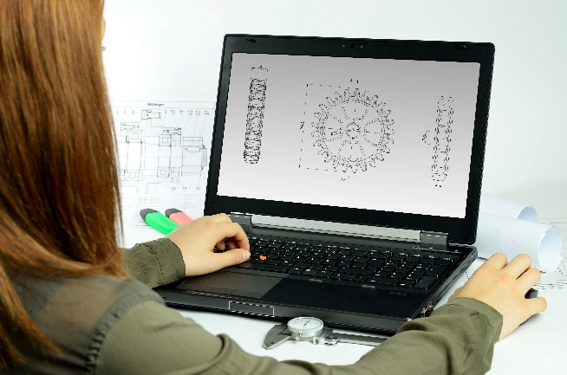
Incorporating the design process into the STEM modules will often result in the need for students to draw plans of their designs. This can be done at a simple level using hand-drawn sketches or at a more technical level using computer-aided design (CAD).
istockphoto.com
By developing skills using industry-standard software, students may be well-placed to explore future career pathways.
There are several CAD software options; two free examples are detailed below. Autodesk is a third package that is also free for educational use.
Tinkercad
- Format: Web-based app requiring internet access via a browser
- Purpose: A simple, online 3D design and 3D printing app
- Home: www.tinkercad.com
- Blog: blog.tinkercad.com
- Tutorials: www.tinkercad.com/learn
- Feature: Connects to 3D printing and laser cutting.
SketchUp
- Format: Can be downloaded and installed on devices, or used in a browser
- Purpose: Enables students to draw in 3D
- Home: www.sketchup.com 'Products' 'SketchUp for Schools'
- Help centre: help.sketchup.com/en
- Blog: blog.sketchup.com
- Tutorials: www.youtube.com/user/SketchUpVideo. From beginner tool tips to intermediate and advanced modelling techniques, the video tutorials help to build SketchUp skills.

Appendix 5: Student journal

When students reflect on learning and analyse their ideas and feelings, they self-evaluate, thereby improving their metacognitive skills.
This module encourages students to self-reflect and record the stages of their learning in a journal, which may take the form of a written journal, a portfolio or a digital portfolio.
istockphoto.com
Using digital portfolios can help develop students’ information and communication technology (ICT) capability.
Reflective practice and recording can be supported in classrooms by creating opportunities for students to think about and record their learning through notes, drawings or pictures. Teachers should encourage students to revisit earlier journal entries to help them observe the progress of their thoughts and understanding.
Journals are a useful tool that gives teachers additional insight into how students value their own learning and progress, as well as demonstrating their individual achievements.
The following links provide background information and useful apps for journaling.
Reflective journal (University of Technology Sydney)
www.uts.edu.au/sites/default/files/reflective_journal.pdf
Reflective writing (University of New South Wales Sydney))
student.unsw.edu.au/reflective-writing
Balancing the two faces of ePortfolios (Helen Barrett, 2009)
electronicportfolios.org/balance/Balancing.jpg
Digital portfolios for students (Cool tools for school)
cooltoolsforschool.wordpress.com/digital-student-portfolios
Kidblog – digital portfolios and blogging
kidblog.org/home
Evernote (a digital portfolio app)
evernote.com
Weebly for education (a drag and drop website builder)
education.weebly.com
Connect – the Department of Education’s integrated, online environment
connect.det.wa.edu.au

Appendix 6: Student activity sheet 1.0: Journal checklist

As an ongoing part of this module, you have been keeping a journal of your work.
Before submitting your journal to your teacher please ensure you have included the following information.
- Tick each box once complete and included.
- Write N/A for items that were not required in this module.
istockphoto.com

Your name and group member's names or photographs
An explanation of the problem you are solving
Your notes from Activity 1
Your notes from Activity 2
Your notes from Activity 3
Your notes from Activity 4
Student activity sheet 3.1: Case study
Student activity sheet 3.2: Prototype troubleshooting
Student activity sheet 4.2: Self-evaluation
Student activity sheet 4.3: Skills self-evaluation
Student activity sheet 1.0: Journal checklist

Appendix 7: Teacher resource sheet 1.1: Cooperative learning – Roles

Cooperative learning frameworks create opportunities for groups of students to work together, generally to a single purpose.
As well as having the potential to increase learning for all students involved, using these frameworks can help students develop personal and social capability.
When students are working in groups, positive interdependence can be fostered by assigning roles to group members.
istockphoto.com
These roles could include:
- Working roles such as Reader, Writer, Summariser, Timekeeper
- Social roles such as Encourager, Observer, Noise monitor, Energiser.
Further to this, specific roles can be delineated for specific activities that the group is completing. It can help students if some background to the purpose of group roles is made clear to them before they start, but at no time should the roles get in the way of the learning. Teachers should decide when or where roles are appropriate to given tasks.


istockphoto.com

Appendix 8: Teacher resource sheet 1.2: Cooperative learning – Think-pair-share
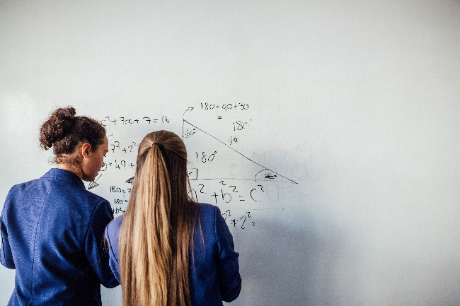
Cooperative learning frameworks create opportunities for groups of students to work together, generally to a single purpose.
As well as having the potential to increase learning for all students involved, using these frameworks can help students develop personal and social capability.
In the 'think' stage, each student thinks silently about a question asked by the teacher.
istockphoto.com
In the 'pair' stage, students discuss their thoughts and answers to the question in pairs.
In the 'share' stage, students share their answer, their partner’s answer or what they decided together. This sharing may be with other pairs or with the whole class. It is important also to let students 'pass'. This is a key element of making the strategy safe for students.

The think-pair-share strategy increases student participation and provides an environment for higher levels of thinking and questioning.

istockphoto.com

Appendix 9: Teacher resource sheet 2.1: Science Journal by Google
Recent advances in the availability of digital technology have changed the scientific landscape considerably, and it is now possible for anyone to conduct observation and measurement without the need for expensive or dedicated scientific tools.
Most average mobile phones and tablets typically feature a wide array of inbuilt sensors, such as accelerometers, gyroscopes, magnetometers, barometers, light sensors, sound sensors and touch sensors.
A multitude of free apps are available which allow users to access these sensors and use them for scientific observation and measurement.

Science Journal (sciencejournal.withgoogle.com/)
Science Journal is a completely free app developed by Google and available for both iOS and Android.
iOS (Apple App Store):
apps.apple.com/au/app/science-journal-by-google/id1251205555
Android (Google Play Store):
play.google.com/store/apps/details?id=com.google.android.apps.forscience.whistlepunk&hl=en_AU
With the Science Journal app, every mobile phone or tablet becomes a powerful tool for real-world science inquiry. Students can use the app to measure results of experiments, capture photos, write down predictions, observations or theories, and organise all of their research in an online digital scrapbook. The app also includes links to over 70 practical science activities developed by education experts.

Instructions on how to use Science Journal
When the app is opened for the first time on a new device:
Google Drive
When it is first opened, the app will ask if the user wishes to sign in to a Google account to use Google Drive. This is entirely optional, and no account is required to use the app. If you do not wish to sign in, simply tap Continue without signing in.
The Google Drive function allows experiments to be synced across devices so that that students can pick up a different device and continue where they left off. If students use the app without signing in, their work will only be stored on that device and students will need to always use the same device to access their work.
Permissions
When Science Journal is first opened, several pop-up windows will appear asking for permission to access the camera and the microphone.
Ensure that the user taps OK, otherwise the app will not be able to access all the device’s sensors. If Science Journal is installed on a class set of devices, bear in mind that these permissions will need to be confirmed separately on each device.
It may also be useful to change the sleep settings on the student’s mobile devices so that the screen does not switch off during experiments. This option can normally be changed in the device’s settings menu.
All images of Science Journal app ©2018 Google LLC, used with permission.
Google and the Google logo are registered trademarks of Google LLC.
How to use Science Journal for an experiment
Starting a new experiment
- Tap on the + icon in the lower right-hand corner of the screen.
- Start by giving the experiment a name. Tap the pencil in the top menu bar and type a name for the experiment.
- Choose a photo to use as the cover image for this experiment.

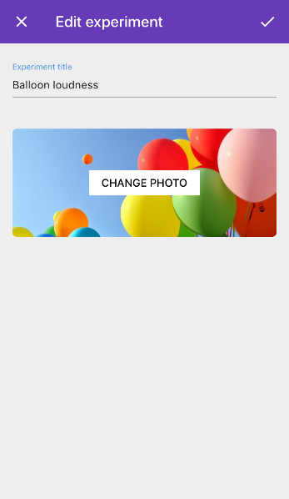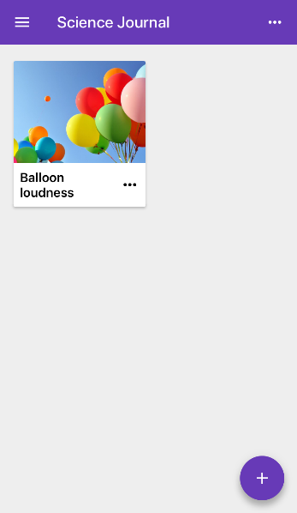
Adding items to an experiment
- The toolbox tray (shown in the bottom of the screenshot below) can be used to add different elements to an experiment.

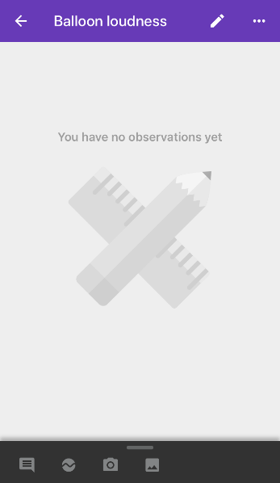
 | Observations
 | Sensor recordings
 | Camera
 | Photo gallery

The first icon is for adding text-based Observations but can also be used to add predictions or any other type of written note.

- Start the experiment by using the Observations icon to write down the research question. When an item is inserted into an experiment, notice that the date and time are also recorded.
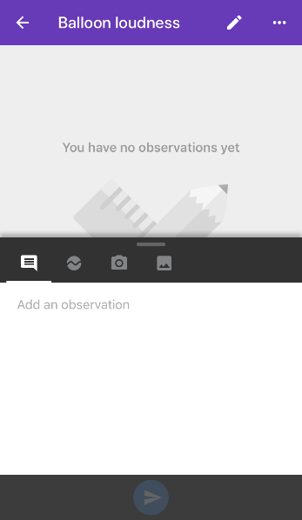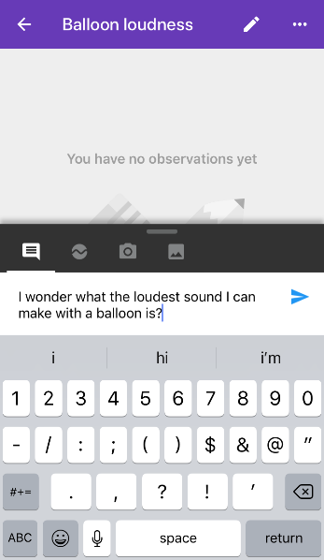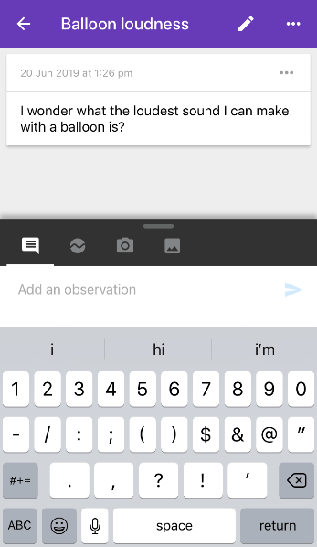
- Next, tap on the Sensor recordings icon. This will open the sensor panel showing a live reading from the default sensor, which is the Accelerometer.
- If using a phone, slide up the sensor panel so that it fills the whole screen and is easier to see.
- Hold the device in portrait mode and try moving the phone or tablet from left to right. The user should notice the sensor reading change to reflect the device’s acceleration.

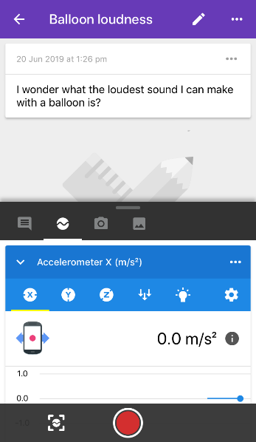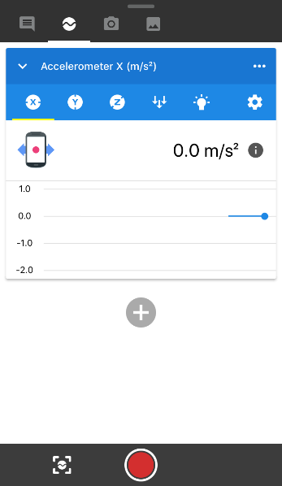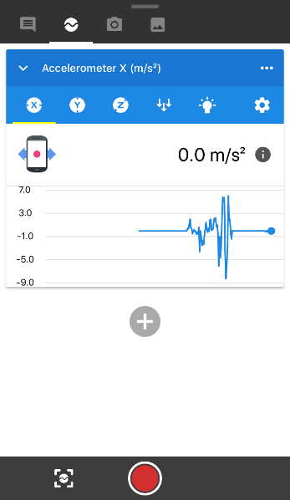
- Try experimenting with some of the other sensors and see what they measure.

Examples of sensors available in Science Journal
Note that available sensors may vary depending on what device is being used.
 | Sensor | What it measures
 | Accelerometer X (m/s²) | Acceleration in X direction
 | Accelerometer Y (m/s²) | Acceleration in Y direction
 | Accelerometer Z (m/s²) | Acceleration in Z direction
 | Barometer (hPa) | Atmospheric pressure
 | Brightness (EV) | Amount of light reaching front camera
 | Compass (degrees) | Orientation of phone to magnetic North
 | Linear accelerometer (m/s²) | Total acceleration (excluding gravity)
 | Magnetometer (µT) | Strength of ambient magnetic field
 | Pitch (Hz) | Frequency of sound reaching microphone
 | Sound intensity (dB) | Volume of sound reaching microphone

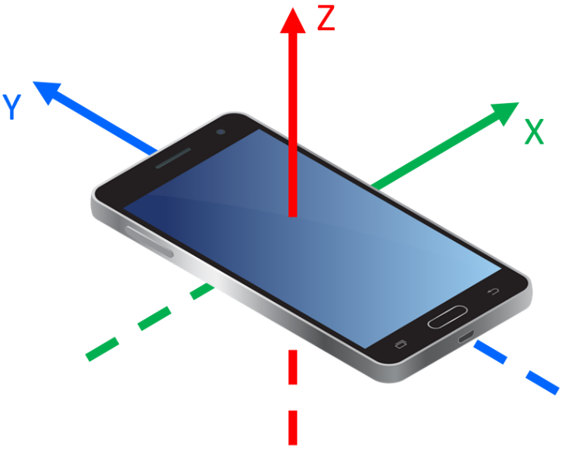
The accelerometer measures the movement of the device in three different directions.
STEM Consortium
When the device is held in portrait mode with the screen facing the user, the x-axis is from left to right and the y-axis is from bottom to top.
The z-axis is in the direction of the screen. When the device is lying flat and motionless on a surface, it will show a constant Z-axis acceleration of 9.8 m/s². This acceleration is due to Earth’s normal gravity.

Adding sensor recordings to the experiment
- Select the sound intensity sensor from the list of sensors. If a phone is being used, slide up the panel so that it fills the entire screen.
- The Sound intensity sensor uses the device’s microphone to display a live reading of how loud the environment is. Try making some noises to see how loud they are on the display.
- When ready to capture some data, press the red record button. The section of the graph that is being recorded will be shown in red.

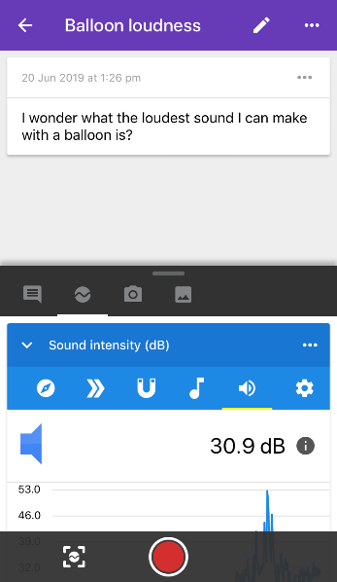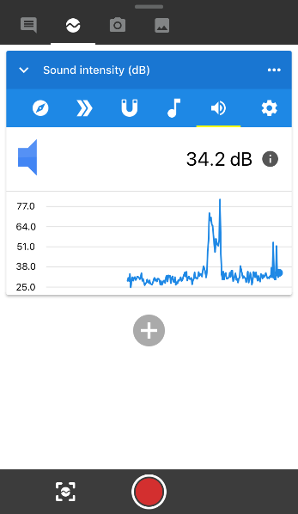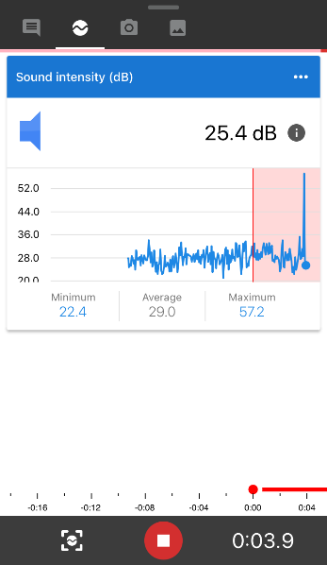
- When finished recording, press the red stop button. The section of graph that was recorded is added to the experiment below the first item.
- Tap on the three dots icon for the recording to view details, archive or delete the recording.

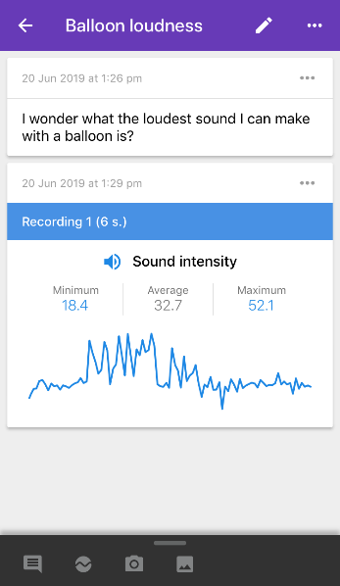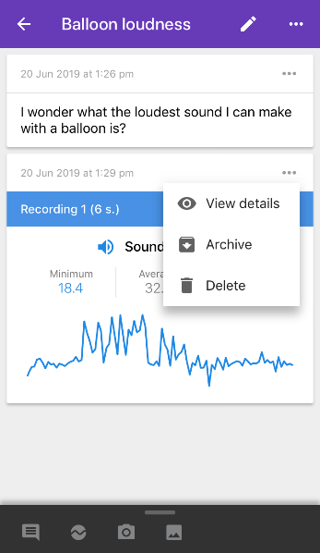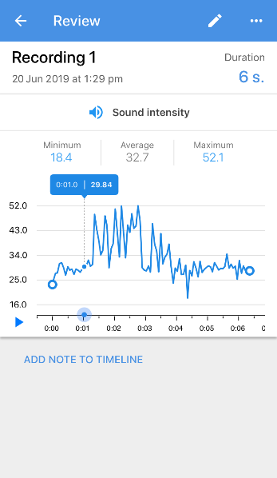
- From the view details screen, view the exact value of individual data points and add text notes to specific points on the timeline.
- Tap the three dots icon again on this screen, then tap share to export numerical data to other applications such as an Excel spreadsheet. Numerical data is exported in the form of a comma-separated variable file (.csv) which can be sent via email and shared with a range of applications.

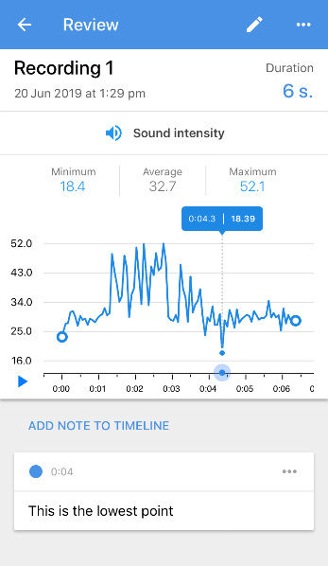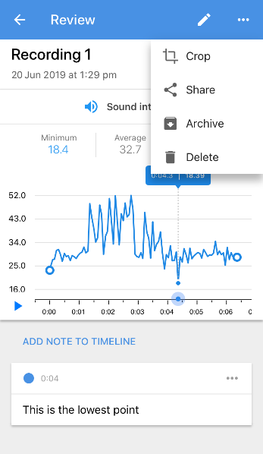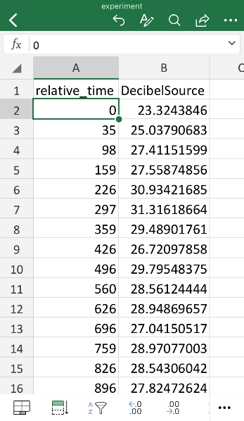
How to add a sensor snapshot to your experiment

- Instead of recording the graph of a sensor over a period, a single, instantaneous snapshot of a sensor reading could be taken. Add a snapshot of any sensor’s value by pressing the snapshot icon:
- Sensor snapshots can be renamed and deleted by tapping the three dots.
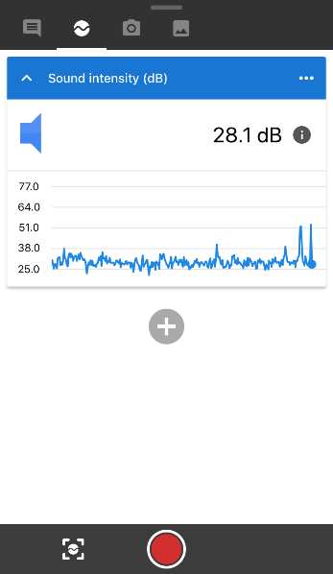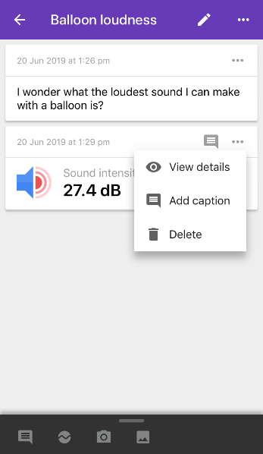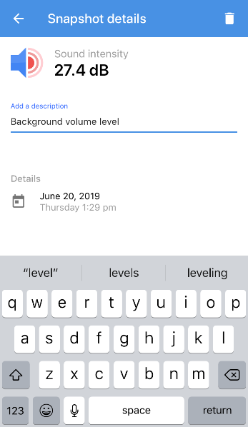

Getting more information about sensors
- While using any sensor, tap the info icon  to get more information about that sensor.

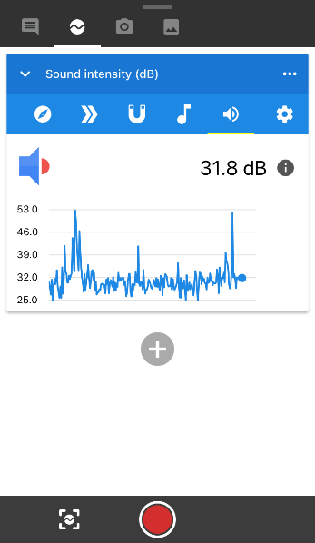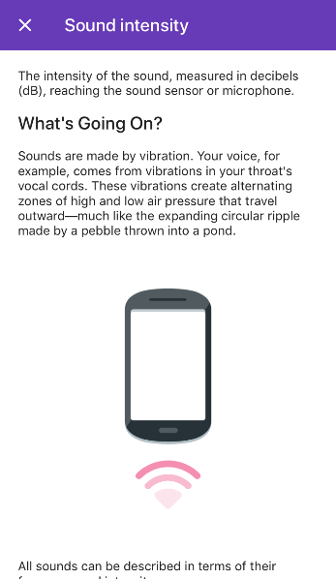
- The camera icon  and the photo gallery icon  can be used to take a new photo or add existing images to your experiment.
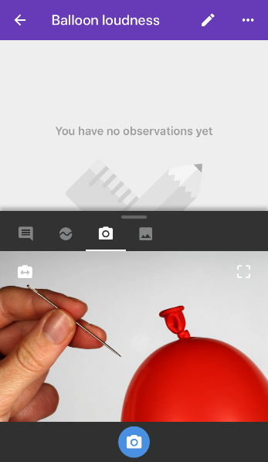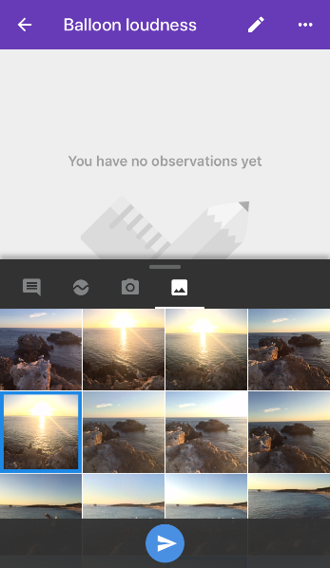

Next steps
A wide range of experiments are available at:
sciencejournal.withgoogle.com/experiments/
To add even more sensors, Science Journal also works with external sensor devices such as PocketLab: www.thepocketlab.com/

Alternatives to Science Journal
Science Journal by Google provides a simple and user-friendly interface for science measurement, but Science Journal is not the only app that can record data from a mobile device’s sensors. A range of other free apps offering similar functionality is available for both iOS and Android.
SPARKvue by PASCO Scientific:
- iOS (Apple App Store)
- Android (Google Play Store)
Vernier Graphical Analysis 4:
- iOS (Apple App Store)
- Android (Google Play Store)
Lab4Physics:
- iOS (Apple App Store)
- Android (Google Play Store)
External sensor devices
Science Journal can take measurements directly from a phone or tablet, but in some experiments, it may be impractical (or dangerous) to use a relatively large and expensive digital device such as an iPad to capture data. Students and educators looking to conduct more ambitious experiments may wish to consider external sensor devices.
PocketLab Voyager (https://www.thepocketlab.com/) is a tiny cube-shaped box measuring 4 cm by 4 cm by 2 cm which contains all the same sensors as a smartphone (plus many more). PocketLab is small and lightweight enough to be attached to a balloon, a model car or a rocket. PocketLab pairs with computers and mobile devices over Bluetooth and can also provide live sensor data to Science Journal, massively expanding the range of available sensors.

Appendix 10: Teacher resource sheet 2.2: Investigated variables option/extension
To encourage collaboration, facilitate small group discussions about the variables that could be investigated and how the investigation could be conducted.
As a class, an agreement will need to be reached on the independent, dependent and control variables, how to maintain consistent acceleration and how to record data.
Independent variables of the structures may be height, base area, surface area (ACMMG216), volume, mass, etc., or any combination of ratios (ACMNA208). If using the accelerometer available in Google Science Journal, the independent variable may be the maximum and minimum acceleration on the x (and/or y). Further potential examples of variables are shown in the table below.
Examples of possible independent and dependent variables:
Variable | Unit of measurement | Means of measurement
Height above floor | centimeter (cm) | Ruler
Area of base | square centimetre (cm²) | Ruler and calculations
Cross-sectional area (area of triangle formed by height and width of base (½×b×h)) | square centimetre (cm²) | Ruler and calculations
Volume | cubic centimetre (cm³) | Ruler and calculations
Height to base area ratio | fraction, decimal or percentage (%) | Ruler and calculations
Taper ratio (width halfway to top of structure vs width at base) | fraction, decimal or percentage (%) | Ruler and calculations
Mass | grams (g) | Balance
Time | seconds (s) | Timer/stopwatch/ Google Science Journal
Horizontal acceleration (aka peak ground acceleration) | metre per second squared (m/s²) | x and/or y accelerometer in Google Science Journal

Appendix 11: Student activity sheet 3.1: Case study
Where is the building located? Country, city, town?

Where is it relative to tectonic plate boundaries and fault lines?

When was the last earthquake in this area? What was the magnitude? The peak ground acceleration (PGA)? The resulting damage?

What is the expected seismic activity? (frequency, scale, etc.)

- What is the likelihood of a low magnitude earthquake occurring in the next 50 years (or other established time span)?

- What is the likelihood of a high magnitude earthquake occurring in the next 50 years (or other established time span)?

What is the purpose/function of the building? (house, school, warehouse, etc.)

How do the location and function impact its design?

How does your structure take seismic activity into account?

What are the criteria from which you based the design of your structure? Indicate on your sketch.
How does your building take seismic activity into account? Indicate on your sketch.

Sketch of your planned structure:

Appendix 12: Student activity sheet 3.2: Prototype troubleshooting
Problem | Cause | Possible changes to your design to solve the problem

Appendix 13: Teacher resource sheet 4.1: 3–2–1 Reflection
3–2–1 Reflection
Name | 3 things I learnt | 2 things I found interesting | 1 thing I found difficult

Appendix 14: Student activity sheet 4.2: Self-evaluation
pixabay.com
Digital tectonic reflection
Photograph or drawing
What did you make? | How do you feel about your solution?
 |   pixabay.com
What do you like about your solution? | What could you have done better?
pixabay.com | pixabay.com
What would you do differently?

pixabay.com

Appendix 15: Student activity sheet 4.3: Skills self-evaluation
 | Always | Usually | Sometimes | Rarely
Remains focused on tasks presented
Completes set tasks to best of their ability
Works independently without disrupting others
Uses time well
Cooperates effectively within the group
Contributes to group discussions
Shows respect and consideration for others
Uses appropriate conflict resolution skills
Comes to class prepared for activities
Actively seeks and uses feedback

Comments: __________________________________________________________________________________________________________________________________________________________________________________________________________________________________________________________________________________________________________________________________________________________

Notes
________________________________________________________________________________________________________________________________________________________________________________________________________________________________________________________________________________________________________________________________________________________________________________________________________________________________________________________________________________________________________________________________________________________________________________________________________________________________________________________________________________________________________________________________________________________________________________________________________________________________________________________________________________________________________________________________________________________________________________________________________________________________________________________________________________________________________________________________________________________________________________________________________________________________________________________________________________________________________________________________________________________________________________________________________________________________________________________________________________________________________________________________________________________________________________________________________________________________

