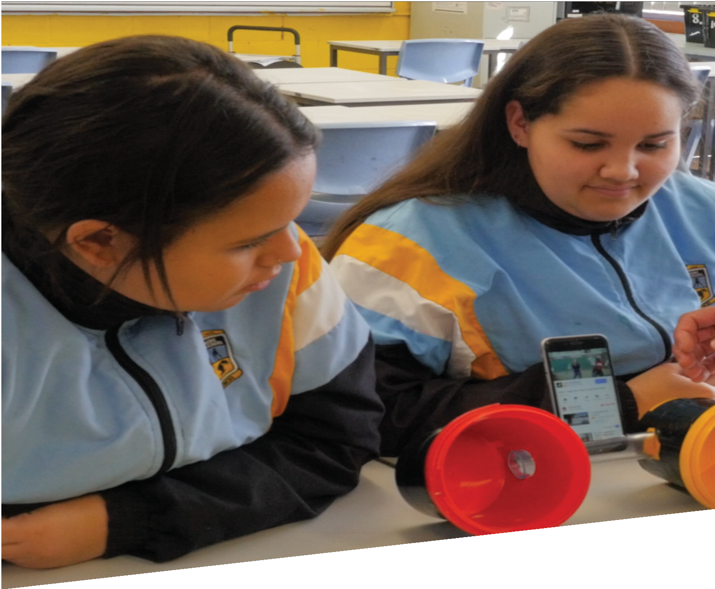


CURRICULUM RESOURCE MODULE
Amp up the volume
YEAR 9
Acknowledgements
The STEM Learning Project is funded by the Western Australian Department of Education (the Department) and implemented by a consortium in STEM education comprising the Educational Computing Association of WA, the Mathematical Association of WA, the Science Teachers Association of WA and Scitech.

We acknowledge and thank the teachers and schools who are the co-creators of these resources.
Copyright and intellectual property
The copyright and intellectual property of this module remain the property of the Department.

Any Western Australian Curriculum content in this resource is used with the permission of the School Curriculum and Standards Authority (the Authority); this permission does not constitute Authority endorsement of the resource. The Authority accepts no liability for any errors or damages arising from reliance on its content.

The Western Australian Curriculum content may be freely copied, or communicated on an intranet, for non-commercial purposes in educational institutions, provided that the Authority is acknowledged as the copyright owner. Copying or communication for any other purpose can be done only within the terms of the Copyright Act 1968 or with prior written permission of the Authority. Any Australian Curriculum content in the Western Australian Curriculum is used by the Authority under the terms of the Creative Commons Attribution-NonCommercial 3.0 Australia licence.

Any content on the www.scsa.wa.edu.au domain that has been derived from the Australian Curriculum may be used under the terms of Creative Commons Attribution-NonCommercial 3.0 Australia licence.

Appendix 2: General capabilities continuums is adapted from ACARA, © Australian Curriculum, Assessment and Reporting Authority (ACARA) 2009 to present, unless otherwise indicated. This material was downloaded from the ACARA website (www.acara.edu.au) (accessed December 2015) and was not modified. The material is licensed under CC BY 4.0 (https://creativecommons.org/licenses/by/4.0/). ACARA does not endorse any product that uses ACARA material or make any representations as to the quality of such products. Any product that uses material published on this website should not be taken to be affiliated with ACARA or have the sponsorship or approval of ACARA. It is up to each person to make their own assessment of the product.

This resource includes references and examples of iOS, Android and other apps. The Department does not endorse or recommend any commercial products and simply provides these as examples for teachers.

The Department is committed to providing quality information to its customers. Whilst every effort has been made to ensure accuracy, currency and reliability of the information within these documents, the Department accepts no responsibility for errors, omissions or amendments made since the time of publishing. Confirmation of information may be sought from the Department or the originating bodies providing the information. The Department has no control over the content of material published on websites to which users are referred in this resource. It is the responsibility of the internet user to make their own decision as to the relevancy, accuracy, currency and reliability of information found on those sites.

This resource contains various images from iStock and Pixabay used under license.

Attributions: Google Docs, Microsoft Excel, Survey Monkey, Kiblog, Weebly, Evernote, Autodesk, Tinkercad, SketchUp, Sound Meter, Spectrum Analyzer, Spectrum View, Decibel X, EQ Bars.


Table of contents
The STEM Learning Project 2
Overview 3
Activity sequence and purpose 6
Background 7
Activity 1: Sound amplification 10
Activity 2: Materials and shapes 17
Activity 3: Design and build 21
Activity 4: Sound test 27
Appendix 1: Links to the Western Australian Curriculum 32
Appendix 1B: Mathematics proficiency strands 34
Appendix 2: General capabilities continuums 35
Appendix 3: Materials list 38
Appendix 4: Design process guide 40
Appendix 4B: Drawing in the design process 41
Appendix 5: Student journal 42
Appendix 6: Student activity sheet 1.0: Journal checklist 43
Appendix 7: Teacher resource sheet 1.1: Cooperative learning – Roles 44
Appendix 8: Teacher resource sheet 1.2: Cooperative learning – Jigsaw 45
Appendix 9: Teacher resource sheet 1.3: Cooperative learning – Placemat 46
Appendix10: Teacher resource sheet 1.4: Cooperative learning – Think-pair-share 47
Appendix 11: Teacher resource sheet 2.1: Sound stations 48
Appendix 12: Teacher resource sheet 2.2: Amplifier review 57
Appendix 13: Student activity sheet 3.1: Model scale diagram 58
Appendix 14: Student activity sheet 3.2: Prototype troubleshooting 59
Appendix 15: Student activity sheet 4.1: Design review 60
Appendix 16: Student activity sheet 4.2: Peer evaluation 61
Appendix 17: Student activity sheet 4.3: Self-evaluation 62

The STEM Learning Project
The aim of the STEM Learning Project is to generate students’ interest, enjoyment and engagement with STEM (Science, Technology, Engineering and Mathematics) and to encourage their ongoing participation in STEM both at school and in subsequent careers. The curriculum resources will support teachers to implement and extend the Western Australian Curriculum and develop the general capabilities across Kindergarten to Year 12.
Why STEM?
A quality STEM education will develop the knowledge and intellectual skills to drive the innovation required to address global economic, social and environmental challenges.
STEM capability is the key to navigating the employment landscape changed by globalisation and digital disruption. Routine manual and cognitive jobs are in decline whilst non-routine cognitive jobs are growing strongly in Australia. Seventy-five per cent of the jobs in the emerging economy will require critical and creative thinking and problem-solving, supported by skills of collaboration, teamwork and literacy in mathematics, science and technology. This is what we call STEM capability. The vision is to respond to the challenges of today and tomorrow by preparing students for a world that requires multidisciplinary STEM thinking and capability.
The approach
STEM capabilities are developed when students are challenged to solve open-ended, real-world problems that engage students in the processes of the STEM disciplines.
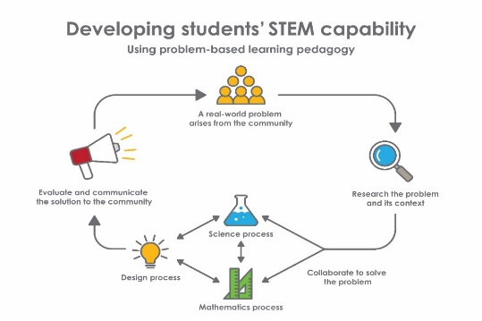
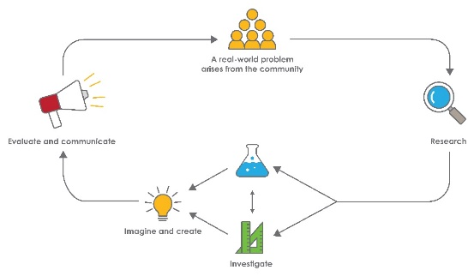
Year 9 – Amp up the volume
STEM Consortium

Overview
What is the context?
People like to share music and videos using their phones in different social situations. To do this, sound must often be amplified.
What is the problem?
How can we build a portable amplifier that passively amplifies the sound produced by our smartphones?
How does this module support integration of the STEM disciplines?
Using science, technology and mathematics to address a real-world problem, students draw on prior knowledge and learn new principles to collaboratively produce a solution.
Science
Students learn about the wave model and characteristics of sound and apply the principles of energy transfer (ACSSU182: Energy transfer through different mediums can be explained using wave and particle models) to the design of a passive amplifier. Students investigate variables affecting sound transfer and amplification through:
- Formulating questions and predicting (ACSIS164: Formulate questions or hypotheses that can be investigated scientifically)
- Planning and conducting investigations to collect reliable data (ACSIS165: Plan, select and use appropriate investigation types to collect reliable data)
- Using digital technologies (ACSIS166: Select and use appropriate equipment, including digital technologies, to collect and record data systematically and accurately)
- Analysing data to identify patterns and relationships between variables (ACSIS169: Analyse patterns and trends in data, including describing relationships between variables and identifying inconsistencies)
- Drawing on scientific principles to make conclusions consistent with the evidence (ACSAIS170: Use knowledge of scientific concepts to draw conclusions that are consistent with evidence).
Technology
Students design a passive amplifier that takes into consideration the ways in which materials and sound energy impact on amplification (ACTDEK043: The characteristics and properties of materials, combined with force, motion and energy, to create solutions). Students prepare a design brief based on specified
success criteria (WATPPS54: Identify and define the needs of a stakeholder, to create a brief, for a solution). They represent their design using appropriate technical terms and assess alternatives (WATPPS57: Design solutions assessing alternative designs against given criteria, using appropriate technical terms and technology).
Students make a prototype and present their solution, justifying the approach taken and the materials used (WATPPS55: Investigate a selection of components/resources to develop solution ideas, identifying and considering constraints). Students use their success criteria to evaluate their designs as well as their design process (WATPPS59: Evaluate design processes and solutions against student-developed criteria).
The Design process guide is included as a resource to help teachers understand the complete design process as developed in the Technologies syllabus.
Mathematics
Students apply index laws to numerical expressions with integer indices (ACMNA209: Apply index laws to numerical expressions with integer indices) and develop an understanding of the decibel scale. They calculate surface areas and volumes of cylinders and right prisms as they determine the quantity of each material required to construct their amplifier (ACMMG216: Calculate areas of composite shapes; ACMMG217: Calculate the surface area and volume of cylinders and solve related problems; and ACMMG218: Solve problems involving the surface area and volume of right prisms).
General capabilities
There are opportunities for the development of general capabilities and cross-curriculum priorities as students engage with Amp up the volume. In this module, students:
- Develop problem-solving skills as they research the problem and its context (Activity 1); investigate parameters impacting on the problem (Activity 2); imagine and develop solutions (Activity 3); and evaluate and communicate their solutions to an audience (Activity 4).
- Utilise creative thinking as they generate possible design solutions; and critical thinking, numeracy skills and ethical understanding as they choose between alternative approaches to solving the problem.
- Utilise personal and social capability as they develop socially cohesive and effective working teams; collaborate in generating solutions; adopt group roles; and reflect on their group work capabilities through sharing their ideas, responding to the suggestions of others and engaging in self and peer evaluation.

- Utilise a range of literacies and information and communication technologies (ICT) capabilities as they record their work in a journal; and present their solutions to an audience in Activity 4.
- Communicate and, using evidence, justify their group’s design to their peers.
What are the pedagogical principles of the STEM learning modules?
The STEM Learning Project modules develop STEM capabilities by challenging students to solve real-world problems set in authentic contexts. The problems engage students in the STEM disciplines and provide opportunities for developing higher order thinking and reasoning, and the general capabilities of creativity, critical thinking, communication and collaboration.
The design of the modules is based on four pedagogical principles:
- Problem-based learning
This is an underlying part of all modules with every module based around solving an initial problem. It is supported through a four-phase instructional model: research the problem and its context; investigate the parameters impacting on the problem; design and develop solutions to the problem; and evaluate and communicate solutions to an authentic audience.
- Developing higher order thinking

Opportunities are created for higher order thinking and reasoning through questioning and discourse that elicits students' thinking, prompts and scaffolds explanations, and requires students to justify their claims. Opportunities for making reasoning visible through discourse are highlighted in the modules with the icon shown here.
- Collaborative learning
This provides opportunities for students to develop teamwork and leadership skills, challenge each other’s ideas, and co-construct explanations and solutions. Information that can support teachers with aspects of collaborative learning is included in the resource sheets.
- Reflective practice
Recording observations, ideas and one’s reflections on the learning experiences in some form of journal fosters deeper engagement and metacognitive awareness of what is being learnt. Information that can support teachers with journaling is included in the resource sheets.
These pedagogical principles can be explored further in the STEM Learning Project online professional learning modules located in Connect Resources.

Activity sequence and purpose
 | Sound amplification  Students engage with the problem of passive sound amplification as they research amplifiers and measure sound levels.
 | Materials and shapes  Students investigate the nature of sound, its transmission, reflection and absorption by materials, and the effect of shape on amplification. Students use this information to formulate principles to guide the design of their passive amplifier.
 | Design and build  Using the principles of energy transfer and evidence from their investigations, students collaboratively design a passive amplifier, make a prototype, select materials and then create their passive amplifier.
 | Sound test  The class measures the sound amplification produced by each design, collecting and displaying data for evaluation. Groups present their amplifiers to the class and justify their design based on scientific principles and their reflections.

Background
Expected learning | Students will be able to:  - Describe the characteristics of sound waves, the reflection and absorption of sound and how the intensity of sound can be measured.  - Write decimal powers of ten using indices.  - Formulate a question and investigate the impact of a variable on the transfer or amplification of sound.  - Explain why particular digital technologies were used to accurately measure sound intensity and amplification, and to organise and display data.  - Analyse and interpret data and use scientific principles to draw conclusions consistent with the evidence.  - Research and imagine possibilities and frame the design of a passive amplifier considering shapes, materials and constraints.  - Consider viable options and create a design based on scientific principles that is represented in an annotated sketch.  - Calculate the surface area and volume of cylinders and prisms to compare sizes and draw conclusions about size and sound amplification.  - Document findings derived from the prototyping and use these to enhance the design.  10. Evaluate the final design using test data.
Vocabulary | The following vocabulary list contains terms that need to be understood, either before the module commences or developed as they are used:  absorption, amplitude, angle of incidence, bivariate, compression, computer-aided design (CAD), decibel, diffused, equilibrium, frequency, ideation, indices, Joules, loudness, micropascal, molecule, passive, pitch, prefix, prototype, rarefaction, reflected, refraction, resonate, sound wave.
Timing | There is no prescribed duration for this module. The module is designed to be flexible enough for teachers to adapt. Activities do not equate to lessons; one activity may require more than one lesson to implement.
Consumable materials | A Materials list is provided for this module. The list outlines materials outside of normal classroom equipment that will be needed to complete the activities.
Safety notes | There are potential hazards inherent in these activities and with the equipment being used, and a plan to mitigate any risks will be required.  Potential hazards specific to this module include but are not limited to:  - Possible exposure to cyber bullying, privacy violations and uninvited solicitations when using the internet  - Repeated exposure to sounds at or above 85 decibels or short-term exposure to extremely high noise levels (140 decibels)  - Cutting tools used to build the amplifiers.
Assessment | The STEM modules have been developed to provide students with learning experiences to solve authentic real-world problems using science, technology, engineering and mathematics capabilities. While working through the module, the following assessment opportunities will arise:  - Real numbers (ACMNA209) can be assessed in  Activity 1, Part 3 when analysing the decibel scale.  - The physics of sound (ACSSU182) can be assessed in Activities 2 and 4 where students justify their amplifiers with reference to sound waves (including the angle of incidence, the angle of reflection and sound absorption) and their data interpretation.  - A Student journal is to be used throughout the activities for students to reflect on their learning and justify their thinking. Journal entries from Activities 2 and 4 can be used to assess Science inquiry skills.  - Design and Technology and Digital Technologies content descriptions can be assessed through journal entries for Activities 3 and 4.  - This module will provide context for test items on Science understandings and Science inquiry skills.  Appendix 1 indicates how the activities are linked to the Western Australian Curriculum.  Evidence of learning from journaling, presentations and anecdotal notes from this module can contribute towards the larger body of evidence gathered throughout a teaching period and can be used to make on-balance  judgements about the quality of learning demonstrated by the students in the science, technologies and mathematics learning areas.  Students can further develop the general capabilities of Information and communication technology (ICT) capability, Critical and creative thinking and Personal and social capability. Continuums for these are included in the General capabilities continuums but are not intended to be for assessment purposes.

Activity 1: Sound amplification
  Activity focus | This activity is designed to capture students’ interest and familiarise them with examples of passive sound amplifiers that are suitable for use with smartphones
Background information | What are the characteristics of sound?  Sound is a form of energy made by vibrating objects. A vibrating object such as a loudspeaker or musical instrument causes small pressure changes in the surrounding air. This creates alternating patterns of compressions (high pressure) and rarefactions (low pressure). The compressions and rarefactions travel through the air away from the vibrating source.  Key points to remember are: sound is created by a vibrating source; the particles in the air around the source vibrate in the same direction as the wave travels (ie as a longitudinal wave); the particles of air vibrate and transfer the sound energy through the air as a wave.  The pitch of a sound is determined by the frequency of vibrations and loudness is determined by the amplitude of the vibrations. Amplitude is the distance from the equilibrium (rest) position of a particle to the point of its maximum displacement. Frequency refers to the number of complete waves that pass a given point per second.  Illustrations and simulations of sound characteristics can be viewed on the Sound is a Pressure wave and Sound webpages (see Digital resources).  How is sound transmitted and reflected?  A medium's ability to transfer sound energy is affected by the spacing of the particles, the speed at which the particles return to their original location when they are disturbed (elasticity) and temperature.  Compared to in air, sound waves travel about thirteen times faster in wood and about four times faster in water. They also travel faster on hotter days, as at higher temperatures the molecules have greater kinetic energy and consequently  collide with each other more frequently than when it is cooler.  When a sound wave reaches a solid surface, it can be reflected (mostly by smooth, hard surfaces), absorbed (more by rough and soft surfaces) or diffused (rough surfaces). The reflection of sound follows the Law of reflection which states that the angle of incidence equals the angle of reflection. Refer to the Reflection, Refraction, and Diffraction as well as the Reflection of Sound webpages for further information (see Digital resources).  What is loudness of sound and how is it measured?  The loudness of a sound is a subjective term describing the ear's perception of the intensity of a sound. Sound intensity depends on the frequency, amplitude and speed of a sound travelling through a particular medium. The perceived loudness depends on the ear's sensitivity to the particular frequencies contained in the sound. The ear's response to increasing sound intensity is a power-of-ten function (ie it is a logarithmic relationship).  A general rule-of-thumb is that the intensity must be increased by about a factor of ten for a sound to be twice as loud. This is why the loudness of sound is measured using the logarithmic decibel scale. On a usual linear scale, the intervals are constant (eg 0 to 10, 10 to 20, 20 to 30 and so on). A logarithmic scale is non-linear with the interval between values being a ratio (multiplier), often 10 (eg 0 to 10, 10 to 100, 100 to 1000 and so on). Logarithmic scales are used when there is a rapid increase in the range of values being measured (exponential change). Examples include the loudness of sounds, intensity of light, magnitude of earthquakes and pH of chemical solutions.  Intensity is the amount of energy per second passing through a square metre (cross-section) (ie Joules per second per square metre). Intensity of sound waves is proportional to the amplitude squared of the vibration. Further information can be found on the Loudness webpage (see Digital resources).  There are many free apps that can be downloaded (see Digital resources) that measure sound intensity in decibels. Other apps show the sound spectrum, that is, the intensity of the various wavelengths that comprise a sound. Complete suites of measurement tools are also available.  What is the difference between active and passive amplification of sound?  An electrical (active) amplification provides additional energy to the electrical signal that carries the wave information, thus increasing the signal’s amplitude. When this electrical signal is converted to sound energy by a speaker, the sound is louder.  Passive amplifiers do not use any additional energy. They use reflection of sound to direct more of the sound waves towards the listener to increase the loudness, as in an orchestral shell, or use surfaces that resonate and increase the number of air particles vibrating, as in the body of an acoustic guitar. Hard, smooth surfaces are best for reflecting sound and can be curved to give more control over the direction of the sound.  Resonance occurs when the frequency of the forced vibrations of an object matches the object’s natural frequency, producing a larger amplitude. For example, the body of an acoustic guitar and the column of air in a woodwind instrument resonate in response to the vibrating string or reed of the instrument thus making the sound louder.
Instructional procedures | The constraints of the project will need to be defined; the fewer the constraints, the greater the learning opportunities.  For example, students could:  - Use only free recycled materials  - Use only materials that need to be cut and shaped  - Use only materials already in the form of a 3D shape that can be modified safely and easily  - Use a 3D printer or other technologies.  Although many websites show homemade products for passive sound amplification (search ‘passive sound amplifier’), they typically do not provide the scientific or design principles on which the design is based.  In this module students work with surface area and volumes of three-dimensional shapes. The webpages listed in the Digital resources section can be used as a resource to develop these mathematical concepts: Geometric solids (3D shapes), Geometry 3-D Shapes Interactive, Basic geometry – Volume and surface area and High school geometry – Solid geometry.
Expected learning | Students will be able to:  - Identify the features of commercial passive amplifiers (Science, Technologies).  - Describe the characteristics of sound waves and the reflection and absorption of sound (Science).  - Explain the relationship between sound intensity, loudness and the decibel scale (Science, Mathematics).  - Identify possible 3D shapes for the design of their amplifier (Mathematics).  - Write decimal powers of ten using indices (Mathematics).
Equipment required | For the class:  Access to a computer, digital projector
Equipment required | For the students:  Individual student journal  Internet access or access to a resource library  Stationery items (eg pens, pencils, felt tip pens, rulers etc)  Student activity sheet 1.0: Journal checklist
Preparation | Decide on the design constraints.  Ensure students have access to digital devices for online research.
Activity parts | Part 1: Introduction  Introduce students to the problem: How can you build a portable amplifier that passively amplifies the sound produced by your smartphone?  Outline the constraints on their design and allow questions to clarify the task.  Explain that the design process will be documented using a student journal or digital portfolio (see Student journal for more information). Students start by recording the problem and constraints in their journal or digital portfolio.  Students work in groups for this activity. The recommended group size is four students and roles may be assigned to group members. Suggestions for group roles are provided in Teacher resource sheet 1.1: Cooperative learning – Roles.  In groups, students discuss the information they will need to create a solution to the problem and write their research questions in their journal under the heading – Questions to be researched.  Student questions could include:  - What is passive amplification?  - What passive amplifiers already exist for smartphones?  - What materials help amplify sounds?  - How does sound get louder?  - How do you measure the loudness of a sound?  - What shapes are used for the amplifiers? Geometric solids (3D shapes) in the Digital resources section can be used to review shapes.  Circulate between groups and prompt student thinking using questions such as:    - How do you make these shapes?  - What is a net and how is it relevant here?  - Do you know how to calculate surface area and volume for different shapes? The following three webpages, listed in the Digital resources section, can be used to review and practise using formulas: Geometry 3-D Shapes Interactive; Basic geometry – Volume and surface area; and High school geometry – Solid geometry.  Groups share their questions and list in their journal any relevant questions they may not have considered in their own group.
Activity parts | Part 2: Student research  In groups, students research the questions developed in  Part 1. Research findings and examples should be recorded either in their journals or using an online collaborative tool.  Provide students with short term goals and assist them to stay focused during their research by:  - Sharing the workload; a cooperative strategy could work well here, see Teacher resource sheet 1.1: Cooperative learning - Roles  - Informing students they will be asked to share one question and their answer with the class  - Suggesting they aim to find the answer to a set number of questions.
Activity parts | Part 3: The decibel scale  Introduce students to the science of sound and passive sound amplification, consolidating the measurement of loudness of sound using a decibel scale and the acoustic properties of materials.  Engage students in researching sound intensity and its measurement using the decibel and the micropascal scales. Refer students to the Loudness webpage (see Digital resources) to initiate research.  Students use their research to construct a digital infographic to represent their understanding of the decibel scale. This resource can be used to develop mathematical understandings of the decibel scale as a logarithmic scale, units of measurement, unit conversions, prefixes and indices.  Students develop three questions related to their infographic that can be used to review their classmates’ knowledge of the decibel scale. Questions should focus on the following mathematical concepts:  - Unit conversions (eg conversions between decibels and micropascals)  - Prefixes (eg conversions between bels and decibels, pascals and micropascals)  - The use of indices in the micropascal scale.  In a class discussion, students explore and reflect on their understanding of the science of sound. Focus questions can include:  - Why do people experience different loudness when listening to sounds of the same intensity?  - How are logarithms used to measure sound intensity?  - How can prefixes, indices and unit conversions make the decibel scale easier to interpret?  Provide time for student self-reflection and journaling. Students should record key information and ideas they consider important for creating a passive amplifier.  Distribute Student activity sheet 1.0: Journal checklist (one per student). Students should ensure all relevant activities on the list are included in their journal. Advise students that they need to submit their journal for feedback and assessment at the end of the module.
Resource sheets | Student journal  Student activity sheet 1.0: Journal checklist  Teacher resource sheet 1.1: Cooperative learning – Roles
Digital resources | Sound is a Pressure Wave (the Physics Classroom, 2019)  www.physicsclassroom.com/class/sound/u11l1c.cfm
Digital resources | Sound (Chris Woodford, 2016)  www.explainthatstuff.com/sound.html
Digital resources | Reflection, Refraction, and Diffraction (the Physics Classroom, 2019)  www.physicsclassroom.com/class/waves/Lesson-3/Reflection,-Refraction,-and-Diffraction
Digital resources | Reflection of Sound (CR Nave, HyperPhysics, 2017)  hyperphysics.phy-astr.gsu.edu/hbase/sound/reflec.html
Digital resources | Loudness (CR Nave, HyperPhysics, 2017)  hyperphysics.phy-astr.gsu.edu/hbase/sound/loud.html
Digital resources | Geometric solids (3D shapes)(Khan Academy, 2019)  www.khanacademy.org/math/basic-geo/basic-geometry-shapes#basic-geo-geometric-solids
Digital resources | Geometry 3-D Shapes Interactive (Annenberg Foundation, 2007)  www.learner.org/series/interactive-geometry-3d-shapes/
Digital resources | Basic geometry – Volume and surface area (Khan Academy, 2019)  www.khanacademy.org/math/basic-geo/basic-geo-volume-sa
Digital resources | High school geometry – Solid geometry (Khan Academy, 2019)  www.khanacademy.org/math/geometry/hs-geo-solids
Digital resources | Apps for measuring sound levels and sound spectrums  Android: Sound Meter, Spectrum Analyzer, Spectrum View  iOS: Decibel X, EQ Bars, Spectrum Analyzer

Activity 2: Materials and shapes
Activity focus   | This activity is designed to develop students' understanding of the principles of sound transfer, particularly those affecting passive amplification. Students use this information to formulate the design parameters for their passive amplifier.
Instructional procedures | With teacher direction, students collaboratively investigate sound transfer principles and the variables that may affect sound amplification. Teacher resource sheet 2.1: Sound stations illustrates how the eight sound station activities can be implemented as student-directed investigations to create opportunities for the development of both sound concepts and science inquiry skills. Alternatively, teachers may choose to implement these as teacher-directed student experiments or some as teacher demonstrations to reduce the organisational and cognitive complexity of the tasks. Teachers need to read this fully and prepare for the experiments that students may conduct.
Expected learning | Students will be able to:  - Formulate a question and investigate the impact of variables on the transfer or amplification of sound (Science).  - Explain why particular digital technologies were used to accurately measure sound intensity and amplification, and to organise and display data (Science, Technologies).  - Analyse and interpret data and use scientific principles to draw conclusions consistent with evidence (Science).
Equipment required | For the class:  Equipment for sound testing stations (see Materials list)
Equipment required | For the students:  Student journals or digital recording device
Preparation | Prior to the activity, source and prepare the materials required to conduct the sound station activities (see Materials list).  Prepare for the sound stations activity as detailed in Teacher resource sheet 2.1: Sound stations.  Download the apps suggested in the Digital resources for Activity 1.
Activity parts | Part 1: Introduction  In groups, students reflect on Activity 1 and share answers to the following questions with the class:  - What new information did you learn?  - What information have you identified that will assist with building a portable amplifier that passively amplifies the sound produced by a smartphone?  Explain to students that in this activity they will:  - Investigate the various principles of sound transfer  - Investigate aspects of sound amplification  - Learn about some science principles that will guide them in the design of a passive amplifier.
Part 2: Investigation
Students plan and conduct investigations to test variables affecting sound transfer. This will develop their understandings of the principles of sound transfer and provide an opportunity to develop inquiry skills.
The instructional procedures and lesson steps are outlined in Teacher resource sheet 2.1: Sound stations.
Part 3: Debrief
Lead a class discussion to confirm the findings from each sound station and determine what constitutes good experimental design.
Focus questions could include:
- What factors can help to amplify a sound?
- How do these factors affect sound amplification?
- What have you learnt that could be applied to designing a passive amplifier?
Ask students to use evidence to justify their claims (eg How do you know that? Why? …because…).
There will be opportunities in this discussion to review the manipulation and control of variables (eg Which variables did you change, measure and keep the same?).
Based on the class discussion, students update their findings from each sound station activity in their journal.
Part 4: Refining selection
Students review the examples of passive amplifiers they researched in Activity 1 and identify those they predict would be most effective. These should be clearly identified in their journals with comments about their expected effectiveness based on their knowledge of sound transfer.
An example of this is provided on Teacher resource sheet 2.2: Amplifier review.
Part 6: Forward-thinking
Based on students’ research and investigations, students record the sound principles they consider important to the design of their amplifier. This will be their starting point in Activity 3. Students should also consider how they would judge the effectiveness and utility of their amplifier and record these proposed success criteria in their journals.
Resource sheets | Materials list  Teacher resource sheet 2.1: Sound stations  Teacher resource sheet 2.2: Amplifier review
Digital resources | Reflection, refraction, and sound waves (BBC, 2019)  www.bbc.co.uk/bitesize/guides/zxk6v9q/revision/1
Digital resources | How brass instruments work – Al Cannon (TED-Ed, 2015)  youtu.be/IYHfiQ4R7Bs
Digital resources | How to make a hosepipe horn (Orchestra of the Age of Enlightenment, 2014)  youtu.be/SpP8uVR0JX4
Digital resources | Top 10 demonstrations with tuning forks (Arbor Scientific, 2013)  youtu.be/vNuDxc9tZMk
Digital resources | Breaking a wine glass using resonance (NeoK12, 2017)  www.neok12.com/video/Sound/zX030f42446f554e757b0777.htm
Digital resources | Amazing resonance experiment! (brusspup, 2013)  youtu.be/wvJAgrUBF4w
Digital resources | Resonance (the Physics Classroom, 2017)  www.physicsclassroom.com/class/sound/Lesson-5/Resonance
Digital resources | PVC Trombone by Kelsey Johnson (Fred & Karen Carrington, 2010)  youtu.be/8ShnfqoBGHo
Digital resources | Apps for measuring sound levels and sound spectrums  Android: Sound Meter, Spectrum Analyzer, Spectrum View  iOS: Decibel X, EQ Bars, Spectrum Analyzer

Activity 3: Design and build
  Activity focus | This activity engages students in the concepts and processes of ideation and prototyping.  Students use the knowledge gained from Activities 1 and 2 to design, build and refine a passive amplifier for a smartphone.
Background information | The design process is an important part of this activity. See Design process guide for further information.  What is ideation?  Ideation is the process of generating, developing and communicating new ideas and is an essential part of the design process. Ideation is used to describe the sequence of thoughts from generating an idea to implementation.  What is prototyping?  Prototyping is the process where a model is built to test a concept, process or idea. Sometimes a prototype is referred to as an early release, sample or beta version. There is an expectation that it will be further developed.  What are the reasons behind these processes?  Ideation and prototyping help people think through ideas and find problems early in the design process, helping to save time and money.
Expected learning | Students will be able to:  - Consider a range of options and create a design based on scientific principles that is documented as an annotated sketch (Technologies).  - Create a prototype (Technologies).  - Document findings from their evaluation of the prototype and use these to enhance the final design (Technologies).  - Calculate the surface area of 3D objects to estimate the quantity of material required for construction (Mathematics).  - Provide a clearly argued justification for their design that demonstrates an understanding of the design principles (Technologies, Science).
Equipment required | For the class:  Safety equipment (eg safety glasses, gloves)  Cutting boards
Equipment required | For the students:  Materials for the construction of amplifiers (see Materials list)  Student activity sheet 3.1: Model scale diagram  Student activity sheet 3.2: Prototype troubleshooting
Preparation | Ensure students have access to the required materials and equipment and understand any relevant safety procedures for using construction equipment.  Organise technical support, if required, to assist students with any specialised construction equipment.  Plan to provide support to students if they are using computer-aided design (CAD). Refer to Drawing in the design process for further information.
Activity parts | Part 1: Introduction  In groups, students use the following prompt questions to reflect on Activity 2 and share their answers with the class.  - What did you learn about the reflection of sound and resonance?  - What did you learn about materials and how they reflect or absorb sound?  - What principles have you developed to guide the design of your amplifier?  Explain to students that in this activity they will:  - Learn about the processes of ideation and prototyping  - Complete concept drawings of their amplifier  - Create a prototype utilising the design principles developed in Activities 1 and 2  - Select appropriate types and quantities of materials to build their amplifier  - Review safety procedures  - Construct the amplifier.
Activity parts | Part 2: Development of a design brief  Students develop a design brief for building a portable amplifier that passively amplifies the sound produced by a smartphone. The design brief should include:  - A statement of the problem  - A list of success criteria  - An outline of the design steps to be taken including evaluation and refinement.  Students document the design brief in their journal.  Review the design process with students, referring to the Design process guide.
Activity parts | Part 3: Ideation  As a class, watch the Science, Engineering and Design! and Prototyping and Model Making videos (see Digital resources) and discuss the definition and purpose of ideation and prototyping.  Students begin the ideation process in their groups. Their task is to design a passive amplifier for a smartphone and create a set of concept sketches based on the scientific principles identified in Activities 1 and 2.  Provide the following guidance to students:  - Use a pencil when making concept drawings so alterations can be made easily.  - Drawings do not have to be perfect; they are not being assessed on their artistic abilities.  - Write notes and label the drawings to explain the different features and materials selected, and to justify the design in terms of the scientific principles.  - Draw different points of view (eg views from the front, side and top).  Students could draw their ideas digitally using software such as Sketch Up or Tinkercad. Support for these can be found in the resource Drawing in the design process.  Allow time for students to brainstorm ideas, generate design options and complete their design sketch.  Monitor the groups’ progress and ask clarifying questions to prompt their thinking and problem-solving such as:    - What scientific principles will inform the design?  - What shapes and materials will you use?  - How will these shapes and materials enhance the functionality of the design?  - Have you provided enough information so that another person could work from your design and build a prototype?  - What components will a successful design include?  Once students have completed the design to a suitable standard they can begin prototyping.
Activity parts | Part 4: Construct the prototype  Ask students to refer to their journal notes on the scientific principles of sound and any concept drawings before they commence prototyping.  Provide students with the paper they will use to create their prototype (approximately ten sheets of A4 paper per group). Students could glue sheets of paper together to form more rigid sheets that can be folded into stronger shapes.  Students complete a scale drawing of their prototype as per Student activity sheet 3.1: Model scale diagram.  As students construct their prototype, they complete Student activity sheet 3.2: Prototype troubleshooting and insert it in their journal once their prototype is complete.
Activity parts | Part 5: Product development  In groups, students discuss any problems identified with their prototype and decide how they could be rectified.  Using their knowledge of sound from Activities 1 and 2, including sound reflection and absorption, sound waves and resonance students finalise the materials they will use for each part of their design. They calculate how much of each material is required using a two-dimensional net of their design.  This activity should be modified to suit the knowledge and skills of the class and resources available. Select from the following options:  - Option 1 – Students collect ready-made objects to construct their amplifier (eg cardboard tubes, plastic cups and food packet boxes).  - Option 2 – Students construct their amplifiers from two-dimensional materials. This option will require students to calculate the dimensions and quantities of the materials required.  - Option 3 – Students use appropriate CAD drawing and construction technologies (3D printer) to construct the model.
Activity parts | Part 6: Production  Students construct their amplifiers. Question students during the process:  - How are you constructing your amplifier? Why are you using that method?  - Are you able to follow your design or are you having to make changes? Why do you need to change your design?  - What problems are you having?  - How are you solving your problems?  Throughout the construction process, prompt students to take photos to document their progress. Students should include the photos in their journal or digital portfolio with an entry about their group's construction methods and their completed amplifier.
Activity parts | Part 7: Review progress and journaling  Evaluation, reflection and refinement are important parts of the design process.  Students reflect on the activity, recording their learning and thinking in their journals. The following questions are a guide for students to consider:  - Does the amplifier work?  - What would you do again? What would you not repeat? Why?  - Do you have any further recommendations for developing this idea?  - Do we need to discard this design altogether and start again?  - Which ideas could we use in a new design?  Groups choose which improvements they will implement and, if necessary, move back to the design phase (as in Part 3).
Resource sheets | Student activity sheet 3.1: Model scale diagram  Student activity sheet 3.2: Prototype troubleshooting  Design process guide  Drawing in the design process
Digital resources | Prototyping and Model Making – Students of Product Design Episode 5 (producttank, 2015)  youtu.be/gWk6br5Ngkc
Science, Engineering and Design! Video 4: Prototyping (MITK12Videos, 2013)
youtu.be/xglG_jGEvNQ

Activity 4: Sound test
  Activity focus | Students test, evaluate and present their smartphone amplifiers to the class.
Instructional procedures | Each group will prepare a presentation to share with the class. Tailor the timing and format of presentations to suit the class. Student groups will need time to practise their presentation.  The presentations provide a rich opportunity for assessing students’ understanding of the science, technology and mathematics principles and processes. This process also requires students to evaluate their design.  Students will need support and scaffolding to help them prepare for their presentation. They may need information about effective presentation skills such as voice clarity, projection, volume, pitch and tone.  To scaffold cooperative group work, each member of the group could have a role and responsibility. For example, one could be the content director, one the media director and a third the presentation director. All students would contribute to deciding on the content, preparing the media and giving the presentation while one student has overall responsibility for managing that phase of the task. See Teacher resource sheet 1.1: Cooperative learning – Roles.  To complete the design process students should will need time to make improvements to their work based on feedback received from the presentations. Time should be taken to discuss how to give constructive feedback and how to take feedback positively.

Expected learning | Students will be able to:  - Prepare a presentation and record journal entries that provide a clear justification for their design, demonstrating an understanding of the scientific principles (Technologies, Science).  - Use appropriate digital technologies to test the performance of amplifiers and collate and graph the data (Mathematics, Technologies).  - Evaluate the design using test data (Technologies).
Equipment required | For the class:  Data logging equipment and software that has been identified for student use (including smartphone apps).  An appropriate space to conduct student presentations and to test amplifiers (there is a need to minimise background noise when recording amplifier sound levels).
Equipment required | For the students:  Student journals or digital portfolios  Graph paper  Stationery items  Laptops, digital projector and screens  Student activity sheet 1.0: Journal checklist  Student activity sheet 4.1: Design review  Student activity sheet 4.2: Peer evaluation  Student activity sheet 4.3: Self-evaluation
Preparation | Provide students with access to activity sheets.  Prepare for the presentations.
Activity parts | Part 1: Evaluation and amplifier testing  Students discuss the effectiveness of their design with their group before demonstrating their amplifier to the class.  Students test the effectiveness of their amplifier. This involves groups setting up their amplifier, testing at determined distances from the amplifier, recording results and collaboratively collating data.  Prior to this, baseline data should be collected without amplification, with measurements taken at standard distances from the source. The background noise level should be controlled.  Results can be represented as a bivariate display with the distance from the amplifier (metres) as the independent variable and loudness (decibels) as the dependent variable. If the data from the testing of each amplifier is collated onto one graph, comparisons will be made more easily.  Digital tools such as Excel and Google docs can be used for tabulating and graphing class results.  Discuss the results with the students using the following focus questions:  - What is the advantage of obtaining quantitative data? (eg actual sound readings)  - How valid are your results? How do you know?  - Which variables could impact data collection or make the results unfair? How could we better control these variables?  - Which of the amplifiers was most effective? Why was it effective? Can you use science to explain its effectiveness?  - Which of the amplifiers was least effective? Why? Can you use science to explain why it is less effective?
Part 2: Presentation planning
In their groups, students decide on the content of their presentation by asking:
- What were we trying to achieve in our design?
- What decisions did we make as we developed our design?
- How did our science, technology and mathematics knowledge help us develop our design?
Presentations should focus on choices of shapes and materials, justifying any changes made during the construction process and reviewing sound test results.
Students decide on the media to be used for their presentation, such as:
- Talk using the model or a poster
- Speak to slides which include photos of the model
- ICT applications such as iMovie.
Assist students to plan and develop their presentations by asking the following questions:
- What headings will be most effective to represent your information?
- How can your explanations be summarised?
- How will relevant diagrams and photos be included to support your presentation?
- What features will make your visual presentation engaging to your audience?
- What parts of the presentation will need a detailed explanation?
- What presentation skills will help your oral presentation impact our audience?
- How can the workload be divided to ensure each group member contributes to the preparation and delivery of the presentation?
Provide a combination of class and homework time for the students to develop and review their presentations, drawing on a range of resources including any shared documents such as Google docs.
Part 3: The presentation
Groups present to the class or other appropriate audience.
Suggested timing for the presentations could include:
- Set up time (2 minutes)
- Presentation time (3 minutes)
- Test results (2 minutes)
- Recording in journals (3 minutes).
During the presentation process, selected students could complete Student activity sheet 4.2: Peer evaluation. It is suggested that students completing this evaluation be rotated.
Part 3: Reviewing designs
Groups discuss peer evaluations and make comparisons with other groups’ presentations to review their designs.
Students use their reflections from this activity and knowledge of variables affecting sound transfer from Activity 2 to complete Student activity sheet 4.1: Design review.
Part 4: Reflection and journaling
Students self-evaluate using Student activity sheet 4.3: Self-evaluation.
Debrief with the class by asking:
- Which scientific principles were most important to consider for the design of a passive amplifier? Why? …because…
- How well did your passive amplifier fit the success criteria?
- Which amplifier was most effective? Why?
- Which amplifier was most aesthetically pleasing? Why?
- Which amplifier was most practical to use? What features enhance usability?
Alternatively, students could be debriefed with a digital survey using an online tool such as Survey Monkey or Google Forms.
Provide time for students to document their reflections in their journals.
Resource sheets | Student activity sheet 1.0: Journal checklist  Student activity sheet 4.1: Design review  Student activity sheet 4.2: Peer evaluation  Student activity sheet 4.3: Self-evaluation

Appendix 1: Links to the Western Australian Curriculum
The Amp up the volume module provides opportunities for developing students’ knowledge and understandings in science, technologies and mathematics. The table below shows how this module aligns to the content of the Western Australian Curriculum and can be used by teachers for planning and monitoring.
AMP UP THE VOLUME  Links to the Western Australian Curriculum | ACTIVITY
 | 1 | 2 | 3 | 4
SCIENCE
SCIENCE UNDERSTANDING
Physical sciences: Energy transfer through different mediums can be explained using wave and particle models (ACSSU182) | ● | ● |  | ●
SCIENCE INQUIRY SKILLS
Questioning and predicting: Formulate questions or hypotheses that can be investigated scientifically (ACSIS164) |  | ● |  | ●
Planning and conducting: Plan, select and use appropriate investigation types to collect reliable data (ACSIS165) |  | ● |  | ●
Planning and conducting: Select and use appropriate equipment, including digital technologies, to collect and record data systematically and accurately (ACSIS166) |  | ● |  | ●
Processing and analysing: Analyse patterns and trends in data, including describing relationships between variables and identifying inconsistencies (ACSIS169) |  | ● |  | ●
Processing and analysing: Use knowledge of scientific concepts to draw conclusions that are consistent with evidence (ACSIS170) |  | ● | ● | ●
DESIGN AND TECHNOLOGIES
KNOWLEDGE AND UNDERSTANDING
Engineering principles and systems: The characteristics and properties of materials, combined with force, motion and energy, to create solutions (ACTDEK043) | ● | ● | ● | ●

AMP UP THE VOLUME  Links to the Western Australian Curriculum | ACTIVITY
DESIGN AND TECHNOLOGIES | 1 | 2 | 3 | 4
DESIGN AND TECHNOLOGIES
PROCESSES AND PRODUCTION SKILLS
Investigating and defining: Identify and define the needs of a stakeholder, to create a brief, for a solution (WATPPS54) |  |  | ● | ●
Investigating and defining: Investigate a selection of components/resources to develop solution ideas, identifying and considering constraints (WATPPS55) | ● | ●
Designing: Design solutions assessing alternative designs against given criteria, using appropriate technical terms and technology (WATPPS57) |  |  | ●
Evaluating: Evaluate design processes and solutions against student-developed criteria (WATPPS59) |  |  |  | ●
MATHEMATICS
NUMBER AND ALGEBRA
Real numbers: Apply index laws to numerical expressions with integer indices (ACMNA209) | ●
MEASUREMENT AND GEOMETRY
Units of measurement: Calculate areas of composite shapes (ACMMG216) | ● |  | ●
Units of measurement: Calculate the surface area and volume of cylinders and solve related problems (ACMMG217) | ● |  | ●
Units of measurement: Solve problems involving the surface area and volume of right prisms (ACMMG218) | ● |  | ●
Further information about assessment and reporting in the Western Australian Curriculum can be found at: k10outline.scsa.wa.edu.au/home.

Appendix 1B: Mathematics proficiency strands
Key ideas
In Mathematics, the key ideas are the proficiency strands of understanding, fluency, problem-solving and reasoning. The proficiency strands describe the actions in which students can engage when learning and using the content. While not all proficiency strands apply to every content description, they indicate the breadth of mathematical actions that teachers can emphasise.
Understanding
Students build a robust knowledge of adaptable and transferable mathematical concepts. They make connections between related concepts and progressively apply the familiar to develop new ideas. They develop an understanding of the relationship between the ‘why’ and the ‘how’ of mathematics. Students build understanding when they connect related ideas, when they represent concepts in different ways, when they identify commonalities and differences between aspects of content, when they describe their thinking mathematically and when they interpret mathematical information.
Fluency
Students develop skills in choosing appropriate procedures; carrying out procedures flexibly, accurately, efficiently and appropriately; and recalling factual knowledge and concepts readily. Students are fluent when they calculate answers efficiently, when they recognise robust ways of answering questions, when they choose appropriate methods and approximations, when they recall definitions and regularly use facts, and when they can manipulate expressions and equations to find solutions.
Problem-solving
Students develop the ability to make choices, interpret, formulate, model and investigate problem situations, and communicate solutions effectively. Students formulate and solve problems when they use mathematics to represent unfamiliar or meaningful situations, when they design investigations and plan their approaches, when they apply their existing strategies to seek solutions, and when they verify that their answers are reasonable.
Reasoning
Students develop an increasingly sophisticated capacity for logical thought and actions, such as analysing, proving, evaluating, explaining, inferring, justifying and generalising. Students are reasoning mathematically when they explain their thinking, when they deduce and justify strategies used and conclusions reached, when they adapt the known to the unknown, when they transfer learning from one context to another, when they prove that something is true or false, and when they compare and contrast related ideas and explain their choices.

Source: ACARA - www.australiancurriculum.edu.au/f-10-curriculum/mathematics/key-ideas/?searchTerm=key+ideas#dimension-content

Appendix 2: General capabilities continuums
The general capabilities continuums shown here are designed to enable teachers to understand the progression students should make with reference to each of the elements. There is no intention for them to be used for assessment.
Information and communication technology (ICT) capability learning continuum
Sub-element | Typically by the end of  Year 8 | Typically by the end of  Year 10
Create with ICT  Generate ideas, plans and processes | use appropriate ICT to collaboratively generate ideas and develop plans | select and use ICT to articulate ideas and concepts, and plan the development of complex solutions
Create with ICT  Generate solutions to challenges and learning area tasks | design and modify simple digital solutions, or multimodal creative outputs or data transformations for particular audiences and purposes following recognised conventions | design, modify and manage complex digital solutions, or multimodal creative outputs or data transformations for a range of audiences and purposes
Communicating with ICT  Collaborate, share and exchange | select and use appropriate ICT tools safely to lead groups in sharing and exchanging information, and taking part in online projects or active collaborations with appropriate global audiences | select and use a range of ICT tools efficiently and safely to share and exchange information, and to collaboratively and purposefully construct knowledge

Critical and creative thinking learning continuum
Sub-element | Typically by the end of  Year 8 | Typically by the end of  Year 10
Inquiring – identifying, exploring and organising information and ideas  Organise and process information | critically analyse information and evidence according to criteria such as validity and relevance | critically analyse independently sourced information to determine bias and reliability
Generating ideas, possibilities and actions  Imagine possibilities and connect ideas | draw parallels between known and new ideas to create new ways of achieving goals | create and connect complex ideas using imagery, analogies and symbolism
Generating ideas, possibilities and actions  Seek solutions and put ideas into action | predict possibilities, and identify and test consequences when seeking solutions and putting ideas into action | assess risks and explain contingencies, taking account of a range of perspectives, when seeking solutions and putting complex ideas into action
Reflecting on thinking and processes  Transfer knowledge into new contexts | justify reasons for decisions when transferring information to similar and different contexts | identify, plan and justify the transfer of knowledge to new contexts

Personal and social capability learning continuum
Sub-element | Typically by the end of  Year 8 | Typically by the end of  Year 10
Social management  Work collaboratively | assess the extent to which individual roles and responsibilities enhance group cohesion and the achievement of personal and group objectives | critique their ability to devise and enact strategies for working in diverse teams, drawing on the skills and contributions of team members to complete complex tasks
Social management  Negotiate and resolve conflict | assess the appropriateness of various conflict resolution strategies in a range of social and work-related situations | generate, apply and evaluate strategies such as active listening, mediation and negotiation to prevent and resolve interpersonal problems and conflicts
Social management  Develop leadership skills | plan school and community projects, applying effective problem-solving and team-building strategies, and making the most of available resources to achieve goals | propose, implement and monitor strategies to address needs prioritised at local, national, regional and global levels, and communicate these widely  discuss the concept of leadership and identify situations where it is appropriate to adopt this role
Further information about general capabilities is available at:
k10outline.scsa.wa.edu.au/home/p-10-curriculum/general-capabilities-over/general-capabilities-overview/general-capabilities-in-the-australian-curriculum

Appendix 3: Materials list
The following materials are required to complete this module. Materials for additional learning opportunities are identified.
General
- Protractor for drawing
- Card or paper and glue for prototypes
- Poster-sized card for presentations
- Device for recording sound levels (there are numerous smartphone apps that can do this)
Safety equipment for construction
- Safety glasses
- Gloves
- Cutting boards
Construction options
Further materials required for this module will vary depending on the option chosen for constructing passive amplifiers. Options and the required materials may include:
Option 1:
Students collect ready-made objects to construct their amplifier.
- Cardboard tubes
- Plastic cups
- Various boxes such as food packaging boxes
Option 2:
Students calculate the dimensions and quantities of material required to construct their amplifier from flat sheets of materials.
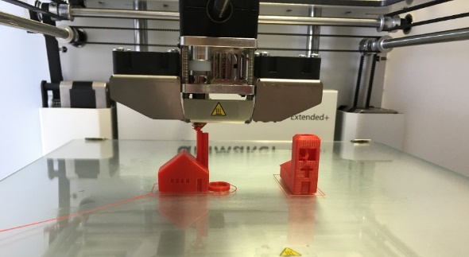
- Cardboard
- Plastic sheeting
- Sheets of paper (glued together)
- Corflute or similar
Option 3:
Students use a 3D printer to build the amplifier.
- 3D printer with software to link to CAD drawings
STEM Consortium
- Filament for the printer

Sound stations activity
Station 1:
- Range of open 3D shapes of similar volume (eg cube, rectangular prism, cylinder and cone) made from the same material (eg sheets of cardboard)
- Device as a sound source
- Device with an app to measure decibels
Station 2:
- A 3D object of three different sizes (cardboard boxes of similar proportion with a closed bottom and open top could be used)
- Device as a sound source
- Device with an app to measure decibels
Station 3:
- Three objects of the same size: one completely open at the top, one with holes to allow sound to ‘escape’ from the top, and one that can be closed once the source has been placed inside
- Device as a sound source
- Device with an app to measure decibels
Station 4:
- A cardboard box and three or more materials that can enclose the sound source. Materials could include bubble wrap, foam, carpet or a sheet of wood. Alternatively, the sound source could be wrapped or covered in the materials.
- Device as a sound source
- Device with an app to measure decibels
Station 5:
- Protractor
- A plastic tube about 50 cm long (eg reticulation pipe with diameter 25 mm to
50 mm)
- A cardboard tube about 50 cm long and 25 mm to 50 mm diameter
- Access to a hard and flat surface such as a concrete wall
Station 6:
- Sheets of A4 paper and A3 paper (these could be scrap paper)
- A roll of adhesive tape on a dispenser
- Device with an app to measure pitch
Station 7:
- Ruler
- A device with an app that records sound spectrums
Station 8:
- Carpet square or similar soft surface
- Desktop or similar hard surface that will resonate
- Tuning fork (if a mounted option is available this is simpler)

Appendix 4: Design process guide
Safe production of the final design or multiple copies of the final design.
Fine tuning the production process, such as division of labour for batch or mass production.
Use of intended materials and appropriate tools to safely make the solution to the design problem.
Reflection on the process taken and the success of the design.
Evaluation can lead to further development or improvement of the design and can be a final stage of the design process before a conclusion is reached.
Could be formal or informal and verbal or written.
Ideation
Development
Development of the design ideas. Improvements, refinements, adding detail, making it better.
Activities such as detailed drawings, modelling, prototyping, market research, gaining feedback from intended user, further research – if needed – to solve an issue with the design, testing different tools or equipment, trialling production processes, measuring or working out dimensions, testing of prototypes and further refinement.
Idea generation – turning ideas into tangible forms so they can be organised, ordered and communicated to others.
Activities such as brainstorming, mind mapping, sketching, drawing diagrams and plans, collecting colour samples and/or material samples and talking through these ideas can help to generate fu creative ideas.
Using the SCAMPER model can assist with this: www.mindtools.com/pages/article/newCT_02.htm
www.designorate.com/a-guide-to-the-scamper-technique-for- creative-thinking
Analysis
Finding useful and helpful information about the design problem.
Gathering information, conducting surveys, finding examples of existing solutions, testing properties of materials, practical testing.
Understanding the meaning of the research findings.
Analysing what the information means, summarising the surveys, judging the value of existing solutions, understanding test results.
Research
Production
Evaluation

Appendix 4B: Drawing in the design process
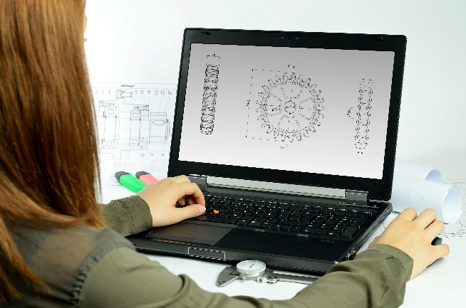
Incorporating the design process into the STEM modules will often result in the need for students to draw plans of their designs. This can be done at a simple level using hand-drawn sketches or at a more technical level using computer-aided design (CAD).
istockphoto.com
By developing skills using industry-standard software, students may be well-placed to explore future career pathways.
There are several CAD software options; two free examples are detailed below. Autodesk is a third package that is also free for educational use.
Tinkercad
- Format: Web-based app requiring internet access via a browser
- Purpose: A simple, online 3D design and 3D printing app
- Home: www.tinkercad.com
- Blog: blog.tinkercad.com
- Tutorials: www.tinkercad.com/learn
- Feature: Connects to 3D printing and laser cutting.
SketchUp
- Format: Can be downloaded and installed on devices, or used in a browser
- Purpose: Enables students to draw in 3D
- Home: www.sketchup.com 'Products' 'SketchUp for Schools'
- Help centre: help.sketchup.com/en
- Blog: blog.sketchup.com
- Tutorials: www.youtube.com/user/SketchUpVideo. From beginner tool tips to intermediate and advanced modelling techniques, the video tutorials help to build SketchUp skills.

Appendix 5: Student journal

When students reflect on learning and analyse their ideas and feelings, they self-evaluate, thereby improving their metacognitive skills.
This module encourages students to self-reflect and record the stages of their learning. This may take the form of a written journal, a portfolio or a digital portfolio.
istockphoto.com
Using digital portfolios can help develop students’ information and communication technology (ICT) capability.
Reflective practice and recording can be supported in classrooms by creating opportunities for students to think about and record their learning through notes, drawings or pictures. Teachers should encourage students to revisit earlier journal entries to help them observe the progress of their thoughts and understanding.
Journals are a useful tool that gives teachers additional insight into how students value their own learning and progress, as well as demonstrating their individual achievements.
The following links provide background information and useful apps for journaling.
Reflective journal (University of Technology Sydney)
www.uts.edu.au/sites/default/files/reflective_journal.pdf
Reflective writing (University of New South Wales Sydney))
student.unsw.edu.au/reflective-writing
Balancing the two faces of ePortfolios (Helen Barrett, 2009)
electronicportfolios.org/balance/Balancing.jpg
Digital portfolios for students (Cool tools for school)
cooltoolsforschool.wordpress.com/digital-student-portfolios
Kidblog – digital portfolios and blogging
kidblog.org/home
Evernote (a digital portfolio app)
evernote.com
Weebly for education (a drag and drop website builder)
education.weebly.com
Connect – the Department of Education’s integrated, online environment
connect.det.wa.edu.au

Appendix 6: Student activity sheet 1.0: Journal checklist

As an ongoing part of this module, you have been keeping a journal of your work.
Before submitting your journal to your teacher please ensure you have included the following information.
- Tick each box once complete and included.
- Write N/A for items that were not required in this module.
istockphoto.com

Your name and group member's names or photographs
An outline of the problem and the constraints on developing a solution as presented to the groups
Your notes from Activity 1
List of ‘research questions’ devised by you and the members of your group (completed in Activity 1)
Your notes from Activity 2
Notes from the Sound stations activity
Your notes from Activity 3
Student activity sheet 3.1: Model scale diagram
Student activity sheet 3.2: Prototype troubleshooting
Your notes from Activity 4
Student activity sheet 4.1: Design review
Student activity sheet 4.2: Peer evaluation
Student activity sheet 4.3: Self-evaluation
Record of results and graphing from the amplifier testing in Activity 4
Student activity sheet 1.0: Journal checklist

Appendix 7: Teacher resource sheet 1.1: Cooperative learning – Roles

Cooperative learning frameworks create opportunities for groups of students to work together, generally to a single purpose.
As well as having the potential to increase learning for all students involved, using these frameworks can help students develop personal and social capability.
When students are working in groups, positive interdependence can be fostered by assigning roles to group members.
istockphoto.com
These roles could include:
- Working roles such as Reader, Writer, Summariser, Timekeeper
- Social roles such as Encourager, Observer, Noise monitor, Energiser.
Further to this, specific roles can be delineated for specific activities that the group is completing. It can help students if some background to the purpose of group roles is made clear to them before they start, but at no time should the roles get in the way of the learning. Teachers should decide when or where roles are appropriate to given tasks.


istockphoto.com

Appendix 8: Teacher resource sheet 1.2: Cooperative learning – Jigsaw
Cooperative learning frameworks create opportunities for groups of students to work together, generally for a single purpose.
As well as having the potential to increase learning for all students involved, using these frameworks can help students develop personal and social capability.
The jigsaw strategy typically has each member of the group becoming an 'expert' on one or two aspects of a topic or question being investigated. Students start in their cooperative groups, then break away to form 'expert’ groups to investigate and learn about a specific aspect of a topic. After developing a sound level of understanding, students return to their cooperative groups and teach each other what they have learnt.
Within each expert group, issues such as how to teach the information to their group members are considered.

Step 1 | Cooperative groups  (of four students) | 1 2 3 4 |  | 1 2 3 4
Step 2 | Expert groups  (size equal to the number of groups) | 1 1 | 2 2 | 3 3 | 4 4
Step 3 | Cooperative groups  (of four students) | 1 2 3 4 |  | 1 2 3 4


Appendix 9: Teacher resource sheet 1.3: Cooperative learning – Placemat
Cooperative learning frameworks create opportunities for groups of students to work together, generally for a single purpose.
As well as having the potential to increase learning for all students involved, using these frameworks can help students develop personal and social capability.
The placemat strategy involves students working collaboratively to record prior knowledge about a common topic and brainstorm ideas. It also allows teachers to readily see the contribution of each student. The diagram below shows a typical placemat template.
istockphoto.com

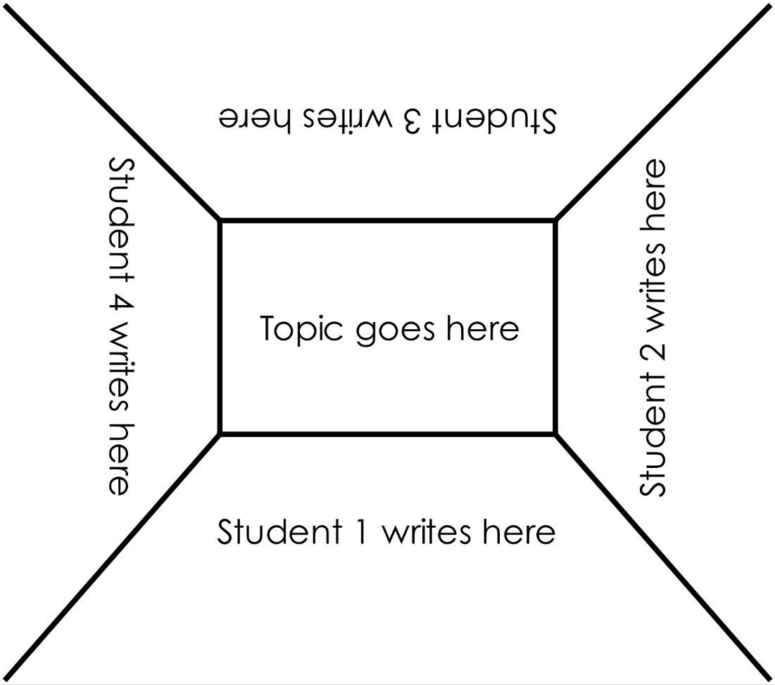

STEM Consortium

Appendix10: Teacher resource sheet 1.4: Cooperative learning – Think-pair-share
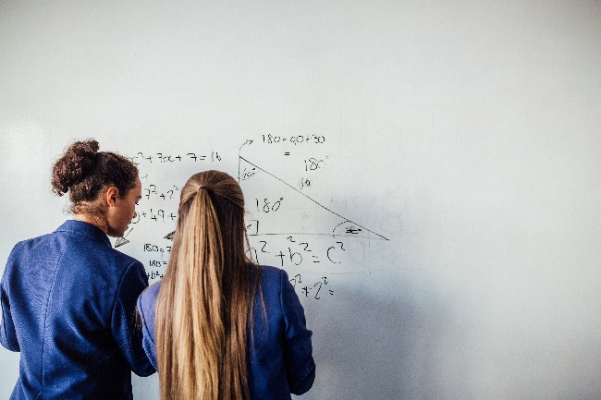
Cooperative learning frameworks create opportunities for groups of students to work together, generally to a single purpose.
As well as having the potential to increase learning for all students involved, using these frameworks can help students develop personal and social capability.
The think-pair-share strategy increases student participation and provides an environment for higher levels of thinking and questioning.
istockphoto.com
In the 'think' stage, each student thinks silently about a question asked by the teacher.
In the 'pair' stage, students discuss their thoughts and answers to the question in pairs.

In the 'share' stage, students share their answer, their partner’s answer or what they decided together. This sharing may be with other pairs or with the whole class. It is important also to let students 'pass'. This is a key element of making the strategy safe for students.
istockphoto.com

Appendix 11: Teacher resource sheet 2.1: Sound stations
Introduction
The sound stations activity is designed with two learning focuses:
- Developing students’ understanding of the principles of sound transfer
- Planning and conducting an investigation to test variables affecting sound transfer.
Eight experiments are to be conducted, each investigating one variable affecting sound transfer. Although each of the experiments investigates the effect of one independent variable on sound transfer and amplification, it is acknowledged that it is difficult to control all other variables.
These experiments will require students to use one device as a sound source and another to record sound levels using a suitable sound meter app. A more complex app can be used for some activities to capture and visualise the frequencies of sounds. These should be downloaded prior to the lesson. Refer to suggested apps in the Digital resources section.
Lesson steps
- Discuss the variables that should be considered in the manufacture of passive amplifiers. Using student contributions decide on the eight variables to investigate as detailed in the Experiment notes that follow.
- Allocate students into eight groups. Each group will focus on one of the variables being investigated.
- Provide time for groups to formulate a question for their experiment and outline how they will manipulate and control variables to make it a fair test. Prompt students to conduct repeat trials and to document their question, procedure and findings in their journals. Students should consider how they will collect baseline sound levels from their sound source if they wish to calculate the degree of amplification. For example, they could hold their sound source in the air at a standard distance from the sound measuring device to collect baseline sound levels. The ambient noise in the classroom will need to be controlled.
- Allow each group to briefly present their experiment design and follow with a class discussion that improves the design so that the final experiment is scientifically sound. The Experiment notes are provided as exemplars of the experiments.
- Each group then sets up and conducts their experiment as designed, recording their findings in their journal for sharing with the class at the debrief. Their notes will need to be detailed enough to enable them to outline their procedure and explain their results.

- Remind students they should aim to record:
- Their investigation question and prediction
- Their procedure
- Their observations
- Their conclusions
- How the results will influence the design of their amplifier.
- After the completion of the experiments, a debrief is held for groups to share results.
Experiment notes
These Experiment notes are provided as exemplars to support teachers. They outline the necessary equipment, a possible procedure and the expected findings.
Station 1: Shape
Aim
To investigate how the shape of an object affects sound amplification.
Equipment
- Variety of open 3D shapes of similar volume (eg cube, rectangular prism, cylinder and cone) made from the same material (eg sheets of cardboard)
- Device as a sound source
- Device with an app to measure decibels
Procedure
Different shapes are used to amplify sound by playing music at the closed end of the shape, and then measuring the sound volume with a second device placed at the open end of the shape. The volume and distance between the sound source and measuring device will need to remain constant to make it a fair test.
Prompts for student thinking
- What difficulties did you have in obtaining reliable measurements? How can you improve this?
- How does the baseline measure of loudness differ from the measurements made using the various shapes?
- How would the reflection of sound within the shape affect loudness as measured by the app?
Expected findings
Placing a sound source within an open three-dimensional shape will cause sound waves to reflect from the sides of the shape and direct the sound towards the listener. When a sound source is placed on a flat surface, the sound would normally be projected over an arc of 180°. When placed at the foot of a cone, for example, the spread of the sound would be constrained by the sides of the cone to an arc of 20° so that the intensity of sound reaching the ear would be higher than when the source is placed on a flat surface.
Station 2: Size
Aim
To investigate how the size of an object affects sound amplification.
Equipment
- Three 3D objects of the same shape but different sizes with a closed bottom and open top (eg cardboard boxes of similar shape)
- Device as a sound source
- Device with an app to measure decibels
Procedure
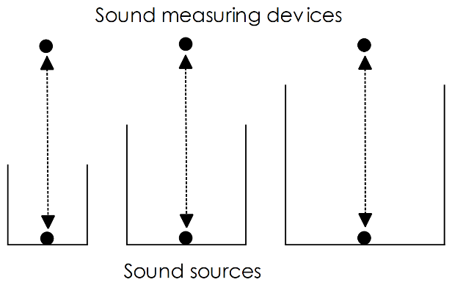
Different sized objects are used to investigate whether size affects the amplification of sound. The sound source is placed inside and on the bottom of the object, and the sound level is measured at a standard height from the sound source. The shape of the object, the sound level at the sound source, and the distance between the sound source and the measuring device are controlled variables while the size of the box is varied.
STEM Consortium
Prompts for student thinking
- What difficulties did you have in obtaining reliable measurements? How could you improve this?
- Does the measure of loudness vary with the size of the objects? Would you expect it to vary? Why?
- Explain how the reflection of sound within the shapes affects loudness as measured by the app.
Expected findings
The sides of the box will reflect sound waves, thus potentially directing more sound energy towards the listener; hence, the box size should theoretically have an impact on loudness. However, it is possible that the impact will not be measurable with the type of device being used.

Station 3: Open or closed
Aim
To investigate the effect of open and closed objects on sound amplification.
Equipment
- Three objects of the same shape and size: one completely open at the top, one with holes to allow sound to ‘escape’ from the top, and one that can be closed once the sound source has been placed inside.
- Device as a sound source
- Device with an app to measure decibels
Procedure
The sound source is placed inside, on the bottom of the object, and the sound level is measured at a standard height from the top of each object. The size of the objects, the distance between the sound source and the measuring device, and the sound level of the sound played inside the object are variables that need to remain constant.
Prompts for student thinking
- What difficulties did you have in obtaining reliable measurements? How could you improve this?
- How did the measure of loudness vary with the type of object? Would you expect it to vary by much? Why?
- How would you explain the differences?
Expected findings
Sound can travel through any medium including air and solids such as cardboard. The open object and the object with holes will allow sound waves to travel out of the object to the device measuring sound levels. Some of the sound waves will be reflected or absorbed by the object. The closed object will cause the sound waves to be internally reflected and the walls of the object to vibrate creating rarefactions and compressions in the surrounding air so that some waves in the air will reach the measuring device. However, much of the sound energy is likely to be absorbed by the object.

Station 4: Sound absorption
Aim
To investigate the sound absorption properties of different materials.
Equipment
- Three or more different materials that can enclose the sound source. Materials could include bubble wrap, foam, carpet or a sheet of wood.
- Device as a sound source
- Device with an app to measure decibels
Procedure
A sound source is covered with a sheet of material. The sound level is measured at a standard distance from the source. The distance between the sound source and the measuring device, and the sound level of the sound being played are variables that need to remain constant. Each material is tested using the same procedure to determine which materials absorb the most or least sound.
Prompts for student thinking
- What difficulties did you have in obtaining reliable measurements? How can you improve this?
- How does the loudness vary with the type of material used to cover the sound source? Did you expect it to vary by much? Why or why not?
- Where does the sound energy go when absorbed by the test material? Would the energy be transferred, transformed or does it just disappear? Explain.
Expected findings
Softer, rougher and thicker materials tend to absorb more sound than hard, smooth and thin materials. Materials with loosely woven fibres are very effective sound absorbers. The sound waves set the fibres of the material in motion and they transform sound energy into kinetic and heat energy.

Station 5: Reflection of sound
Aim
To investigate the reflection of sound.
Equipment
- Protractor
- A plastic tube not previously used by other students about 50 cm long (eg reticulation pipe with a diameter between 25 mm and 50 mm)
- A cardboard tube about 50 cm long and 25 mm to 50 mm in diameter
- Access to a hard, flat surface such as a concrete wall or floor
Procedure
One student speaks at a normal level into a plastic tube directed at a flat hard surface and a second student listens with a cardboard tube held to an ear. This student has to ‘catch’ the sound reflected off the surface. A third student could estimate and note the angles of incidence and reflection as the sound waves leave the source and may reflect off the inner walls of the amplifier. Reflection, refraction, and sound waves (see Digital resources), can be used to assist with drawing a labelled sound wave diagram for this station.
Safety note
The plastic tube the students speak through must be sterile. Each student will use an unused plastic tube.
Prompts for student thinking
- What difficulties did you have in obtaining reliable measurements? How can you improve this?
- What did you expect the relationship between the two angles to be? Why?
- Was your prediction confirmed?
- Explain how a sound shell (as shown here) works using what you have learnt about the reflection of sound.

Expected findings
When sound is reflected off hard, flat surfaces the angles of incidence and reflection are equal. This principle is utilised when designing passive amplifiers such as orchestral shells and megaphones. These work by directing more sound waves to the listener than would occur without reflection.
Digital resources
Reflection, refraction, and sound waves (BBC, 2019)
pixabay.com
www.bbc.co.uk/bitesize/guides/zxk6v9q/revision/1

Station 6: Air column length
Aim
To investigate the effect of air column length on sound quality.
Equipment
- Sheets of A4 paper and A3 paper
- A roll of adhesive tape on a dispenser
- Device with an app to measure pitch
Procedure
A sheet of A4 paper and a sheet of A3 paper are rolled lengthwise to form tubes of the same diameter and different lengths. Sounds are created by blowing into the tubes with vibrating lips. The pitch of the sound is captured using a device with an app such as SpectrumView which shows the range of sound frequencies generated.
Safety note
Each paper tube must only be used by one student.
Prompts for student thinking
- What difficulties did you have in obtaining reliable measurements? How could you improve this?
- What did you observe about the pitch of sounds produced by tubes of different length? What factors do you think affected the quality of the sound?
Expected findings
The shorter the tube of resonating air, the higher the frequency and pitch of the sounds (eg piccolo, flute, bassoon).

Digital resources
These video clips show how the air column lengths of different brass instruments affect the quality of sound:
How brass instruments work – Al Cannon (TED-Ed, 2015)
youtu.be/IYHfiQ4R7Bs
How to make a hosepipe horn (Orchestra of the Age of Enlightenment, 2014)
youtu.be/SpP8uVR0JX4

Station 7: Frequency of vibration
Aim
To investigate the effect of frequency of vibration on the pitch of the sound.
Equipment
- Flexible ruler
- A device with an app that records sound spectra
Procedure
A ruler is held onto a desk with part of its length hanging out over the edge of the desk. The end is given a flick causing the ruler to vibrate. When vibrating, the ruler is moved backwards, and forwards so more or less protrudes over the edge. The frequency of vibration of the ruler and the pitch (frequency) of the sound produced is observed. This can be captured and visualised on a suitable app.
Prompts for student thinking
- What difficulties did you have in getting reliable (repeatable) data? How could you improve this?
- What did you discover about the relationships between ruler length, frequency of vibration and the pitch of sound?
- How did the sound created by the vibrating ruler reach your ear or smartphone?
Expected findings
As the length of the ruler extending over the edge of the desk increases, the frequency of vibration slows and the pitch of the sound falls.

Station 8: Resonance
Aim
To investigate how resonance affects sound amplification.
Equipment
- Carpet square or similar soft surface
- Desktop or similar hard surface that will resonate
- Tuning fork (preferably a mounted option)
Procedure
The stem of a vibrating tuning fork is placed against a flat hard surface, such as the top of a desk. This is repeated on a soft surface such as a carpet square, and students can observe and explain what happens.
Prompts for student thinking
- What difficulties did you have in obtaining reliable measurements? How could you improve this?
- Compare the sounds produced on the two surfaces.
- From your understanding of resonance explain your observations.
- Describe how the amount of sound energy reaching your ear differs under these two conditions.
Expected findings
When placed on a hard surface, the vibrations of the tuning fork cause the surface to vibrate, which in turn creates sound waves in the air that is in contact with the surface. The amplification is greatest when the frequency of the tuning fork matches the natural frequency at which the surface vibrates. For example, the body of a guitar is made of a particular type of wood and dimensions so that it freely vibrates when the guitar strings are plucked. On the soft surface, the sound is dampened as sound energy causes fibres in the material to move and the sound energy is transformed into kinetic and heat energy.
The following digital resources provide examples of resonance.
Top 10 demonstrations with tuning forks (Arbor Scientific, 2013)
youtu.be/vNuDxc9tZMk
Breaking a wine glass using resonance (NeoK12, 2017)
www.neok12.com/video/Sound/zX030f42446f554e757b0777.htm
Amazing resonance experiment! (brusspup, 2013)
youtu.be/wvJAgrUBF4w
Resonance (the Physics Classroom, 2017)
www.physicsclassroom.com/class/sound/Lesson-5/Resonance
PVC Trombone by Kelsey Johnson (Fred & Karen Carrington, 2010)
youtu.be/8ShnfqoBGHo

Appendix 12: Teacher resource sheet 2.2: Amplifier review
Rank 3: Although this is made of hard plastic which will reflect sound well, the sound has to bounce around corners which might result in poor sound quality. I like it because I think it would be cheap to make and looks cool. I don’t like the set of speaker openings at the top because I think they would be unnecessary as most of the sound would escape through the bottom openings.
3
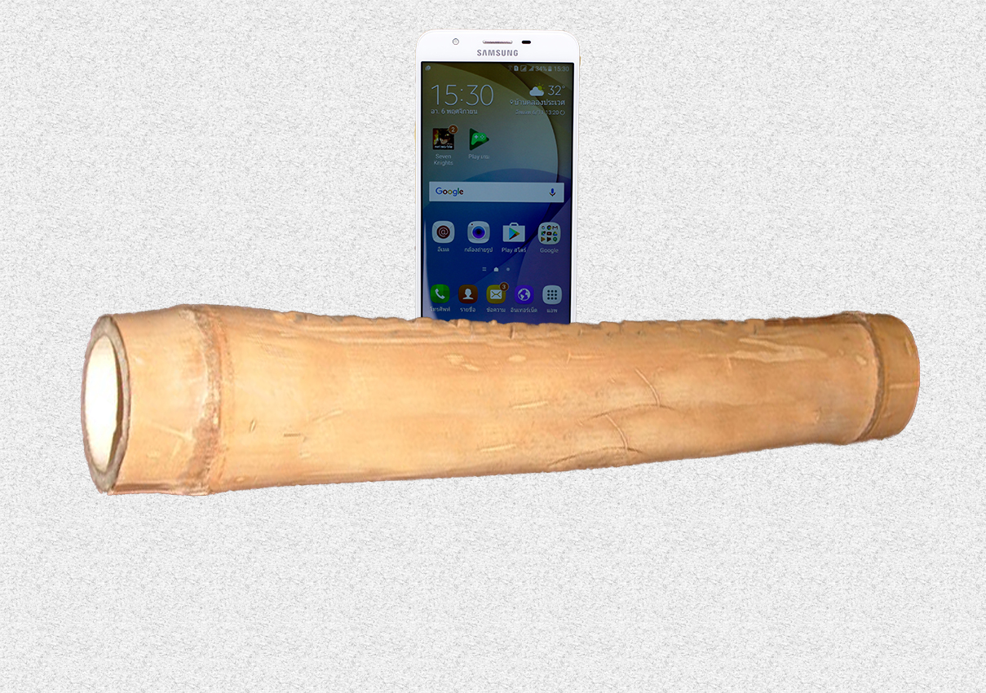
1
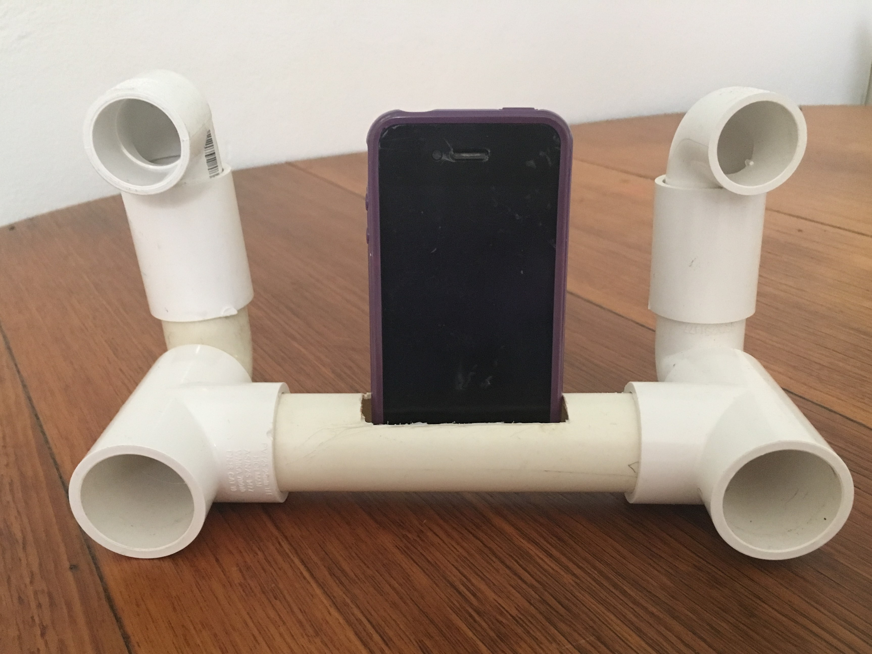
←

↑
I gave this amplifier a ranking of 1 because it is made of a hard substance and will reflect sound well. I like that is it made of natural wood and is a very simple design. I also like the fact it would be easy to transport. I don’t like the colour the amplifier comes in, it isn’t very exciting.
2
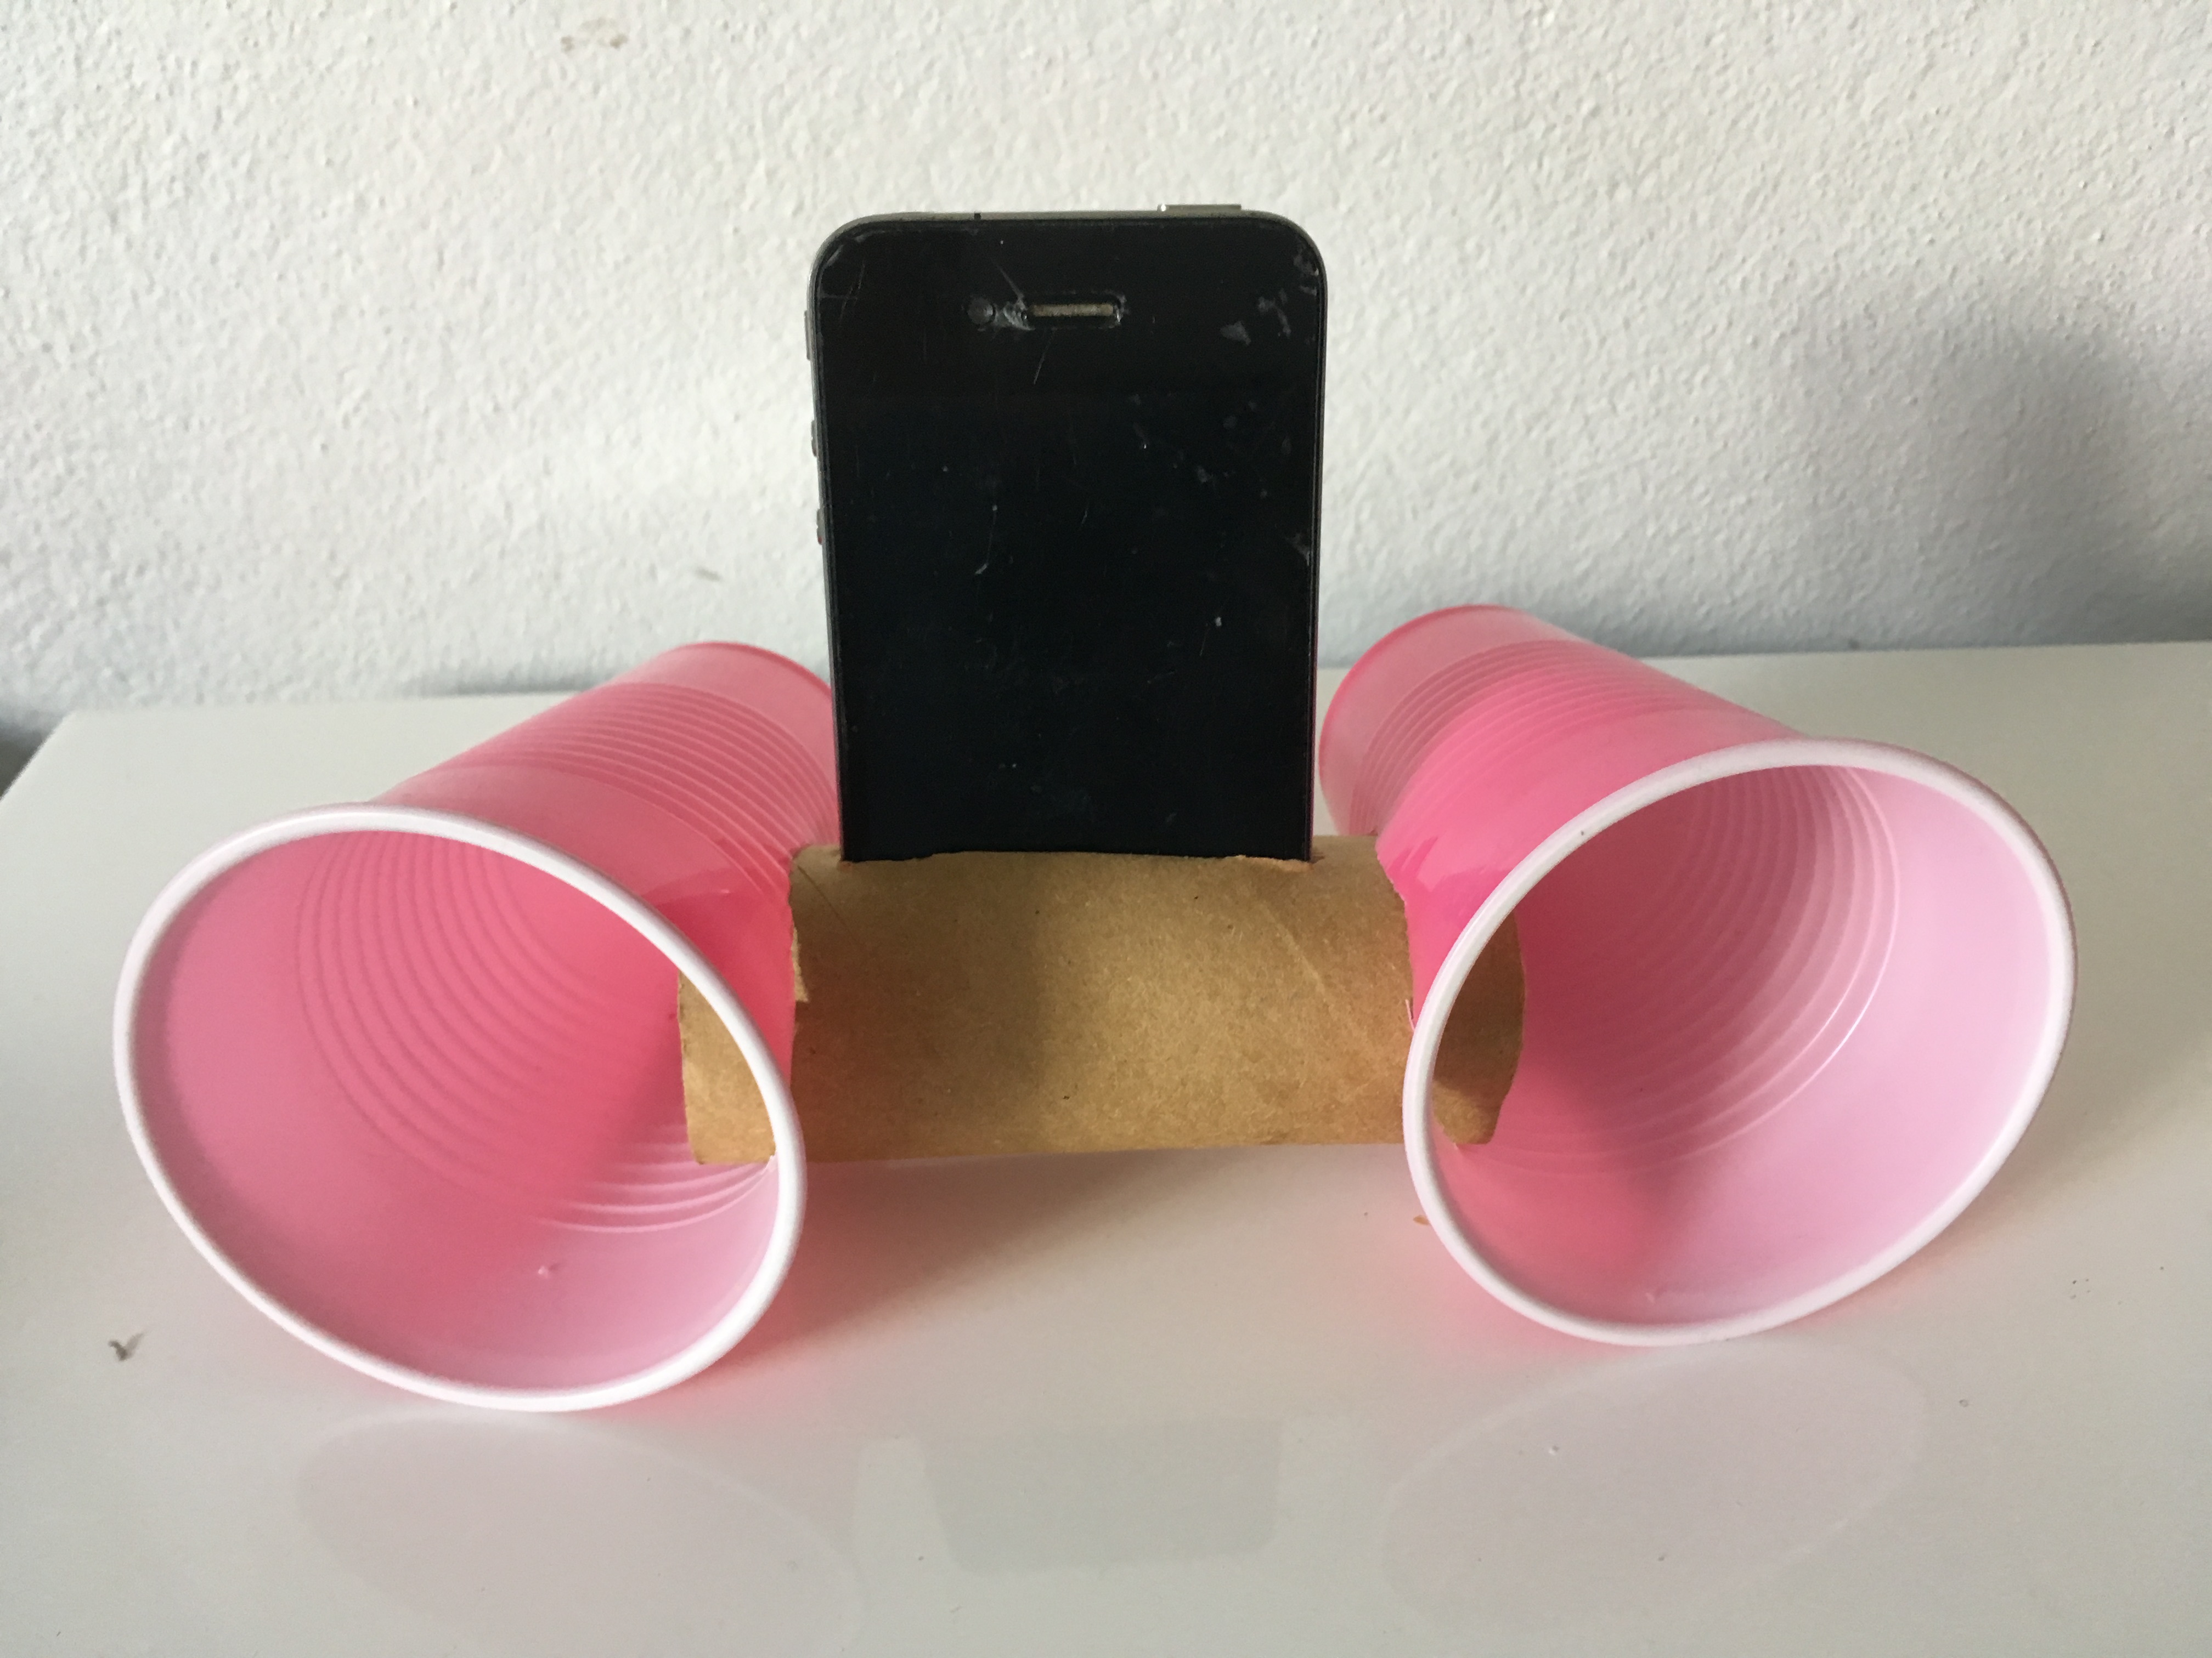
Note for teachers:
This is an example of how this task could be completed by students. Students can hand write comments and cut and paste a picture if they wish. Students could also use digital software to make an amplifier ranking poster.

4
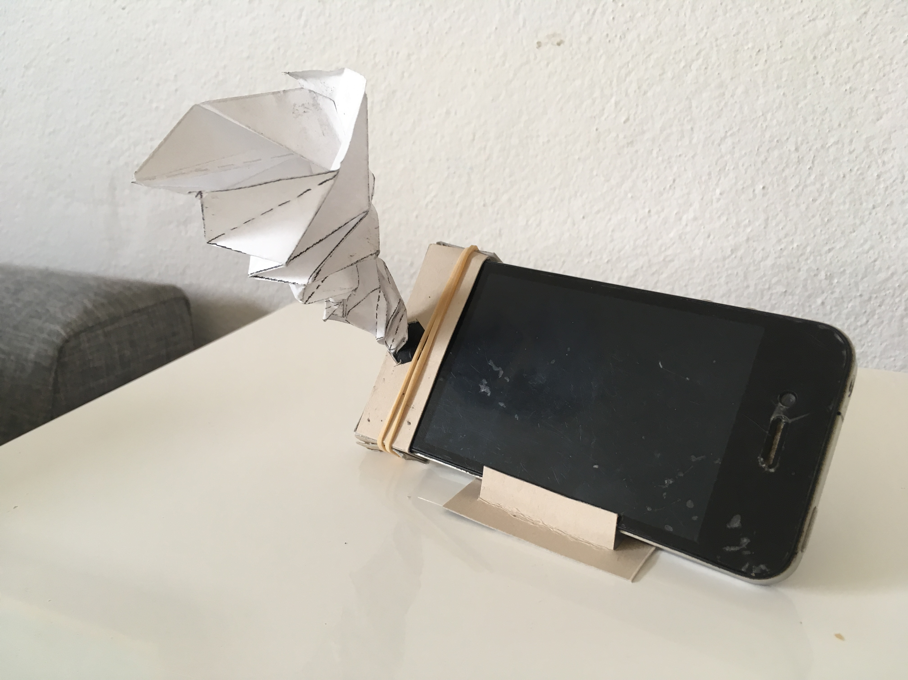
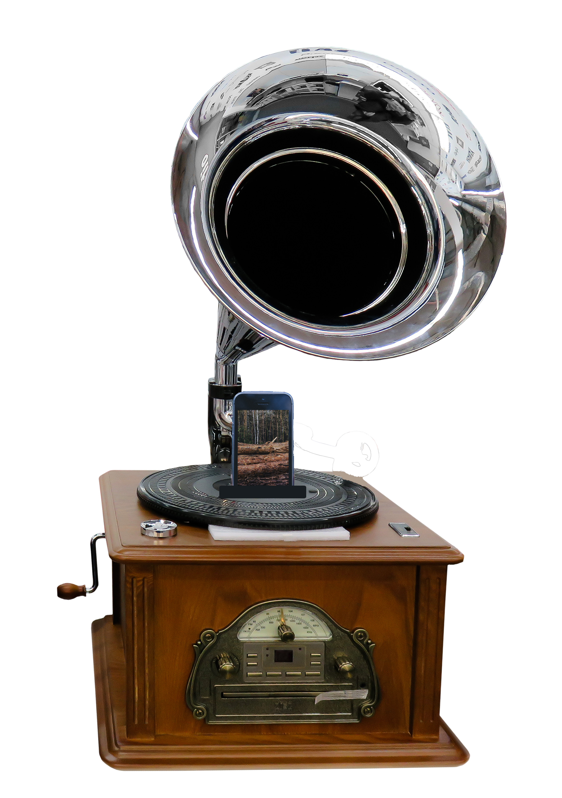
5

Appendix 13: Student activity sheet 3.1: Model scale diagram
Introduction
The diagram below shows a scale drawing of a passive amplifier for a smartphone. It also shows the phone's location and the sound source on the phone.
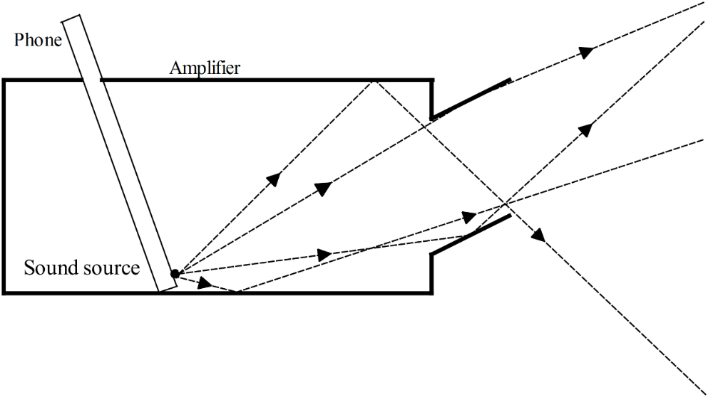
Added to the diagram is a series of directed lines that represent the sound waves leaving the source and their path out of the amplifier. Each of the sound waves that reflect off the walls of the amplifier is drawn so that the law of reflection (angle of incidence equals angle of reflection) is obeyed.
STEM Consortium
Task 1: Draw a scale diagram of your amplifier as in the example above.
It is acceptable for your scale to be 1:1, but the measurements need to be correct. If the longest dimension of your amplifier is larger than the size of your sheet of paper, you will need to draw the diagram to scale. For example, a scale of 2:1 means that 2 units on the amplifier are represented as 1 unit in the scale drawing, so that 20 cm on the object would be drawn as 10 cm in the scale drawing.
Choose a scale that enables you to include the whole object within the page and leave enough space around the drawing for labelling and annotations.
Compare the longest dimension of the object with the longest dimension of your page. If the object is twice as long as the page, choose a scale such as 4:1 or 5:1 to enable you to fit the drawing on the page and leave space for annotations.
As you construct your drawing, ensure that all measurements on the object are scaled to the correct measurement on the drawing. This will ensure the drawing shows the object in the correct proportions.
Task 2: As in the example, draw the path of at least four sound waves starting from the source and leaving the amplifier. Use a protractor to ensure the law of reflection is obeyed.
You will be able to use this diagram in Activity 4 to help justify your design.

Appendix 14: Student activity sheet 3.2: Prototype troubleshooting
Problem | Reason for the problem | Possible changes to your design to solve the problem

Appendix 15: Student activity sheet 4.1: Design review
Things I would keep the same _________________________________________________________________________________________________________________________________________________________________________________________________________________________
Things I would change
________________________________________________________________________________________________________________________________________________________________________________________________________________________________________________________
Photograph or drawing

Appendix 16: Student activity sheet 4.2: Peer evaluation
 | Always | Usually | Sometimes | Rarely
Remains focused on tasks presented
Completes set tasks to best of their ability
Works independently without disrupting others
Uses time well
Cooperates effectively within the group
Contributes to group discussions
Shows respect and consideration for others
Uses appropriate conflict resolution skills
Comes to class prepared for activities
Actively seeks and uses feedback

Comments: __________________________________________________________________________________________________________________________________________________________________________________________________________________________________________________________________________________________________________________________________________________________

Appendix 17: Student activity sheet 4.3: Self-evaluation
 | Always | Usually | Sometimes | Rarely
Remains focused on tasks presented
Completes set tasks to best of their ability
Works independently without disrupting others
Uses time well
Cooperates effectively within the group
Contributes to group discussions
Shows respect and consideration for others
Uses appropriate conflict resolution skills
Comes to class prepared for activities
Actively seeks and uses feedback

Comments: __________________________________________________________________________________________________________________________________________________________________________________________________________________________________________________________________________________________________________________________________________________________

Notes
________________________________________________________________________________________________________________________________________________________________________________________________________________________________________________________________________________________________________________________________________________________________________________________________________________________________________________________________________________________________________________________________________________________________________________________________________________________________________________________________________________________________________________________________________________________________________________________________________________________________________________________________________________________________________________________________________________________________________________________________________________________________________________________________________________________________________________________________________________________________________________________________________________________________________________________________________________________________________________________________________________________________________________________________________________________________________________________________________________________________________________________________________________________________________________________________________________________________

Notes
________________________________________________________________________________________________________________________________________________________________________________________________________________________________________________________________________________________________________________________________________________________________________________________________________________________________________________________________________________________________________________________________________________________________________________________________________________________________________________________________________________________________________________________________________________________________________________________________________________________________________________________________________________________________________________________________________________________________________________________________________________________________________________________________________________________________________________________________________________________________________________________________________________________________________________________________________________________________________________________________________________________________________________________________________________________________________________________________________________________________________________________________________________________________________________________________________________________________

Notes
________________________________________________________________________________________________________________________________________________________________________________________________________________________________________________________________________________________________________________________________________________________________________________________________________________________________________________________________________________________________________________________________________________________________________________________________________________________________________________________________________________________________________________________________________________________________________________________________________________________________________________________________________________________________________________________________________________________________________________________________________________________________________________________________________________________________________________________________________________________________________________________________________________________________________________________________________________________________________________________________________________________________________________________________________________________________________________________________________________________________________________________________________________________________________

